CNNs for TR-XPS fits

# Database generation for training, validation and test of CNN models

The database is composed of spectra artificially generated with pseudo-Voigt function:

$$y(a,b,c)=c\left(α\exp\left(-\frac{{\left(a-x\right)}^{2}}{2{ \left(βb\right)}^{2}}\right)+\left(1-α\right)\frac{{\left(Γb\right)}^{2}}{1+{\left(a-x\right)}^{2}}\right)$$

Scaling factors between the Gaussian and Lorentzian functions are fixed according to previous study:

$α=0.3$

$β=0.510$

$Γ=0.441$

Explored ranges for the global parameters for the pseudo-Voigt peak:

* $a$: [2, 13]
* $b$: [0.3, 1.9]
* $c$: [0.05, 1.05]

Parameters are explored randomly with a uniform distribution.

Entries of the database are generated with sums of 1 to 5 “pseudo-Voigt” sub peaks:

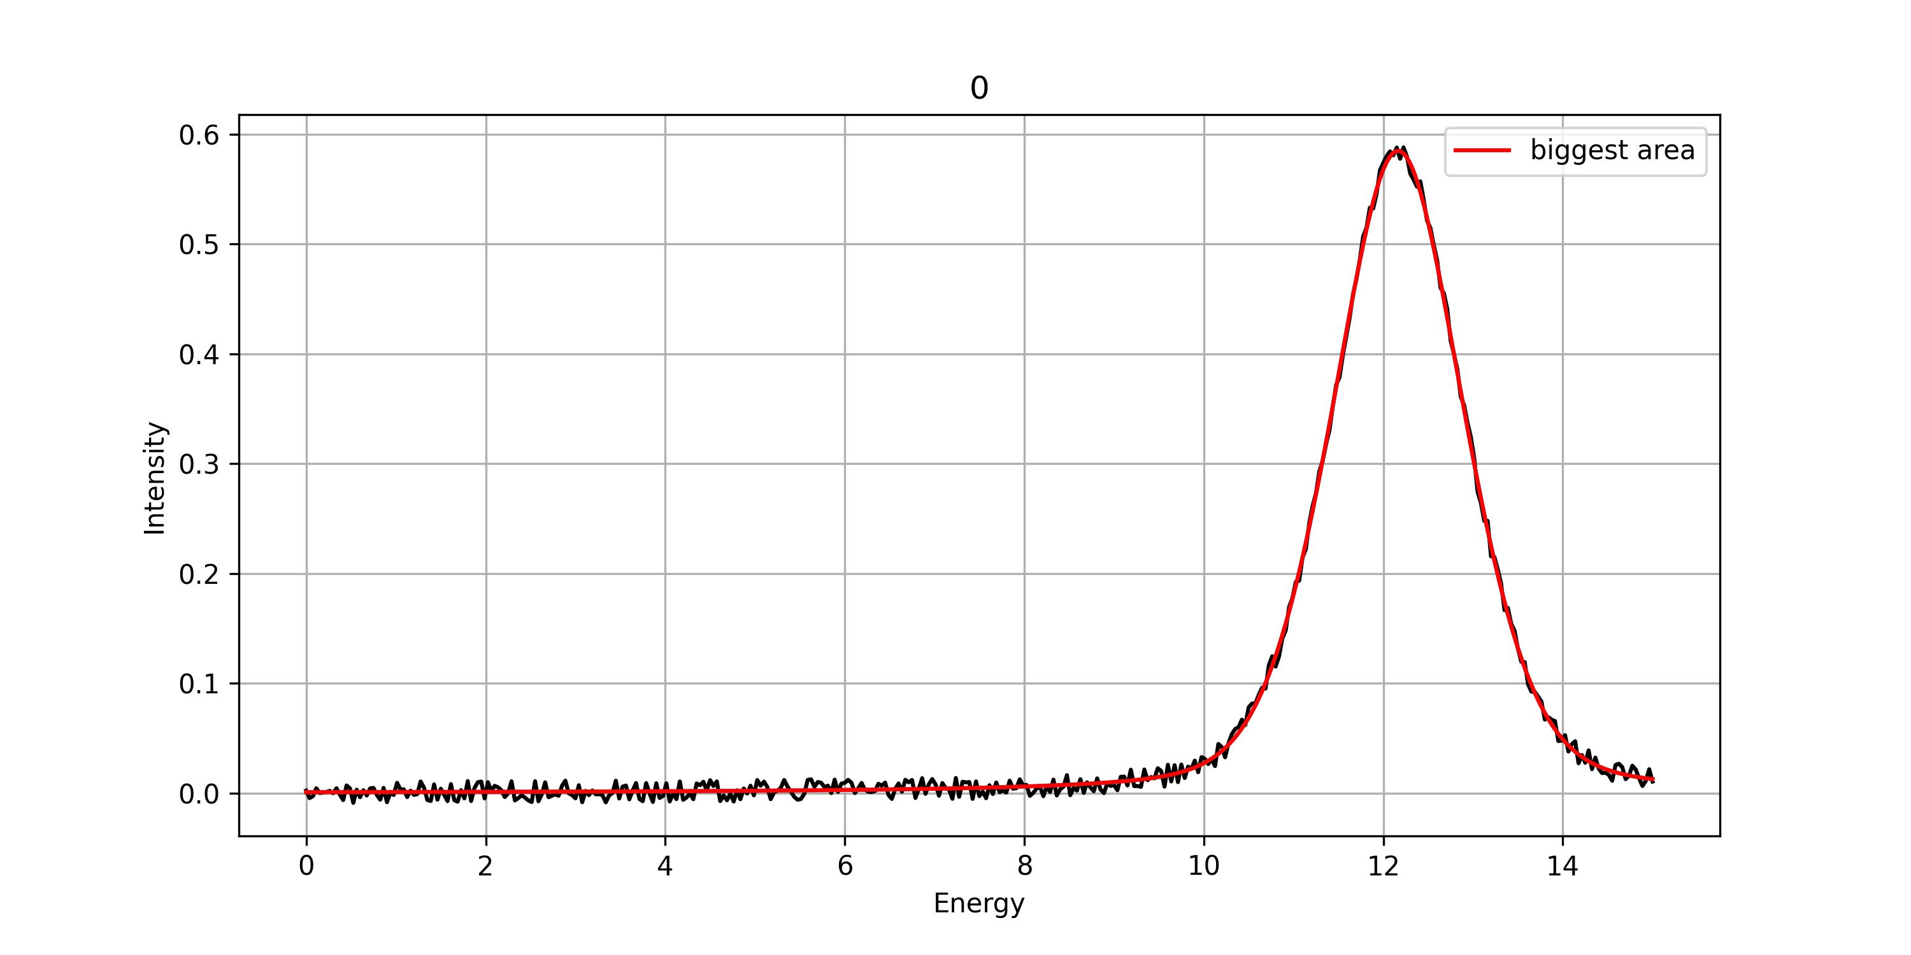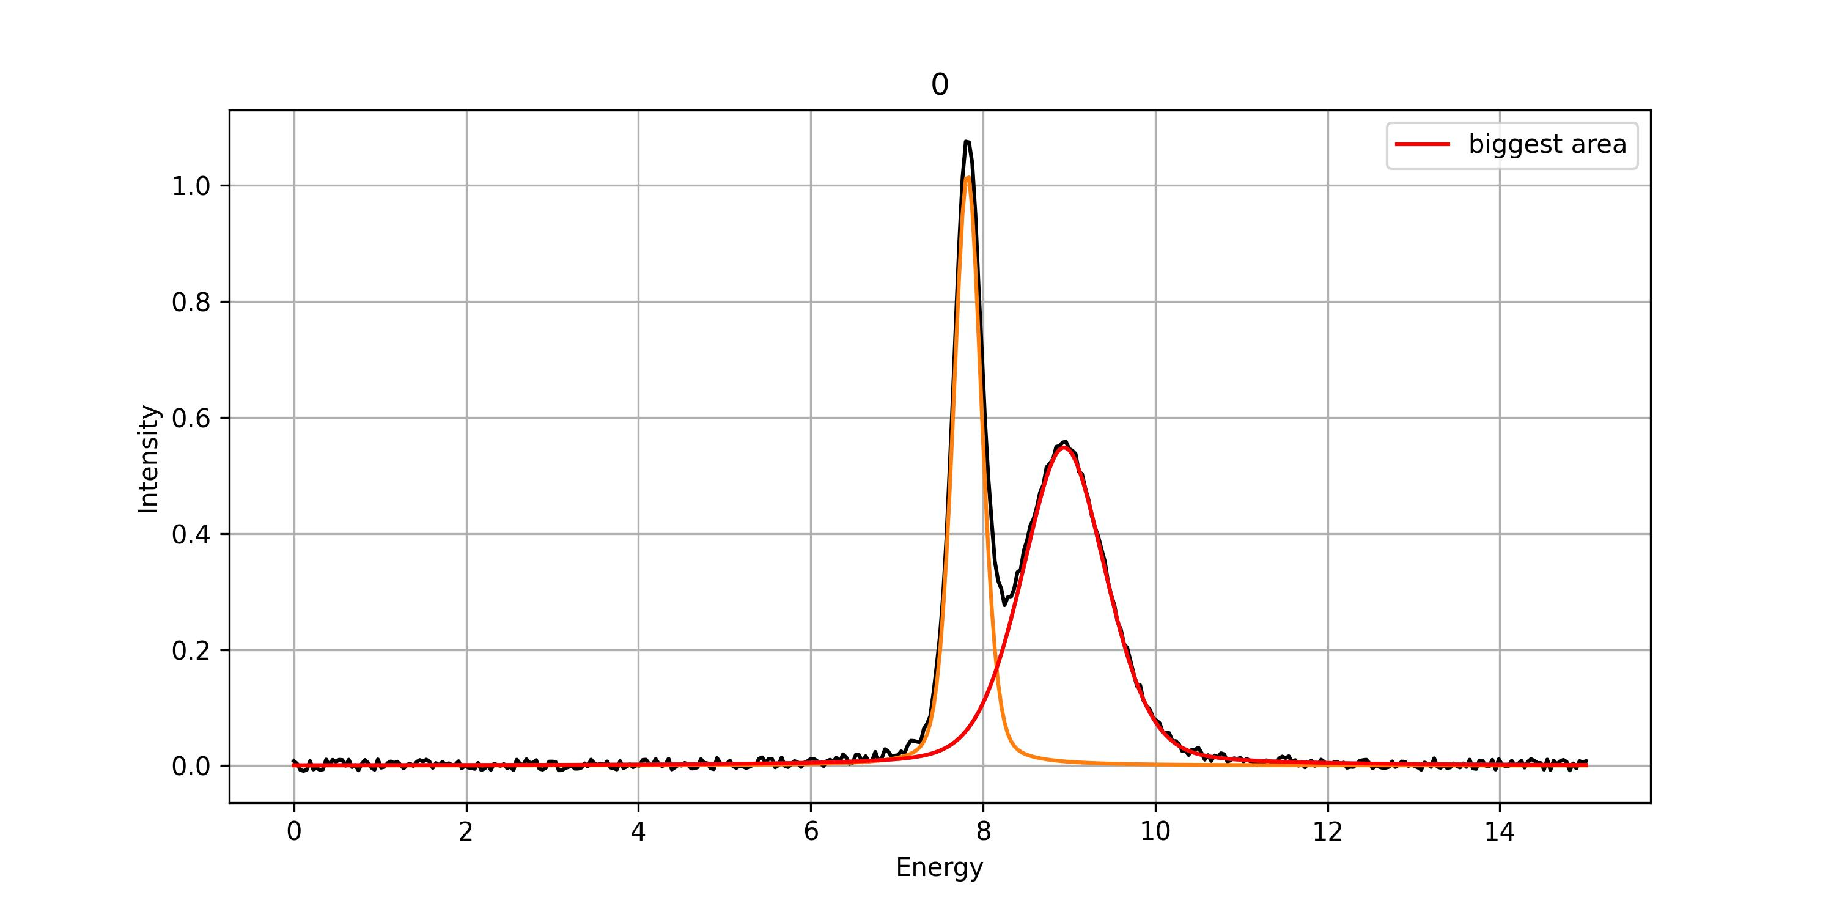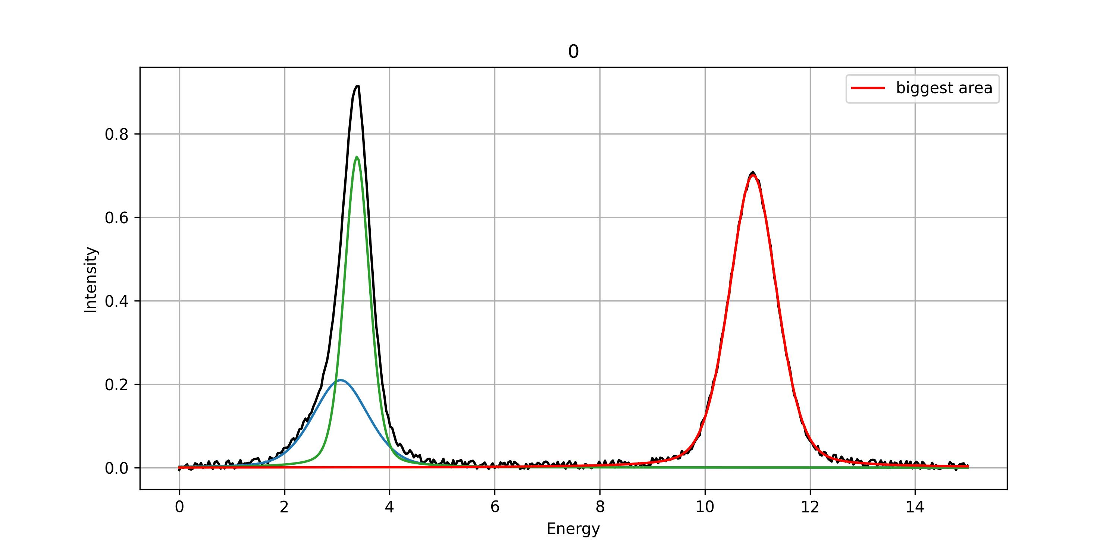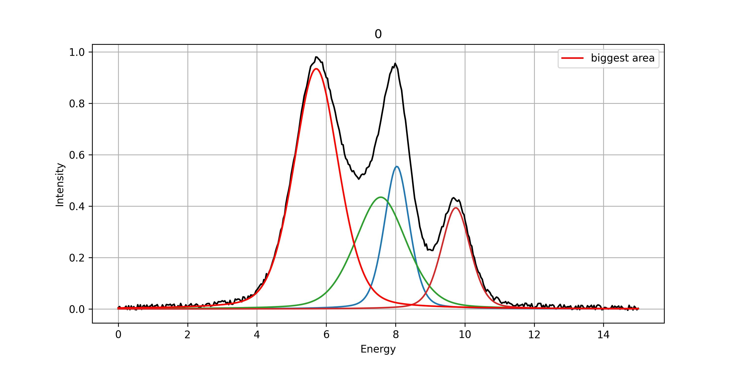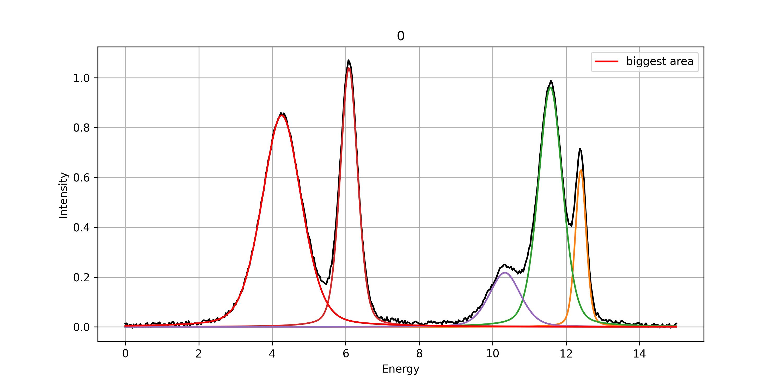

Centers of the sub-peaks are kept more than 0.2 away from each other.

The database is split into training, validation and test databases with a ratio 0.8:0.1:0.1.

Training objectives of the CNNs: find the following parameters:

|  |  |  |  |
| --- | --- | --- | --- |
| Position of major sub-peak (a) | Width of major sub-peak (b) | Amplitude of major sub-peak (c) | Number of sub-peaks in spectrum |

**Conclusion:**

* Minimal distance between two sub-peaks is 0.2: Is it enough? Is it too small?
* CNNs could be modified to be trained to directly find 15 parameters: a,b and c for each sub-peak, with c being potentially 0.
* In some cases, the sub-peaks are completely distinct: maybe not useful?

# CNN architectures implemented by Park et al

Six architectures are implemented and compared.

Here they are trained and tested on a small database on a laptop. Too small to compare output precision, but enough to compare processing times.

* Size of total database: 28 293
* Size of training database: 22 634
* Size of validation database: 2 829
* Size of test database: 2 830

|  |  |  |  |  |  |
| --- | --- | --- | --- | --- | --- |
|  | Description of the model | Number of trainable parameters | Training time (50 epochs) | Average fit time | Average recursive fit time |
| LeNet | First proposed CNN architecture, which consists of alternating convolution and subsampling (pooling) layers | 226 468 | 103 s  (2 min) | 2.20e-04 s | 0.14 s |
| Alex_ZFNet | Improvement of LeNet by introducing maxpooling, dropout, and rectified linear unit (ReLU) activation function | 1 632 436 | 1 259 s  (21 min) | 5.62e-04 s | 0.16 s |
| VGGNet | Uniform network structure but with increased number of convolution filters. | 1 784 420 | 1 070 s  (18 min) | 6.06e-04 s | 0.15 s |
| ResNet | Employs the so-called “skip connections” to enhance back-propagation of the loss function gradient deep into the network layers. | 4 056 228 | 2 804 s  (47 min) | 1.23e-03 s | 0.16 s |
| SEResNet | ’Squeeze-and-excitation (SE)  block’ is introduced to improve performance with a small  amount of computational cost increase | 4 145 308 | 3 331 s  (55 min) | 1.40e-03 s | 0.17 s |
| sparse_densenet  Model proposed by Park et al. | Idea of SE block from SENet was implemented into the so-called ’sparse-dense block’. Each sparse-dense block consists of serially connected pairs of convolution layers (CONV) and a SE block, where identity mapping connects input and output layers of two CONV-CONV-SE triplets in a sparse-dense block. Batch normalization and SE layers were placed between adjacent sparse-dense blocks to rebalance weights of convolution feature maps. | 4 173 818 | 3 317 s  (55 min) | 1.60e-03 s | 0.20 s |

**Conclusion:**

* Training time is much larger for elaborated models, but fit time remains low.
* Structure of sparse-densenet is not obvious: CONV block in CONV-CONV-SE triplet could have been constructed differently (in coherence with previous architectures). Modifications of the architecture will be tested.

# Training of sparse-densenet and LeNet on large databases

Comparison of two configurations of training database and epochs (training iterations):

* Case A: 225 000 entries database, training over 100 epochs
* Case B: 1 412 000 entries database, training over 50 epochs

|  |  |
| --- | --- |
| **Case A** | **Case B** |
| Size of total database: 225 118  **Size of training database: 180 094**  **Size of validation database: 22 512**  Size of test database: 22 512 | Size of total database: 1 412 339  **Size of training database: 1 129 871**  **Size of validation database: 141 234**  Size of test database: 141 234 |
| Sparse_densenet:  Training time for 100 epochs: 51 290 s (14 h)  LeNet:  Training time for 100 epochs: 859 s (14 min) | Sparse_densenet:  Training time for 50 epochs: 247 987 s (69 h)  LeNet:  Training time for 50 epochs: 9 315 s (3 h) |
|  |  |

**Conclusion:**

* Sparse densenet performs significantly better, but needs significantly more time to train
* 50 epochs are enough to train the models: no performance improvements until 100 epochs
* Larger database ensures higher performances: total loss on training database down to 0.5 in case B, versus 1 in case A.
* Larger database induces significantly larger training time.

# Test of sparse-densenet and LeNet

Same configurations as above:

* Case A: 225 000 entries database, training over 100 epochs
* Case B: 1 412 000 entries database, training over 50 epochs

|  |  |
| --- | --- |
| **Case A** | **Case B** |
| Size of total database: 225 118  Size of training database: 180 094  Size of validation database: 22 512  **Size of test database: 22 512** | Size of total database: 1 412 339  Size of training database: 1 129 871  Size of validation database: 141 234  **Size of test database: 141 234** |
| Sparse_densenet:  MAE on center: 0.14  MAE on width: 0.03  MAE on amplitude: 0.02  MAE on peak number: 0.07  Avg fit time: 1.28e-03 s  LeNet:  MAE on center: 0.48  MAE on width: 0.08  MAE on amplitude: 0.05  MAE on peak number: 0.28  Avg fit time: 1.29e-04 s | Sparse_densenet:  MAE on center: 0.09  MAE on width: 0.02  MAE on amplitude: 0.01  MAE on peak number: 0.03  Avg fit time: 1.41e-03 s  LeNet:  MAE on center: 0.25  MAE on width: 0.05  MAE on amplitude: 0.03  MAE on peak number: 0.10  Avg fit time: 1.16e-04 s |
|  |  |

**Conclusion:**

* Precision on fitted params is higher with sparse-densenet model in both cases A and B.
* Fitting time remains low: 1e-03 s for sparse-densenet vs 1.e-04 s for LeNet

Results from Park et al. (total database of 1 500 000 entries):

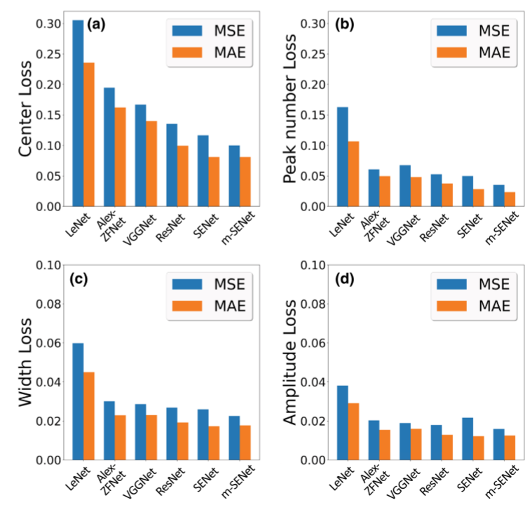

# Iterative fitting using sparse-densenet and LeNet: comaprison of models

Quality of iterative fit is quantified through R2 value:

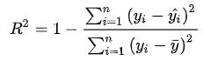

Only the best performing training case is considered:

|  |
| --- |
| **Case B** |
| Size of total database: 1 412 339  Size of training database: 1 129 871  Size of validation database: 141 234  **Size of test database: 141 234** |

|  |  |
| --- | --- |
| LeNet: | Sparse_densenet: |
| Average recursive fit time: 0.14 s per spectrum | Average recursive fit time: 0.20 s per spectrum |
| Distribution of R2 values: | |
|  |  |
| Examples of fits (only cases with five sub-peaks) with R2 values showed in histogram: | |
| |  |  |  |  |  |  |  |  |  |  |  | | --- | --- | --- | --- | --- | --- | --- | --- | --- | --- | --- | |  | Peak 1 | | Peak 2 | | Peak 3 | | Peak 4 | | Peak 5 | | |  | True | Fit | True | Fit | True | Fit | True | Fit | True | Fit | | Position | 7.46 | 6.79 | 6.76 | 7.48 | 2.31 | 2.22 | 12.73 | 12.68 | 5.55 | 5.56 | | Width | 1.44 | 1.74 | 1.71 | 1.38 | 1.80 | 1.77 | 1.38 | 1.38 | 0.82 | 0.81 | | Amplitude | 1.02 | 0.93 | 0.85 | 0.91 | 0.62 | 0.61 | 0.57 | 0.56 | 0.63 | 0.61 | | |  |  |  |  |  |  |  |  |  |  |  | | --- | --- | --- | --- | --- | --- | --- | --- | --- | --- | --- | |  | Peak 1 | | Peak 2 | | Peak 3 | | Peak 4 | | Peak 5 | | |  | True | Fit | True | Fit | True | Fit | True | Fit | True | Fit | | Position | 2.93 | 2.95 | 5.84 | 5.84 | 6.99 | 6.99 | 4.40 | 4.42 | 10.81 | 10.84 | | Width | 1.82 | 1.82 | 1.88 | 1.89 | 0.90 | 0.89 | 0.34 | 0.34 | 0.87 | 0.86 | | Amplitude | 0.63 | 0.62 | 0.53 | 0.54 | 0.71 | 0.70 | 0.82 | 0.81 | 0.16 | 0.16 | |
|  |  |
|  |  |
| |  |  |  |  |  |  |  |  |  |  |  | | --- | --- | --- | --- | --- | --- | --- | --- | --- | --- | --- | |  | Peak 1 | | Peak 2 | | Peak 3 | | Peak 4 | | Peak 5 | | |  | True | Fit | True | Fit | True | Fit | True | Fit | True | Fit | | Position | 5.41 | 5.28 | 9.60 | 4.42 | 4.37 | 9.53 | 4.80 | 4.76 | 7.49 |  | | Width | 1.70 | 1.65 | 1.64 | 1.29 | 1.17 | 1.60 | 1.20 | 0.73 | 0.52 |  | | Amplitude | 0.71 | 0.87 | 0.47 | 0.64 | 0.58 | 0.47 | 0.57 | 0.27 | 0.26 |  | | |  |  |  |  |  |  |  |  |  |  |  | | --- | --- | --- | --- | --- | --- | --- | --- | --- | --- | --- | |  | Peak 1 | | Peak 2 | | Peak 3 | | Peak 4 | | Peak 5 | | |  | True | Fit | True | Fit | True | Fit | True | Fit | True | Fit | | Position | 5.22 | 2.10 | 2.10 | 5.26 | 7.92 | 7.88 | 9.91 | 5.22 | 4.95 | 9.90 | | Width | 0.91 | 0.95 | 0.96 | 0.89 | 0.59 | 0.61 | 0.34 | 0.54 | 0.60 | 0.33 | | Amplitude | 0.94 | 0.75 | 0.75 | 0.68 | 0.49 | 0.48 | 0.59 | 0.42 | 0.09 | 0.59 | |

**Conclusion:**

* Results with **sparse-densenet** are significantly more accurate.
* Graphs showed here are associated to 5 sub-peaks cases: the most difficult to fit
* R2 values of 0.98 are already low enough to be associated to bad parameter estimation.

# Iterative fitting using sparse-densenet: quantification of error

**MAE on position, width and amplitude over the total database:**

|  |  |  |  |  |  |
| --- | --- | --- | --- | --- | --- |
|  | Peak 1 | Peak 2 | Peak 3 | Peak 4 | Peak 5 |
| Position | 0.21 | 0.52 | 0.79 | 0.94 | 0.89 |
| Width | 0.03 | 0.07 | 0.12 | 0.15 | 0.16 |
| Amplitude | 0.03 | 0.05 | 0.06 | 0.07 | 0.05 |

|  |  |  |  |  |
| --- | --- | --- | --- | --- |
|  | Peak 1 | Peak 2 | Peak 3 | Peak 4 |
| Position | 0.13 | 0.33 | 0.50 | 0.47 |
| Width | 0.02 | 0.05 | 0.09 | 0.10 |
| Amplitude | 0.02 | 0.03 | 0.04 | 0.04 |

|  |  |  |  |
| --- | --- | --- | --- |
|  | Peak 1 | Peak 2 | Peak 3 |
| Position | 0.06 | 0.16 | 0.18 |
| Width | 0.02 | 0.04 | 0.05 |
| Amplitude | 0.01 | 0.02 | 0.02 |

|  |  |  |
| --- | --- | --- |
|  | Peak 1 | Peak 2 |
| Position | 0.03 | 0.03 |
| Width | 0.01 | 0.02 |
| Amplitude | 0.01 | 0.01 |

|  |  |
| --- | --- |
|  | Peak 1 |
| Position | 0.01 |
| Width | 0.01 |
| Amplitude | 0.00 |

Results from Park et al. on **main peak**:

|  |  |
| --- | --- |
|  | Main peak |
| Position | 0.06 |
| Width | 0.02 |
| Amplitude | 0.01 |

**Quality of the fit versus restriction of R2:**

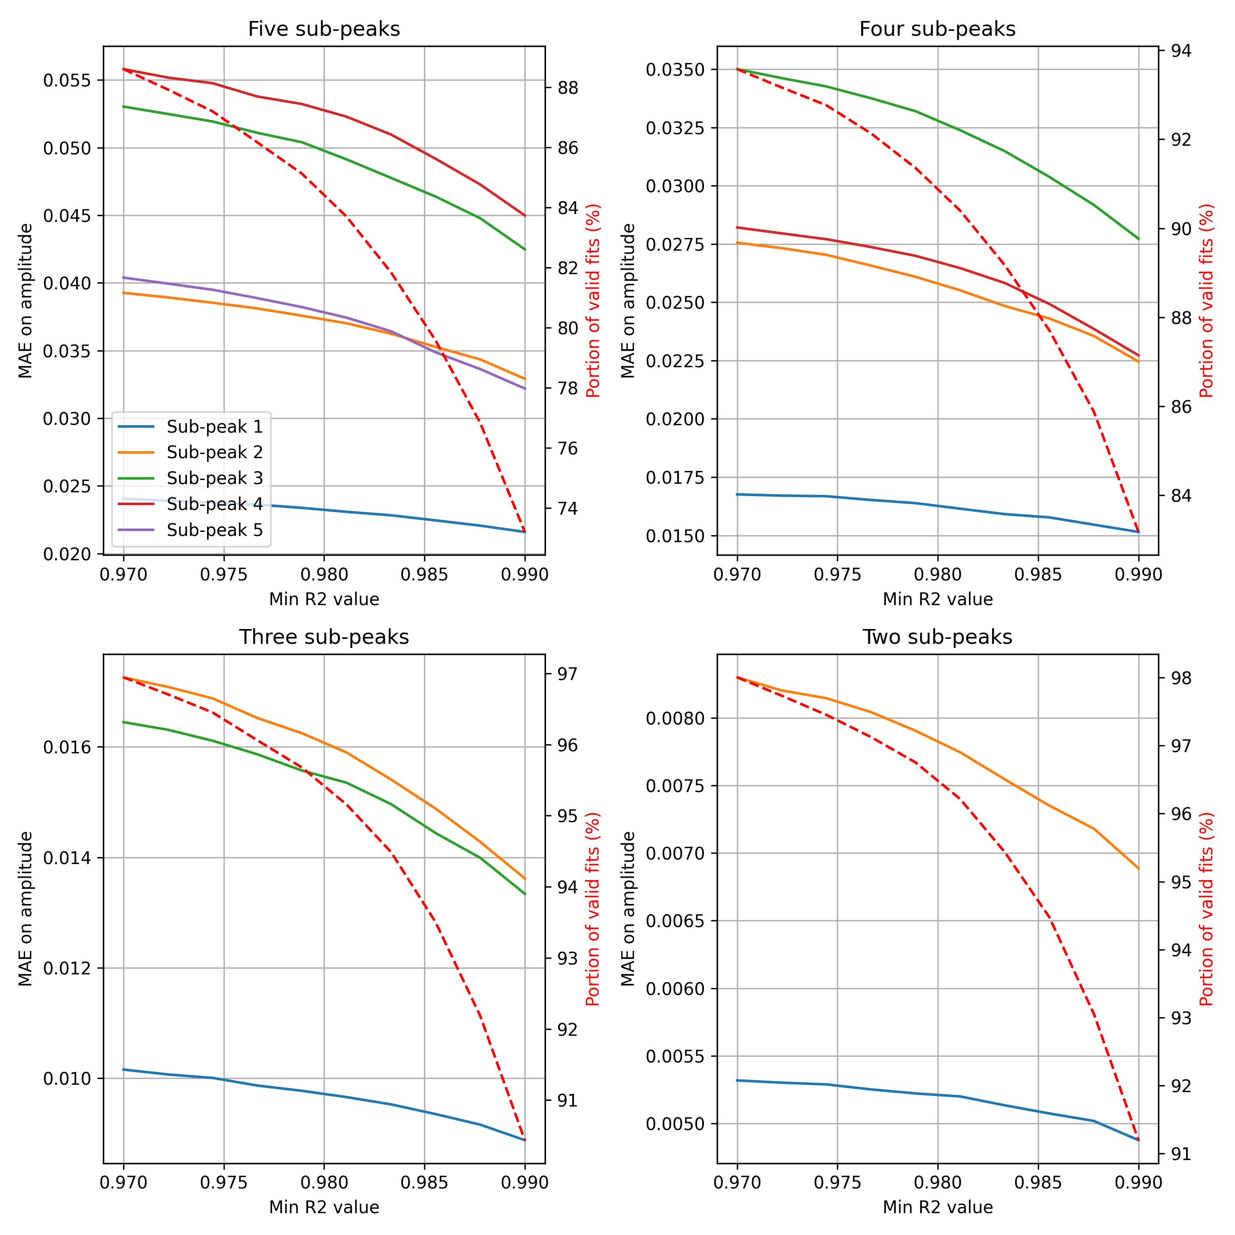

If only fits with R2 values above 0.98 are considered reliable

* 85 % of cases with five sub-peaks are selected
  + MAE on amplitude of fifth peak is 0.0375 (vs more than 0.04 for the full database)
* 96 % of cases with two sub-peaks are selected
  + MAE on amplitude of second peak is 0.0078 (vs more than 0.0085 for the full database)

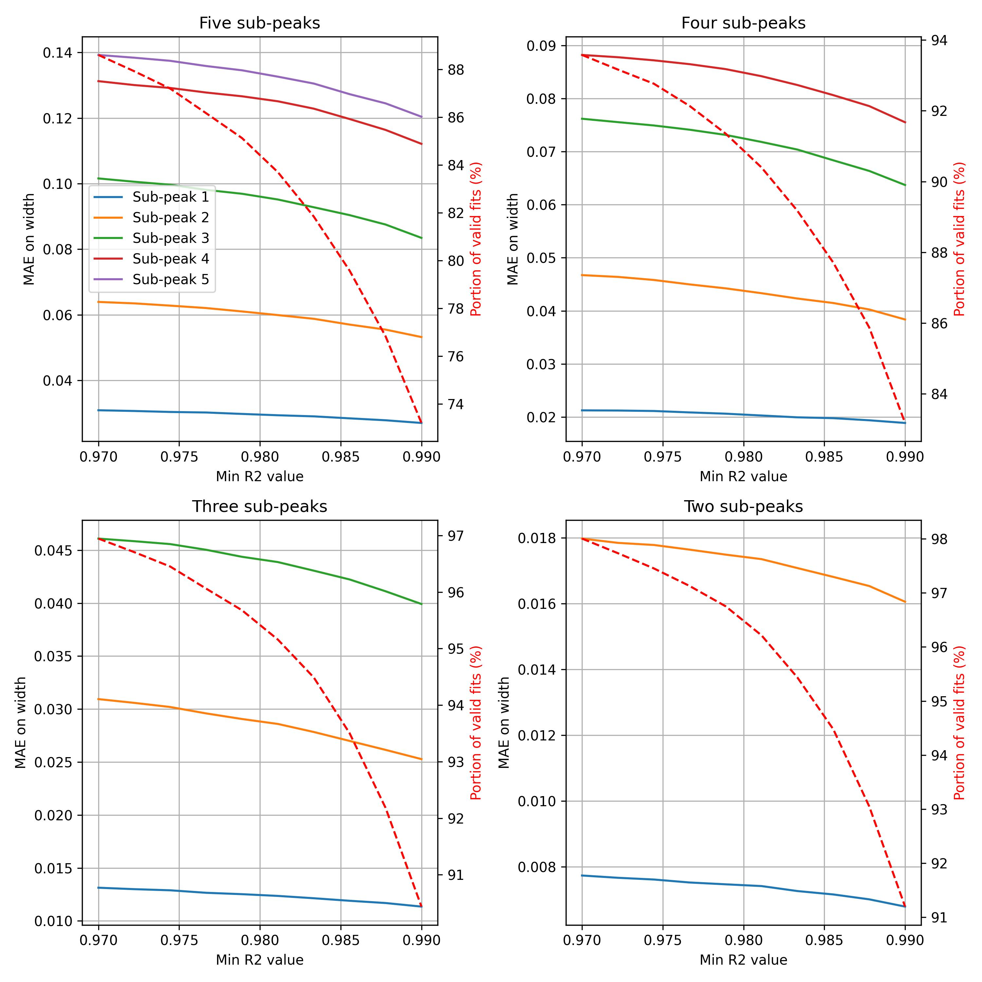

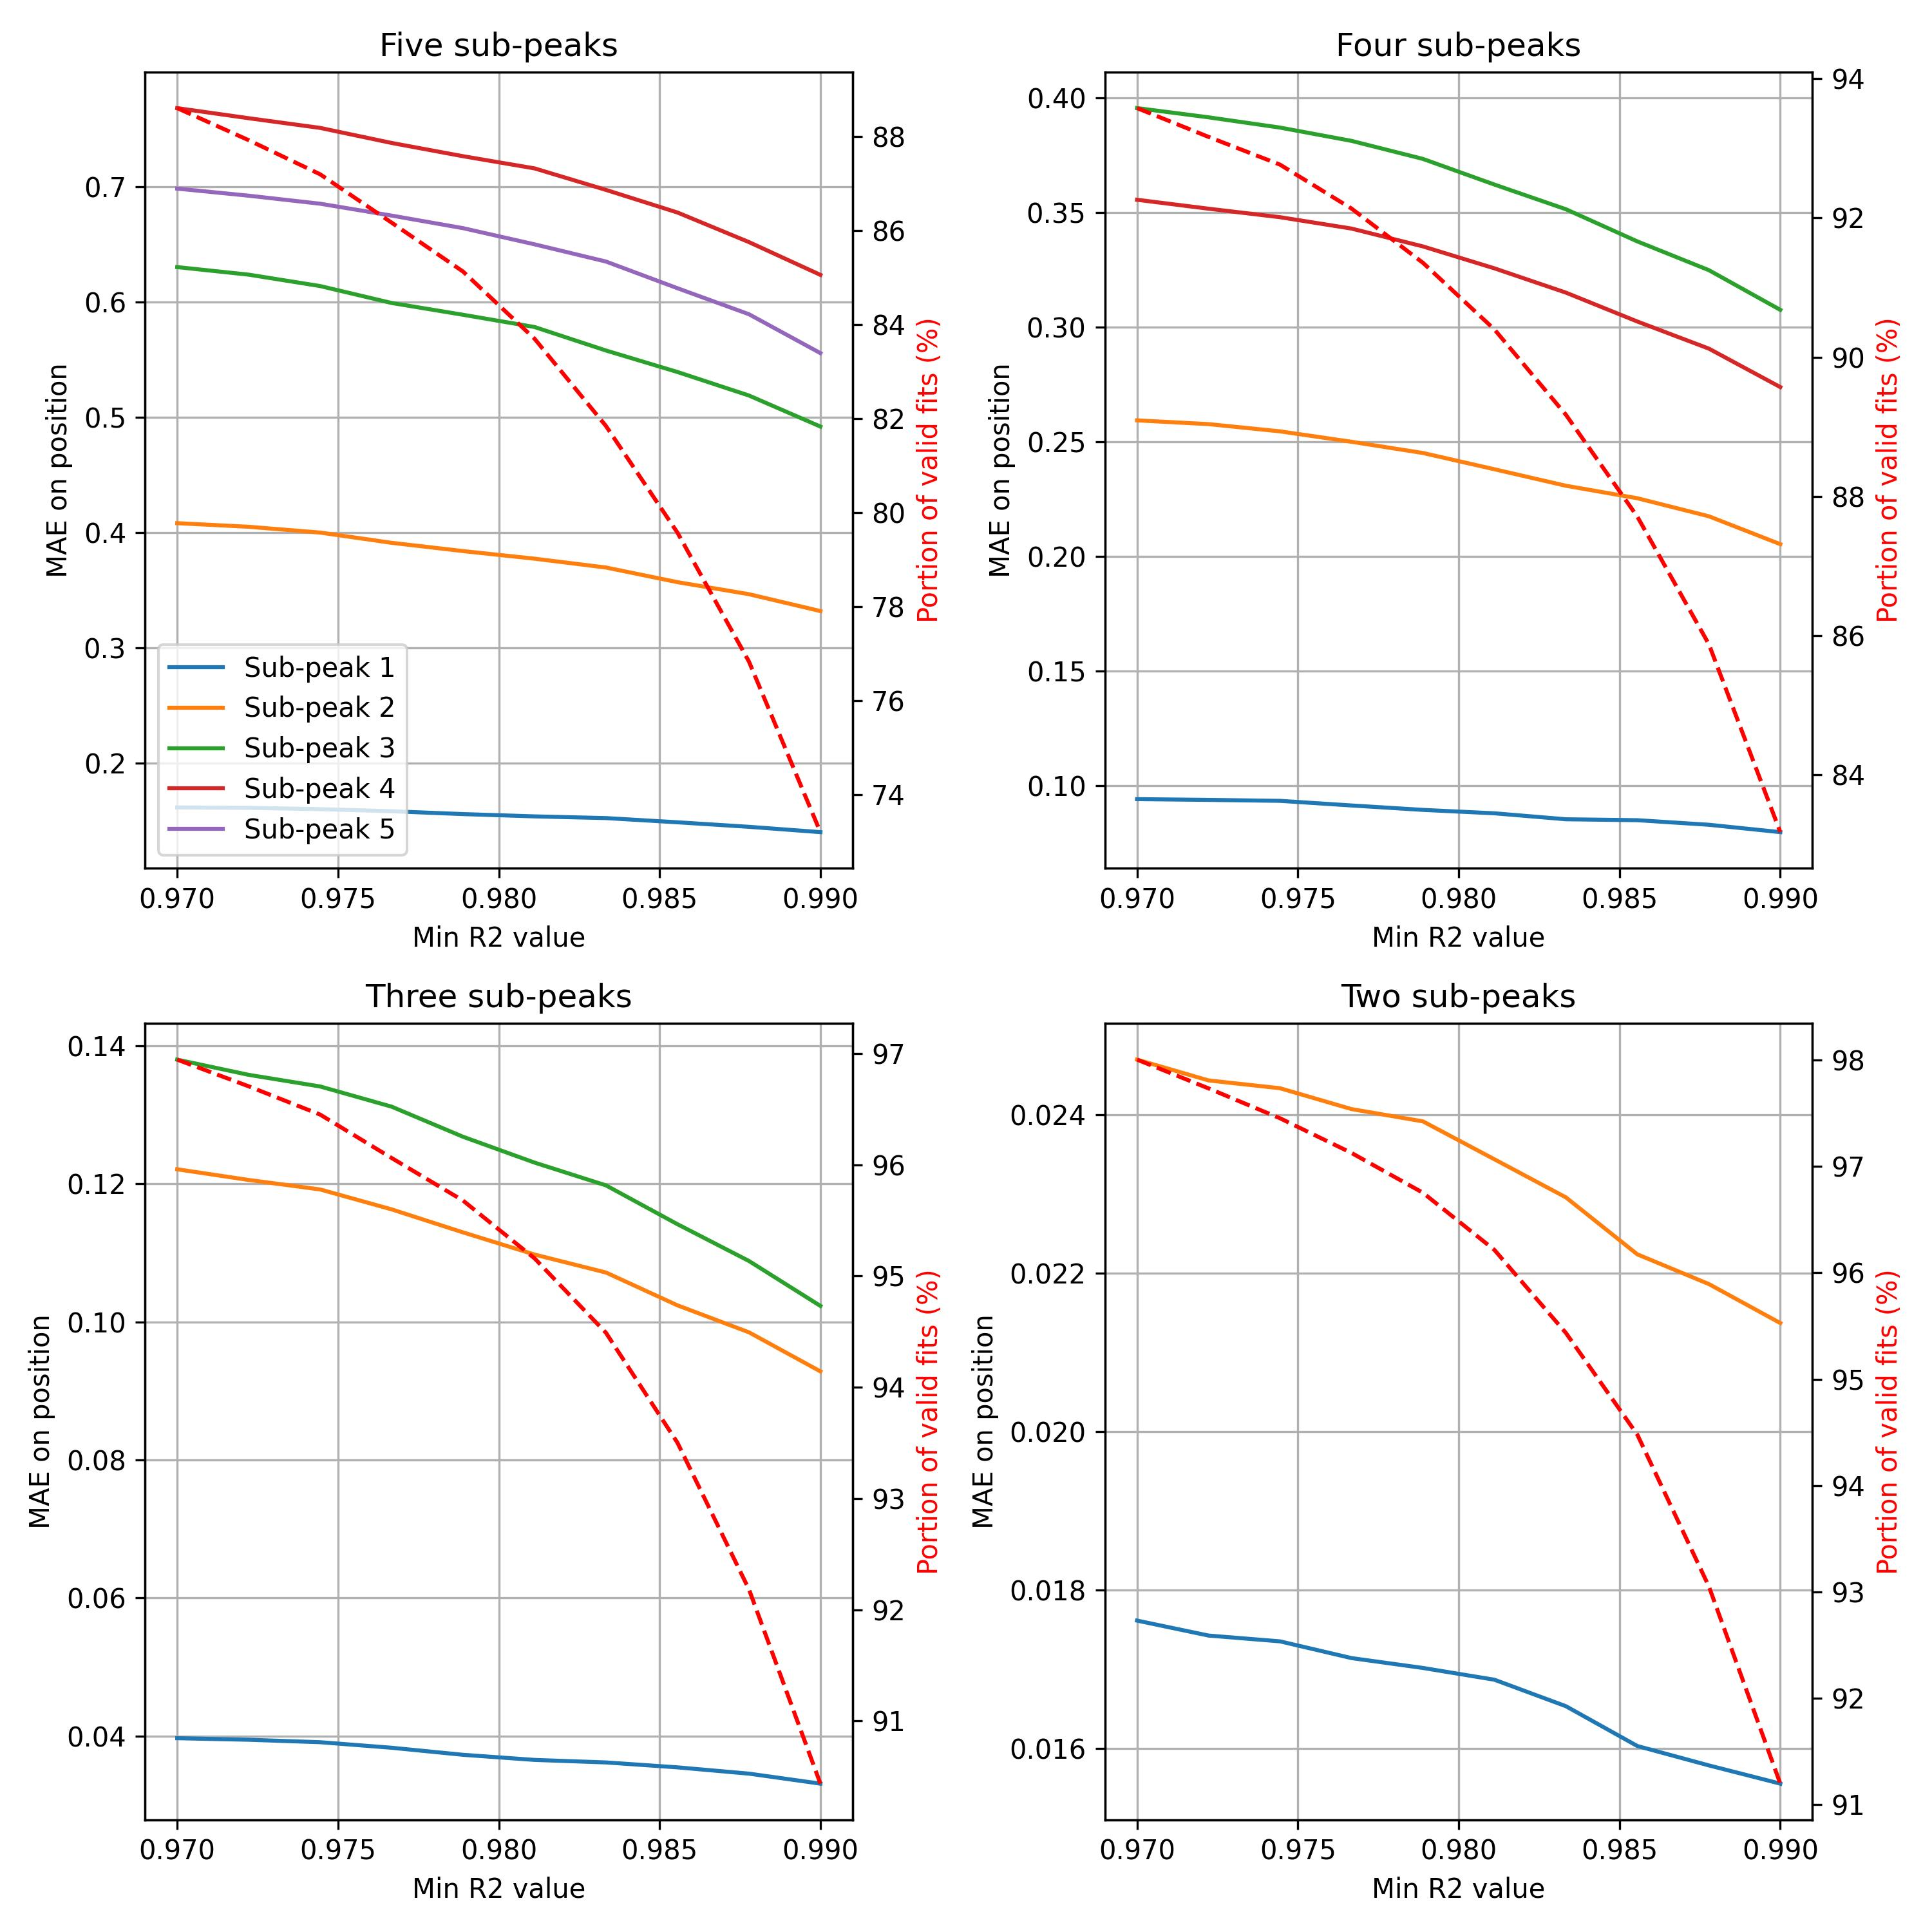

**Conclusion**

* A minimum R2 value of 0.98 allow to remove significantly bad fits
* For cases with 5 sub-peaks, the fit quality is significantly lower than cases with three peaks or less
* In the work of Park et al, a “polishing” step is implemented. It consists in doing a classical fit with least squares reduction, initialized by iterative CNN results. This could be applied to cases with R2 values lower than 0.98.

**Fit examples:**

Example with five sub-peaks:

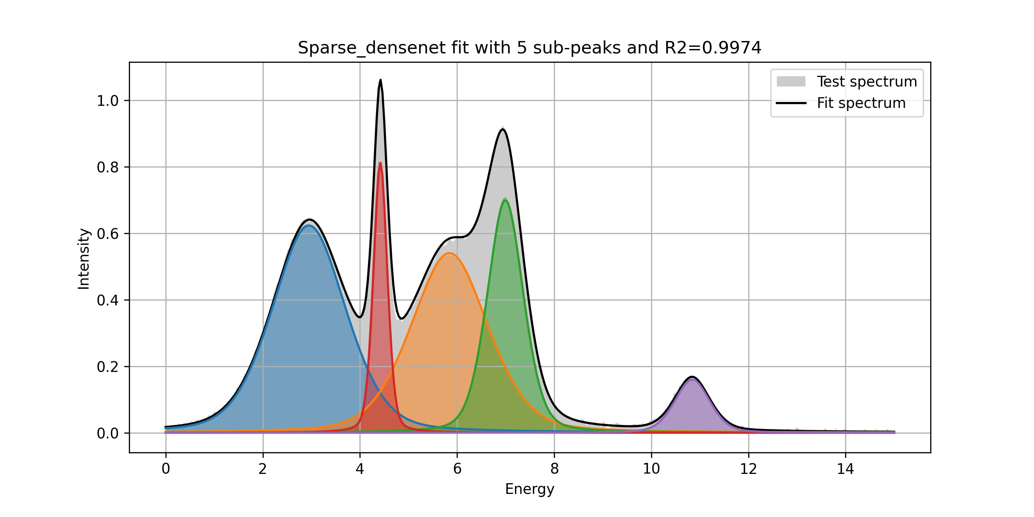

|  |  |  |  |  |  |  |  |  |  |  |
| --- | --- | --- | --- | --- | --- | --- | --- | --- | --- | --- |
|  | Peak 1 | | Peak 2 | | Peak 3 | | Peak 4 | | Peak 5 | |
|  | True | Fit | True | Fit | True | Fit | True | Fit | True | Fit |
| Position | 2.93 | 2.95 | 5.84 | 5.84 | 6.99 | 6.99 | 4.40 | 4.42 | 10.81 | 10.84 |
| Width | 1.82 | 1.82 | 1.88 | 1.89 | 0.90 | 0.89 | 0.34 | 0.34 | 0.87 | 0.86 |
| Amplitude | 0.63 | 0.62 | 0.53 | 0.54 | 0.71 | 0.70 | 0.82 | 0.81 | 0.16 | 0.16 |

Example with four sub-peaks:

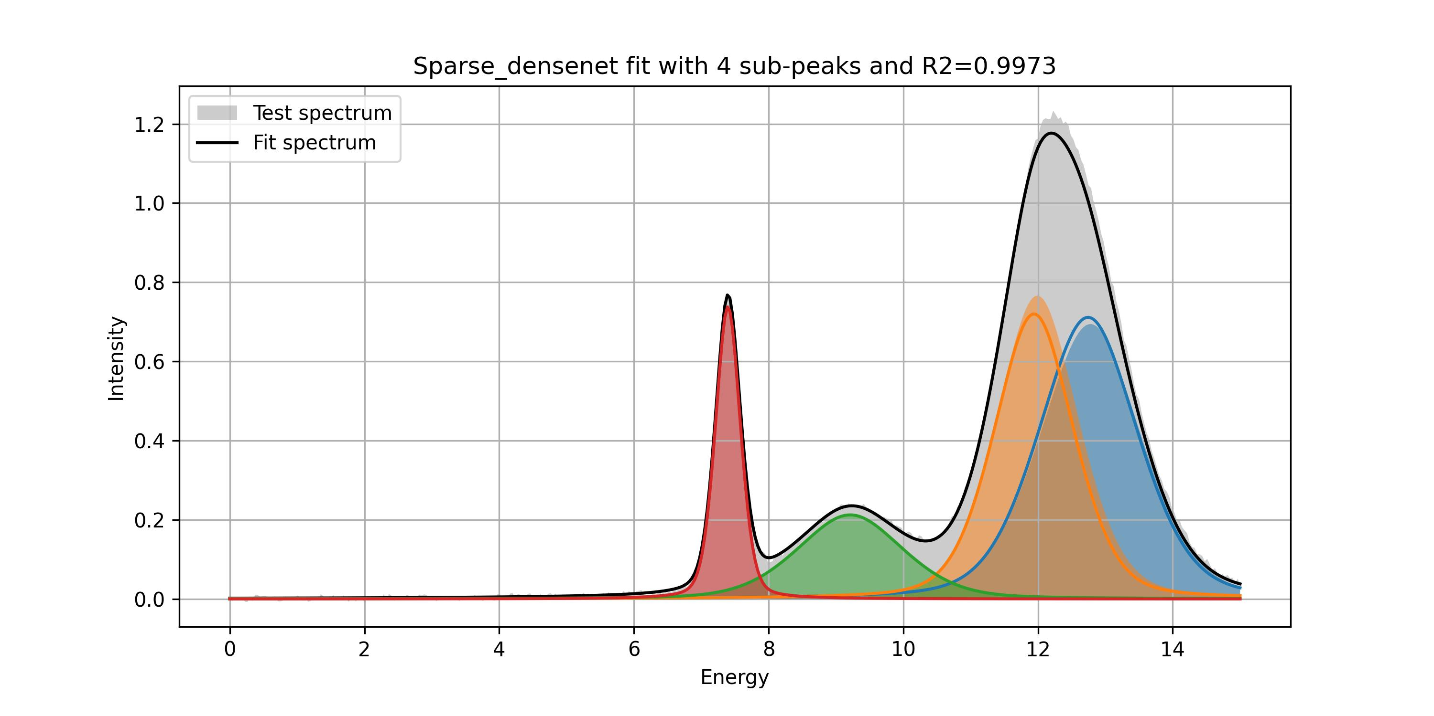

|  |  |  |  |  |  |  |  |  |
| --- | --- | --- | --- | --- | --- | --- | --- | --- |
|  | Peak 1 | | Peak 2 | | Peak 3 | | Peak 4 | |
|  | True | Fit | True | Fit | True | Fit | True | Fit |
| Position | 12.78 | 12.74 | 11.99 | 11.94 | 9.23 | 9.21 | 7.40 | 7.40 |
| Width | 1.79 | 1.75 | 1.46 | 1.40 | 1.86 | 1.87 | 0.44 | 0.44 |
| Amplitude | 0.69 | 0.71 | 0.77 | 0.72 | 0.21 | 0.21 | 0.75 | 0.74 |

Example of fit with three sub-peaks:

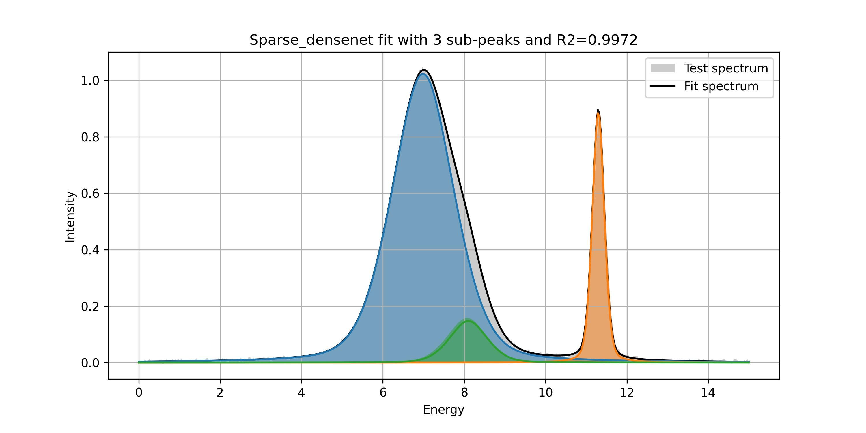

|  |  |  |  |  |  |  |
| --- | --- | --- | --- | --- | --- | --- |
|  | Peak 1 | | Peak 2 | | Peak 3 | |
|  | True | Fit | True | Fit | True | Fit |
| Position | 6.97 | 6.99 | 11.33 | 11.30 | 8.07 | 8.10 |
| Width | 1.81 | 1.82 | 0.36 | 0.35 | 1.16 | 1.09 |
| Amplitude | 1.02 | 1.02 | 0.87 | 0.89 | 0.16 | 0.15 |

Example of fit with two sub-peaks:

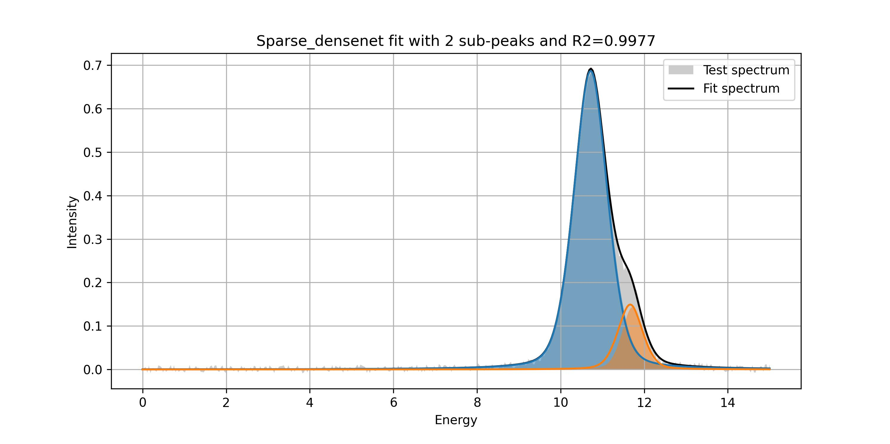

|  |  |  |  |  |
| --- | --- | --- | --- | --- |
|  | Peak 1 | | Peak 2 | |
|  | True | Fit | True | Fit |
| Position | 10.74 | 10.72 | 11.72 | 11.66 |
| Width | 0.97 | 0.95 | 0.60 | 0.70 |
| Amplitude | 0.68 | 0.69 | 0.14 | 0.15 |

# Polishing step employing basin-hopping least square reduction

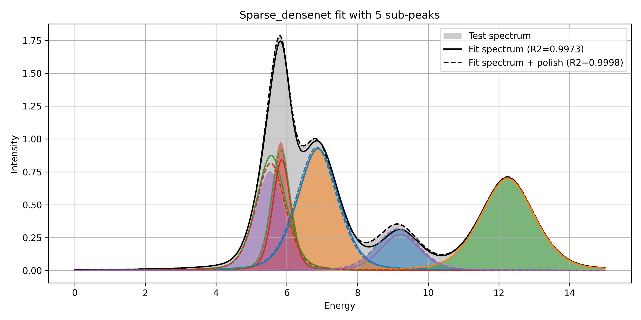

Elapsed time for polishing one fit: 30 s

|  |  |  |  |  |  |
| --- | --- | --- | --- | --- | --- |
| True value | | | | | |
|  | Peak 1 | Peak 2 | Peak 3 | Peak 4 | Peak 5 |
| Position | 9.14 | 6.84 | 12.25 | 5.83 | 5.52 |
| Width | 1.42 | 1.38 | 1.81 | 0.66 | 1.01 |
| Amplitude | 0.31 | 0.94 | 0.70 | 0.98 | 0.76 |
| CNN recursive fit | | | | | |
|  | Peak 5 | Peak 1 | Peak 2 | Peak 4 | Peak 3 |
| Position | 9.21 | 6.89 | 12.24 | 5.86 | 5.56 |
| Width | 1.32 | 1.38 | 1.81 | 0.61 | 1.01 |
| Amplitude | 0.27 | 0.93 | 0.70 | 0.84 | 0.87 |
| CNN recursive fit + polish | | | | | |
|  | Peak 5 | Peak 1 | Peak 2 | Peak 3 | Peak 4 |
| Position | 9.14 | 6.84 | 12.25 | 5.84 | 5.54 |
| Width | 1.42 | 1.37 | 1.81 | 0.64 | 1.00 |
| Amplitude | 0.32 | 0.94 | 0.70 | 0.92 | 0.82 |

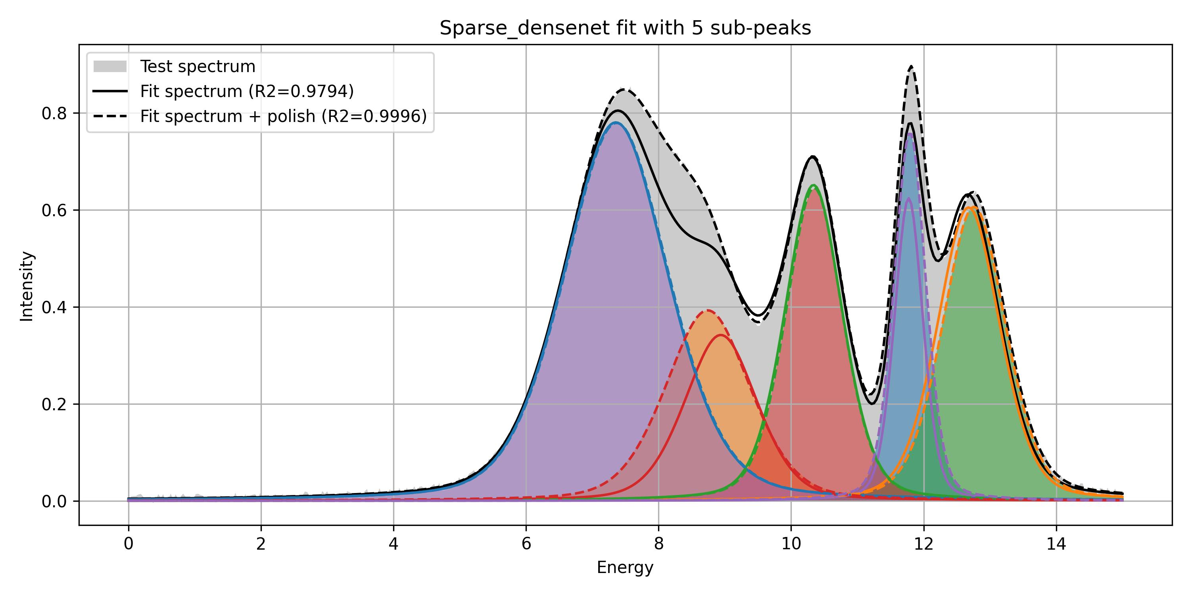

Elapsed time for polishing one fit: 33 s

|  |  |  |  |  |  |
| --- | --- | --- | --- | --- | --- |
| True value | | | | | |
|  | Peak 1 | Peak 2 | Peak 3 | Peak 4 | Peak 5 |
| Position | 11.79 | 8.74 | 12.76 | 10.35 | 7.36 |
| Width | 0.57 | 1.55 | 1.15 | 1.03 | 1.89 |
| Amplitude | 0.76 | 0.39 | 0.61 | 0.64 | 0.78 |
| CNN recursive fit | | | | | |
|  | Peak 5 | Peak 4 | Peak 2 | Peak 3 | Peak 1 |
| Position | 11.77 | 8.94 | 12.68 | 10.34 | 7.35 |
| Width | 0.52 | 1.31 | 1.13 | 1.04 | 1.89 |
| Amplitude | 0.62 | 0.34 | 0.60 | 0.65 | 0.78 |
| CNN recursive fit + polish | | | | | |
|  | Peak 5 | Peak 4 | Peak 2 | Peak 3 | Peak 1 |
| Position | 11.79 | 8.74 | 12.76 | 10.35 | 7.37 |
| Width | 0.57 | 1.53 | 1.14 | 1.03 | 1.89 |
| Amplitude | 0.76 | 0.39 | 0.61 | 0.65 | 0.78 |

3 and half modes

* One spectrum
* Time resolved
* “kinetic”: spectrum after spectrum, or

Sparse_densenet:

Size of test database: 500

Avg fit time (iterative fit A): 0.21 s per spectrum

Avg fit time (iterative fit A + internal polish): 0.22 s per spectrum

Avg end polish time after iterative fit A: 2.01 s per spectrum, 161 spectra treated

Avg fit time (iterative fit B): 0.21 s per spectrum

Avg fit time (iterative fit B + internal polish): 0.20 s per spectrum

Avg end polish time after iterative fit B: 2.18 s per spectrum, 167 spectra treated

LeNet:

Size of test database: 500

Avg fit time (iterative fit A): 0.15 s per spectrum

Avg fit time (iterative fit A + internal polish): 0.16 s per spectrum

Avg end polish time after iterative fit A: 4.33 s per spectrum, 403 spectra treated

Avg fit time (iterative fit B): 0.18 s per spectrum

Avg fit time (iterative fit B + internal polish): 0.16 s per spectrum

Avg end polish time after iterative fit B: 8.57 s per spectrum, 394 spectra treated

# Iterative fitting: benchmark of six procedures:

**Description of six iterative fitting procedures:**

|  |  |  |
| --- | --- | --- |
| **A1:** number of recursive fits is defined by the first CNN application | **A2:** number of recursive fit is defined by the first CNN application.  After each CNN fit, a least square reduction with gradient descent is employed to polish the sub-peak fit. | **A3:** number of recursive fit is defined by the first CNN application.  At the end of the recursive fit, a least square reduction with a global optimization algorithm is employed to polish the total fit. |
| **B1:** number of recursive is defined by the max value of the remaining spectrum. | **B2:** number of recursive is defined by the max value of the remaining spectrum.  After each CNN fit, a least square reduction with gradient descent is employed to polish the sub-peak fit. | **B3:** number of recursive is defined by the max value of the remaining spectrum.  At the end of the recursive fit, a least square reduction with a global optimization algorithm is employed to polish the total fit. |

Procedure A3 is employed by Park et al.

Quality of iterative fit is quantified through R2 value:



For procedures A3 and B3, not all fits are polished: only those with R2 value below **0.995** are polished.

The procedures are benchmarked over 500 spectra of the test database.

**Average processing times:**

|  |  |  |
| --- | --- | --- |
| **A1:** 0.21 s | **A2:** 0.22 s | **A3:** 0.21 + 2.01 s  161 out of 500 fits needed to be polished |
| **B1:** 0.21 s | **B2:** 0.20 s | **B3:** 0.21 + 2.18 s  167 out of 500 fits needed to be polished |

The final polishing step is much slower than other procedures.

Internal polishing fits are very quick in A2 and B2.

**Distributions of R2 values:**

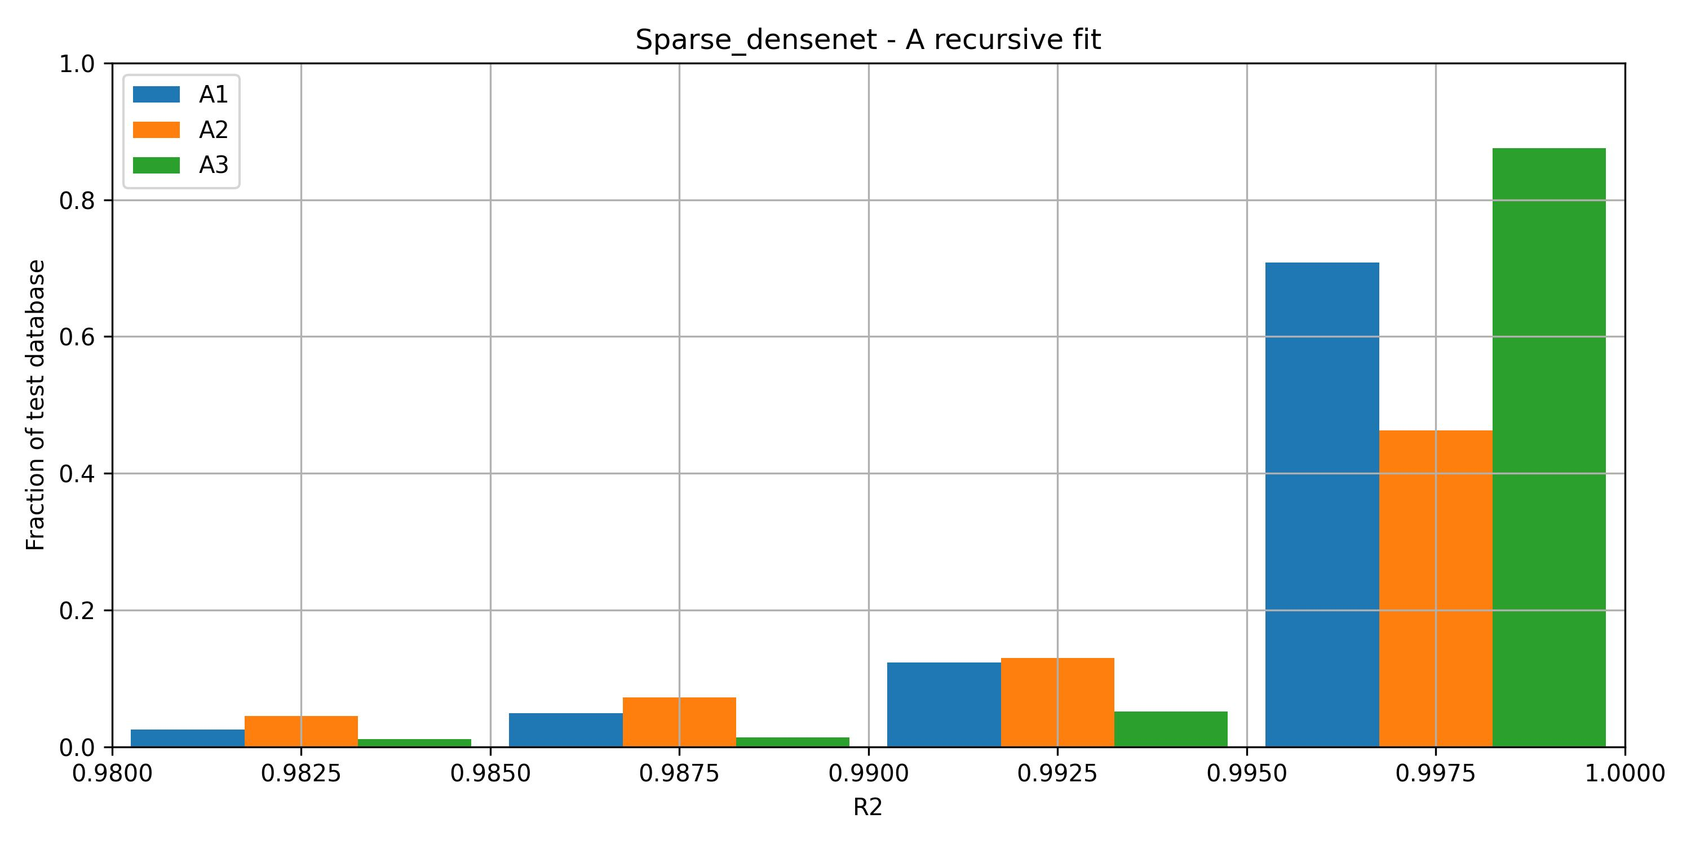

A3 shows best results: distribution shifted to higher R2 values.

Adding the internal polishing step actually diminish performances.

The effect of the supplementary polishing step of A3, applied to A1 cases where R2 < 0.955 appears clearly: less cases than A1 with R2 bellow 0.995, more cases above 0.995.

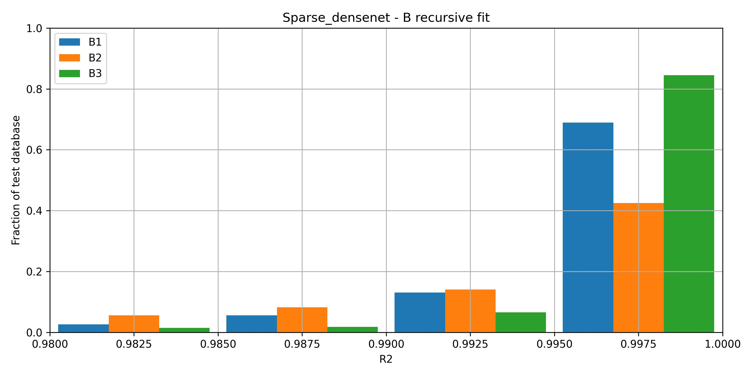

When the number of sub-peaks is defined differently, similar trends between the 3 configurations is observed.

B procedures perform less well than A procedures:

* More than 90% of fits have R2 > 0.995 with A3.
* Approx. 85% of fits have R2 > 0.995 with B3

**MAE values:**

**MAE on number of sub-peaks:**

|  |  |  |
| --- | --- | --- |
| **A1:** 0.032 | **A2:** 0.032 | **A3:** 0.032 |
| **B1:** 0.198 | **B2:** 0.518 | **B3:** 0.198 |

The external polishing step do not modify the number of identified peaks.

The B procedures, relying on max intensity of remaining spectrum performs less well.

The internal polishing step of B2 even disturbs results and induce more errors in peak number identification.

**MAE on peaks parameters:**

|  |  |  |  |  |  |  |  |
| --- | --- | --- | --- | --- | --- | --- | --- |
|  |  | Sub peak 1 | Sub peak 2 | Sub peak 3 | Sub peak 4 | Sub peak 5 | Avg all peaks |
| One sub-peak | | | | | | | |
| A1 | MAE on position | 0.010 |  |  |  |  | 0.010 |
| MAE on width | 0.006 |  |  |  |  | 0.006 |
| MAE on amplitude | 0.002 |  |  |  |  | 0.002 |
| A2 | MAE on position | 0.002 |  |  |  |  | 0.002 |
| MAE on width | 0.005 |  |  |  |  | 0.005 |
| MAE on amplitude | 0.001 |  |  |  |  | 0.001 |
| A3 | MAE on position | 0.007 |  |  |  |  | 0.007 |
| MAE on width | 0.006 |  |  |  |  | 0.006 |
| MAE on amplitude | 0.002 |  |  |  |  | 0.002 |
| Two sub-peaks | | | | | | | |
| A1 | MAE on position | 0.018 | 0.024 |  |  |  | 0.021 |
| MAE on width | 0.011 | 0.023 |  |  |  | 0.017 |
| MAE on amplitude | 0.006 | 0.010 |  |  |  | 0.008 |
| A2 | MAE on position | 0.092 | 0.205 |  |  |  | 0.148 |
| MAE on width | 0.155 | 0.313 |  |  |  | 0.234 |
| MAE on amplitude | 0.062 | 0.067 |  |  |  | 0.064 |
| A3 | MAE on position | 0.014 | 0.020 |  |  |  | 0.017 |
| MAE on width | 0.011 | 0.020 |  |  |  | 0.015 |
| MAE on amplitude | 0.006 | 0.008 |  |  |  | 0.007 |
| Three sub-peaks | | | | | | | |
| A1 | MAE on position | 0.036 | 0.133 | 0.161 |  |  | 0.110 |
| MAE on width | 0.014 | 0.041 | 0.055 |  |  | 0.037 |
| MAE on amplitude | 0.011 | 0.021 | 0.022 |  |  | 0.018 |
| A2 | MAE on position | 0.544 | 1.182 | 2.252 |  |  | 1.326 |
| MAE on width | 0.378 | 0.223 | 2.413 |  |  | 1.004 |
| MAE on amplitude | 0.145 | 0.104 | 0.173 |  |  | 0.141 |
| A3 | MAE on position | 0.066 | 0.155 | 0.152 |  |  | 0.124 |
| MAE on width | 0.019 | 0.041 | 0.053 |  |  | 0.038 |
| MAE on amplitude | 0.012 | 0.021 | 0.019 |  |  | 0.017 |
| Four sub-peaks | | | | | | | |
| A1 | MAE on position | 0.156 | 0.328 | 0.381 | 0.403 |  | 0.317 |
| MAE on width | 0.024 | 0.052 | 0.071 | 0.091 |  | 0.060 |
| MAE on amplitude | 0.017 | 0.030 | 0.035 | 0.028 |  | 0.027 |
| A2 | MAE on position | 0.844 | 3.664 | 2.517 | 4.164 |  | 2.797 |
| MAE on width | 0.626 | 1.482 | 0.742 | 3.990 |  | 1.710 |
| MAE on amplitude | 0.181 | 0.153 | 0.206 | 0.178 |  | 0.179 |
| A3 | MAE on position | 0.198 | 0.320 | 0.409 | 0.383 |  | 0.327 |
| MAE on width | 0.029 | 0.051 | 0.075 | 0.092 |  | 0.062 |
| MAE on amplitude | 0.021 | 0.029 | 0.035 | 0.028 |  | 0.028 |
| Five sub-peaks | | | | | | | |
| A1 | MAE on position | 0.173 | 0.496 | 0.845 | 1.055 | 0.887 | 0.691 |
| MAE on width | 0.031 | 0.072 | 0.104 | 0.160 | 0.156 | 0.105 |
| MAE on amplitude | 0.028 | 0.043 | 0.061 | 0.067 | 0.050 | 0.050 |
| A2 | MAE on position | 1.331 | 2.914 | 3.209 | 3.049 | 3.004 | 2.701 |
| MAE on width | 0.897 | 1.147 | 0.742 | 1.047 | 0.551 | 0.877 |
| MAE on amplitude | 0.593 | 0.193 | 0.243 | 0.259 | 0.211 | 0.300 |
| A3 | MAE on position | 0.233 | 0.572 | 0.789 | 0.871 | 0.774 | 0.648 |
| MAE on width | 0.044 | 0.080 | 0.098 | 0.144 | 0.142 | 0.102 |
| MAE on amplitude | 0.035 | 0.046 | 0.058 | 0.060 | 0.045 | 0.049 |

**Examples of fits:**

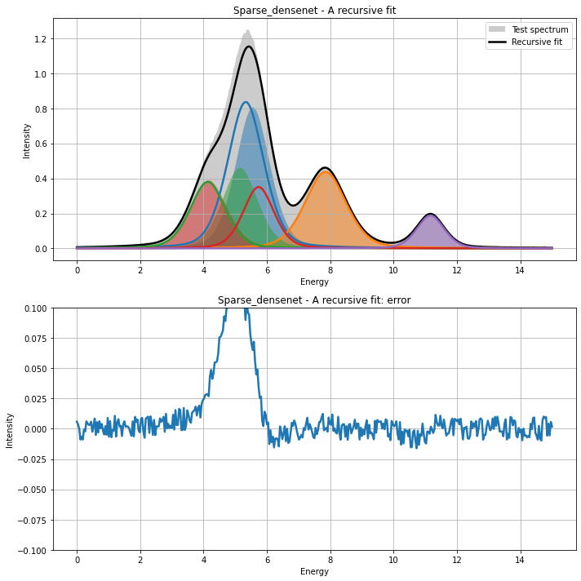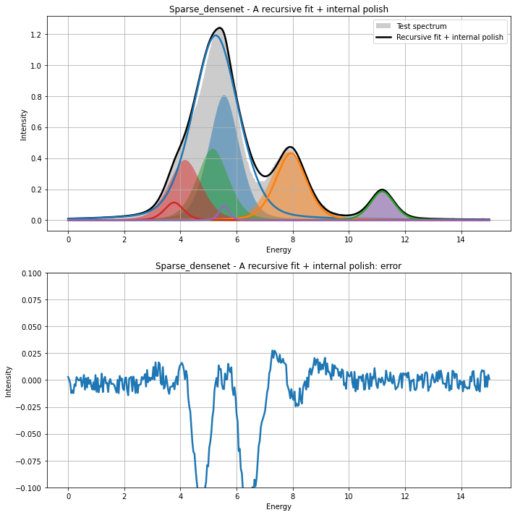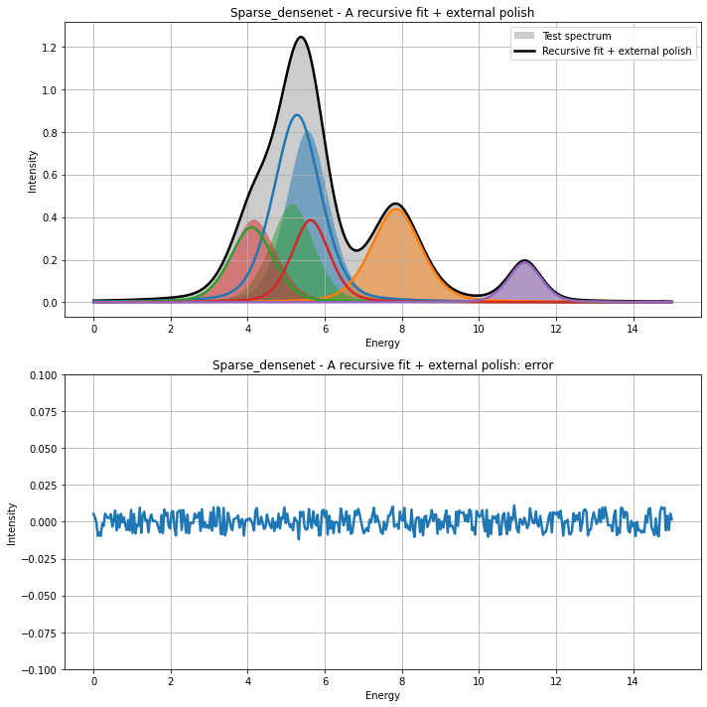

|  |  |  |  |  |  |
| --- | --- | --- | --- | --- | --- |
|  | Sub peak 1 | Sub peak 2 | Sub peak 3 | Sub peak 4 | Sub peak 5 |
|  | True | | | | |
| Position | 5.56 | 7.85 | 5.15 | 4.16 | 11.18 |
| Width | 1.29 | 1.53 | 1.34 | 1.38 | 1.00 |
| Amplitude | 0.81 | 0.44 | 0.46 | 0.39 | 0.19 |
|  | A recursive fit | | | | |
| Position | 5.33 | 7.85 | 4.13 | 5.74 | 11.16 |
| Width | 1.36 | 1.55 | 1.32 | 1.16 | 1.04 |
| Amplitude | 0.84 | 0.44 | 0.38 | 0.35 | 0.19 |
|  | A recursive fit + internal polish | | | | |
| Position | 5.26 | 7.93 | 11.19 | 3.77 | 5.56 |
| Width | 1.94 | 1.32 | 1.01 | 0.82 | 0.43 |
| Amplitude | 1.19 | 0.43 | 0.19 | 0.11 | 0.09 |
|  | A recursive fit + external polish | | | | |
| Position | 5.28 | 7.85 | 4.10 | 5.63 | 11.19 |
| Width | 1.46 | 1.54 | 1.32 | 1.17 | 1.02 |
| Amplitude | 0.88 | 0.44 | 0.35 | 0.39 | 0.19 |

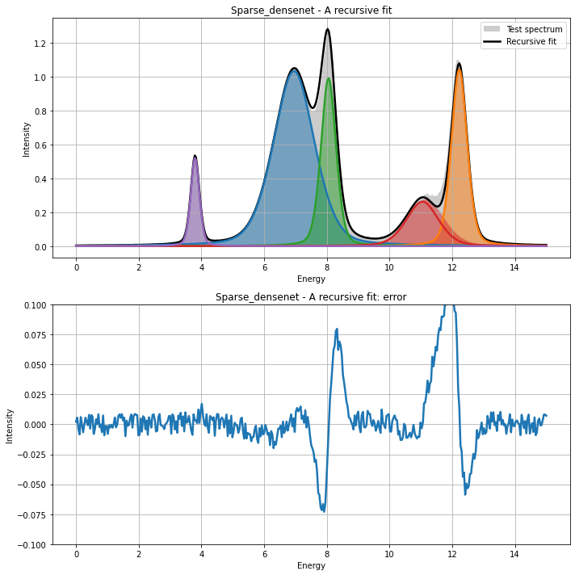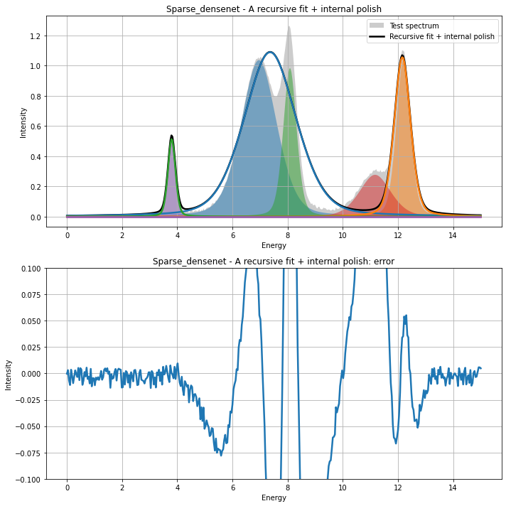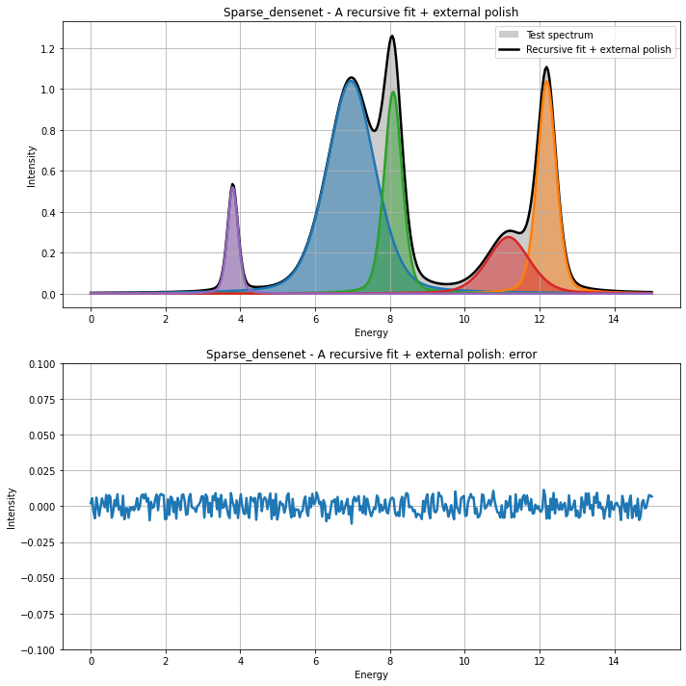

|  |  |  |  |  |  |
| --- | --- | --- | --- | --- | --- |
|  | Sub peak 1 | Sub peak 2 | Sub peak 3 | Sub peak 4 | Sub peak 5 |
|  | True | | | | |
| Position | 6.96 | 12.19 | 8.08 | 11.17 | 3.80 |
| Width | 1.55 | 0.60 | 0.58 | 1.36 | 0.33 |
| Amplitude | 1.04 | 1.04 | 0.99 | 0.28 | 0.52 |
|  | A recursive fit | | | | |
| Position | 6.95 | 12.22 | 8.05 | 11.05 | 3.80 |
| Width | 1.56 | 0.60 | 0.57 | 1.22 | 0.33 |
| Amplitude | 1.03 | 1.04 | 0.99 | 0.26 | 0.52 |
|  | A recursive fit + internal polish | | | | |
| Position | 7.37 | 12.16 | 3.80 | 9.02 | 9.02 |
| Width | 2.26 | 0.70 | 0.33 | 0.32 | 0.32 |
| Amplitude | 1.09 | 1.06 | 0.51 | 0.00 | 0.00 |
|  | A recursive fit + external polish | | | | |
| Position | 6.96 | 12.19 | 8.09 | 11.17 | 3.80 |
| Width | 1.54 | 0.60 | 0.57 | 1.35 | 0.34 |
| Amplitude | 1.04 | 1.04 | 0.99 | 0.28 | 0.52 |

# Recursive fit of experimental data

**Example 1**

|  |  |  |  |  |
| --- | --- | --- | --- | --- |
| November 2021 | CTF3 | 10 mW | Pb 4f 7/2 | TR CTF3 Pb4f 10mW_0000_ATR_00000_00000_ |

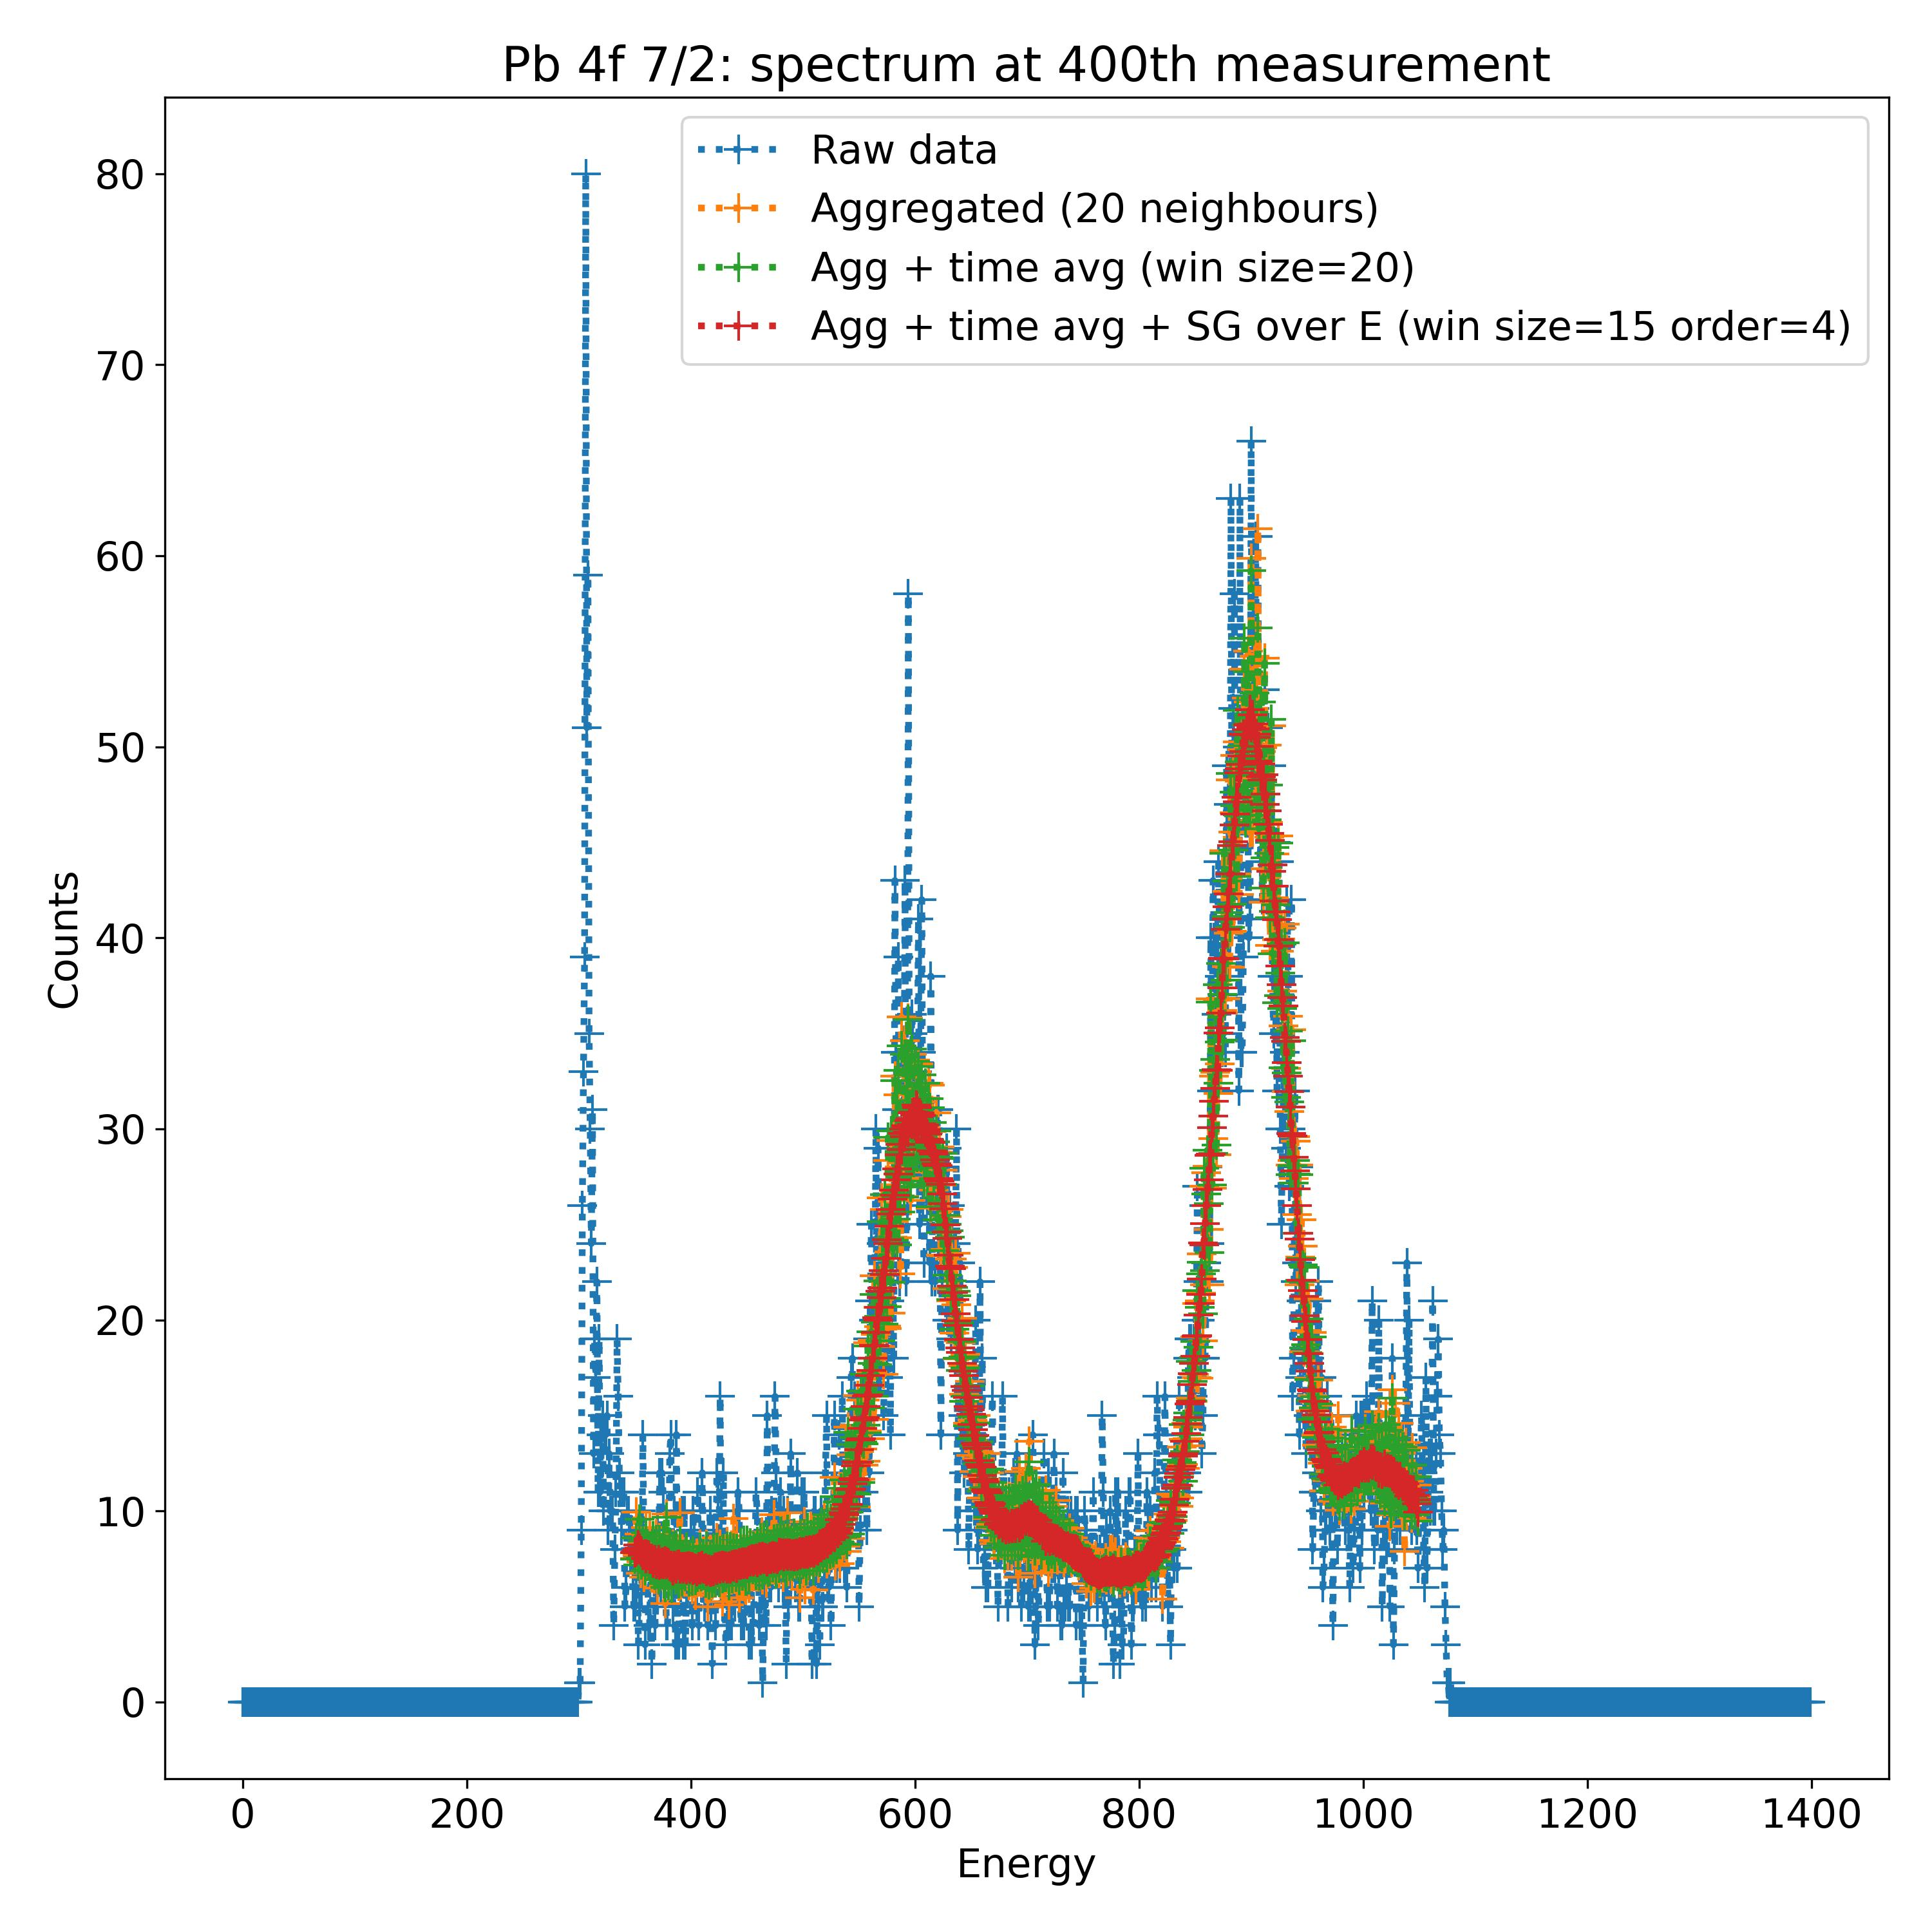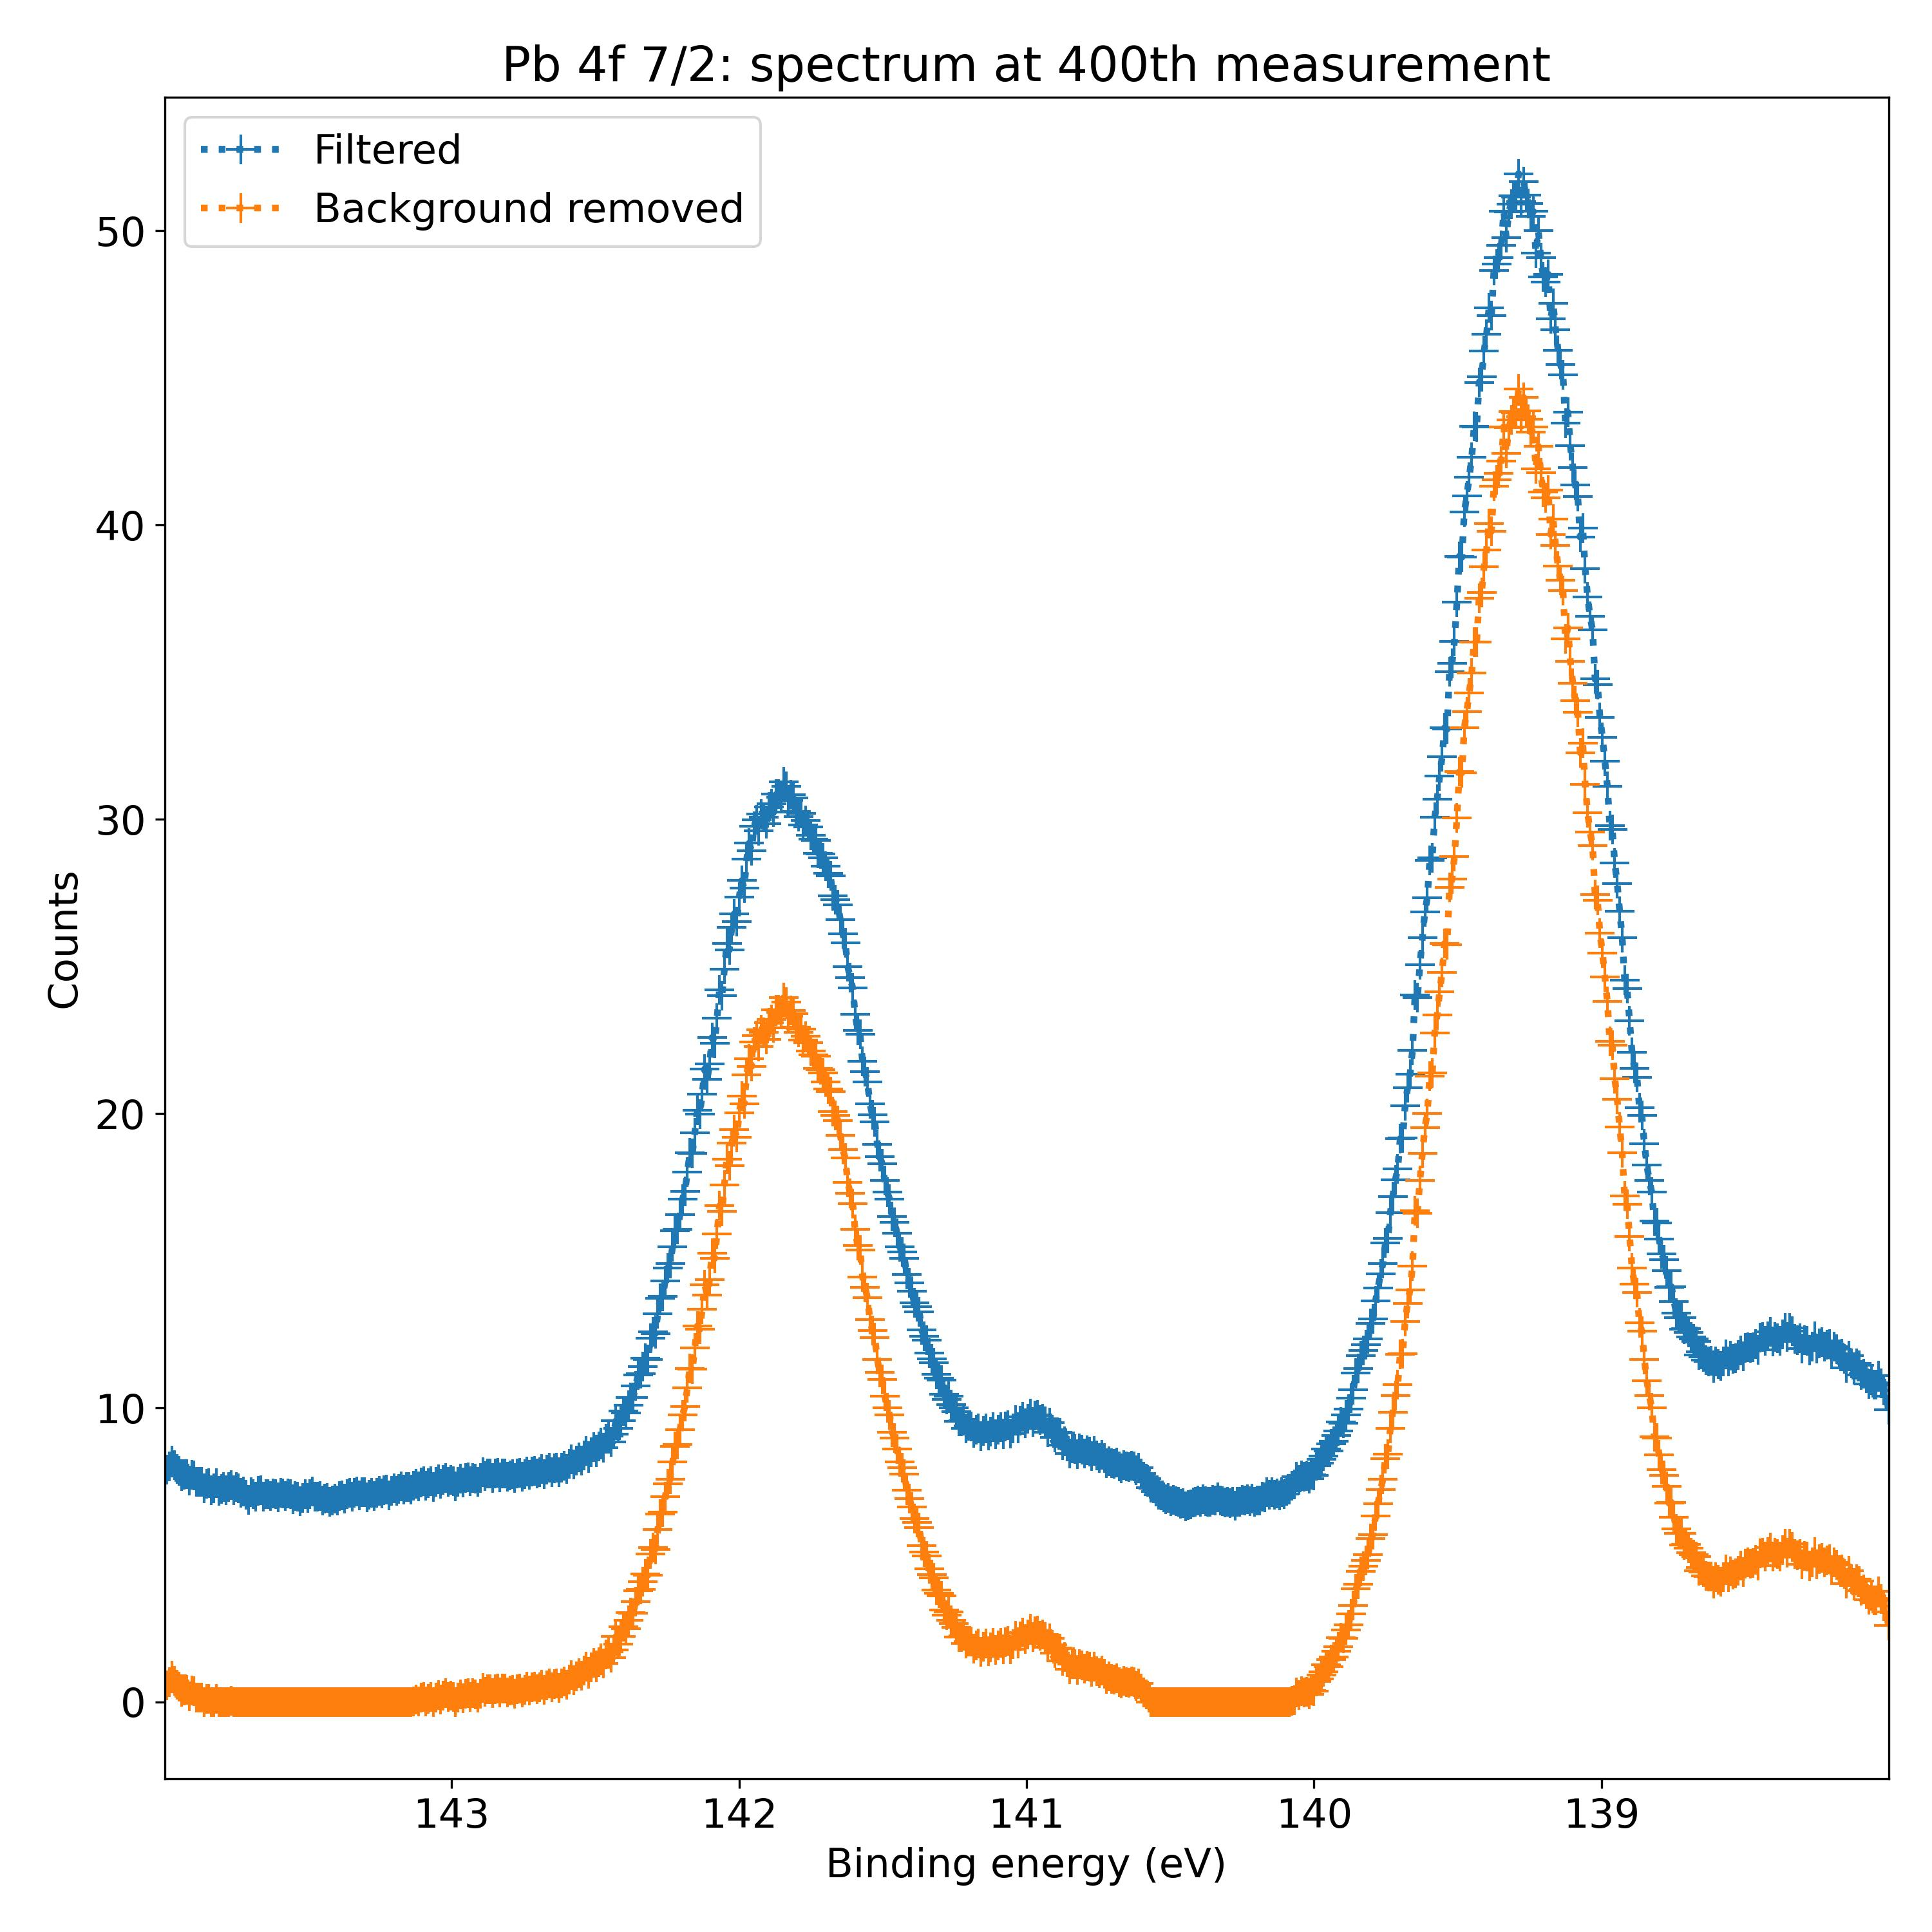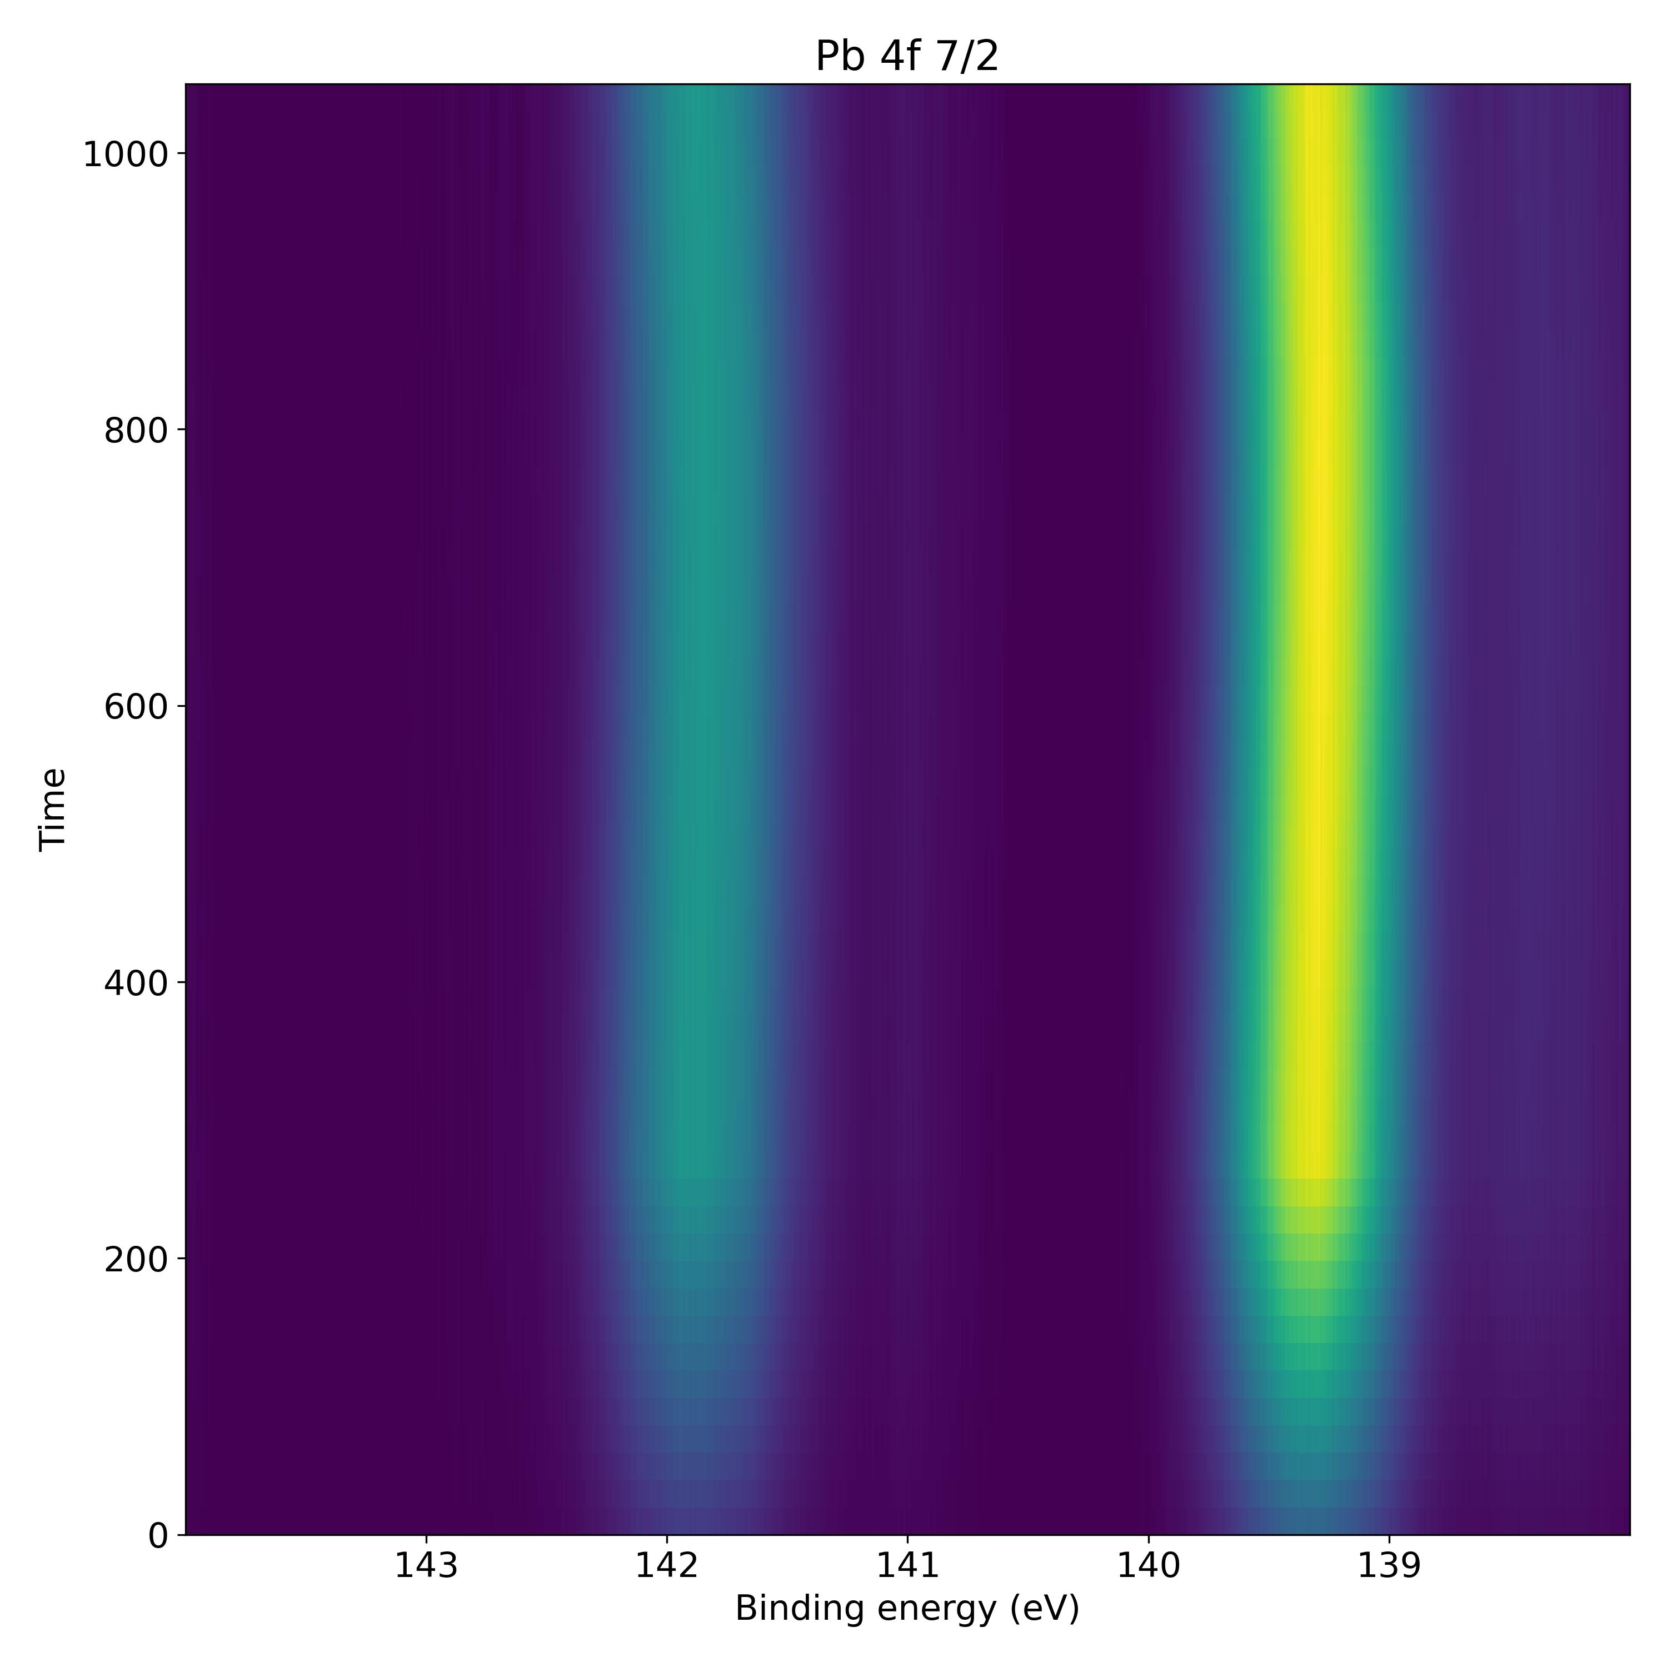

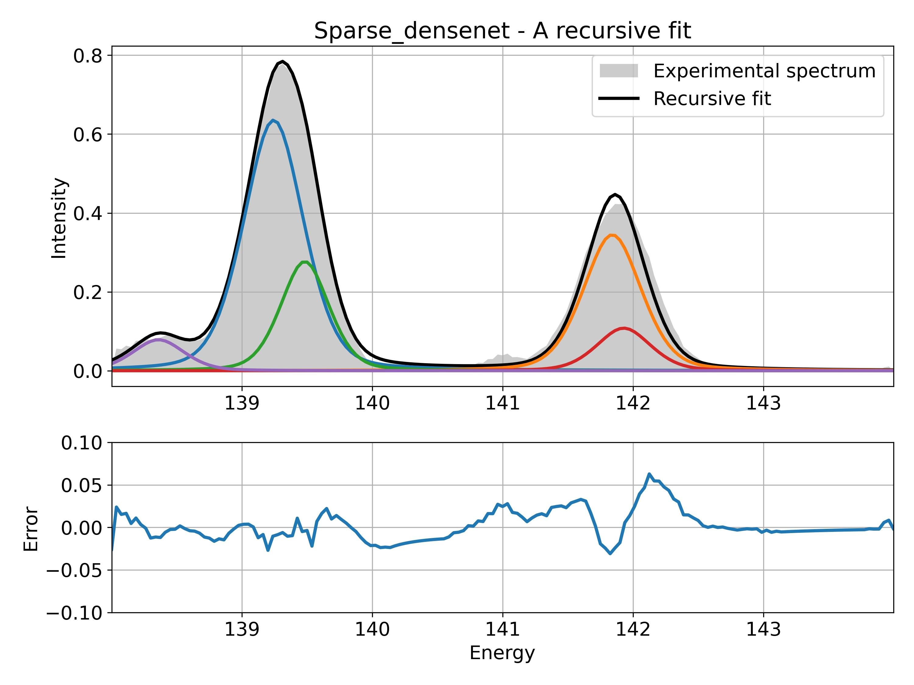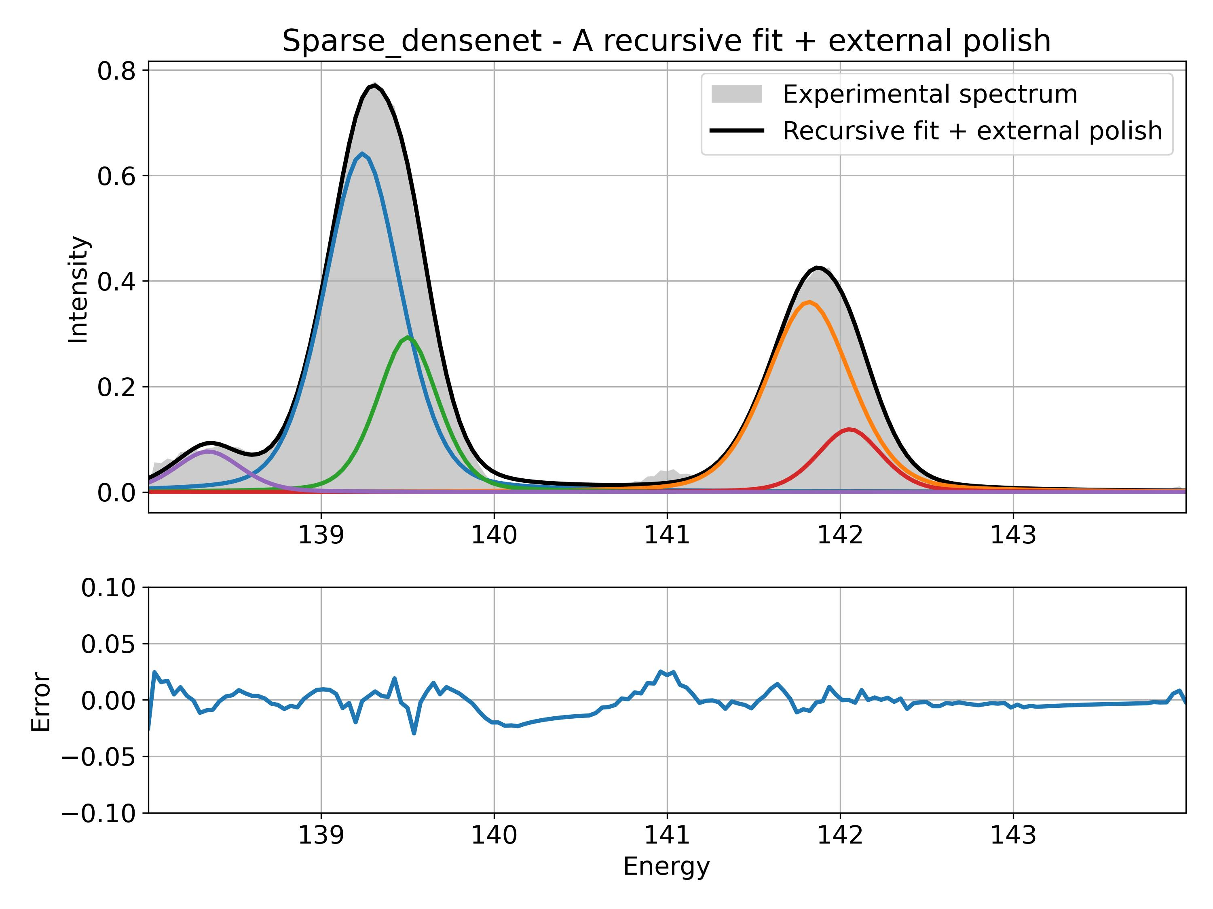

Additional wrong contributions inside main peak.

Focus on peak at 142 eV:

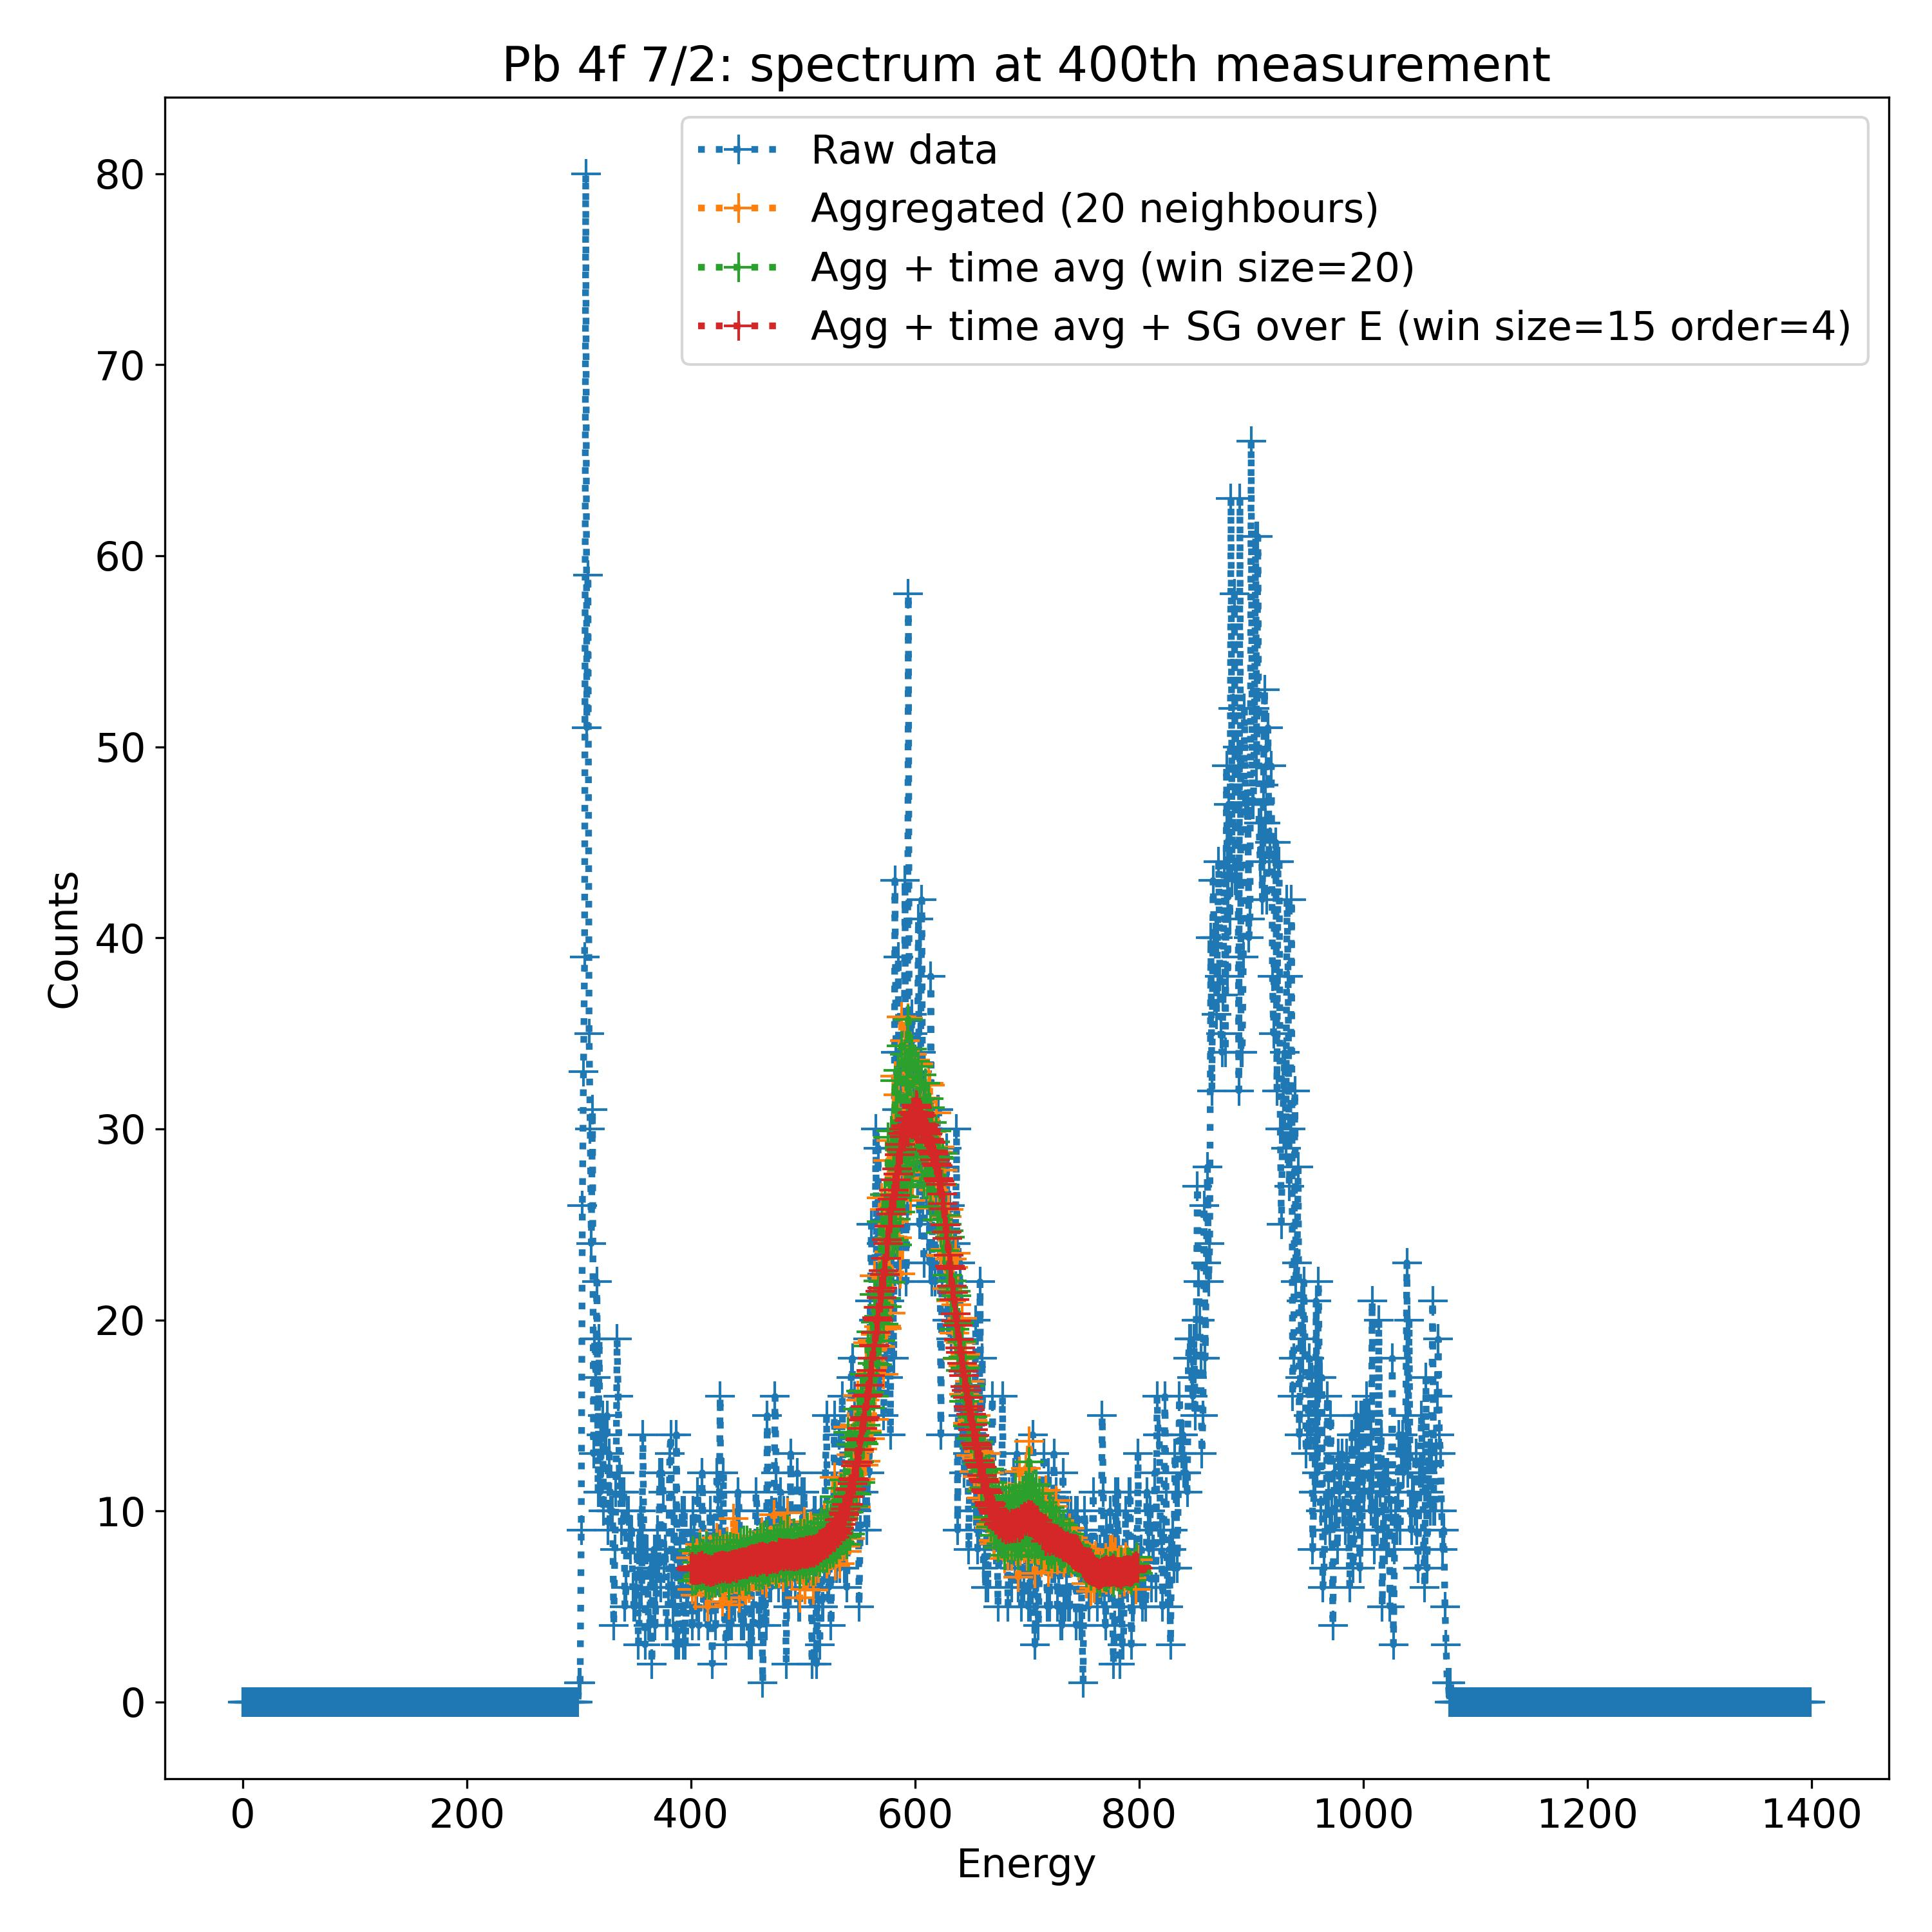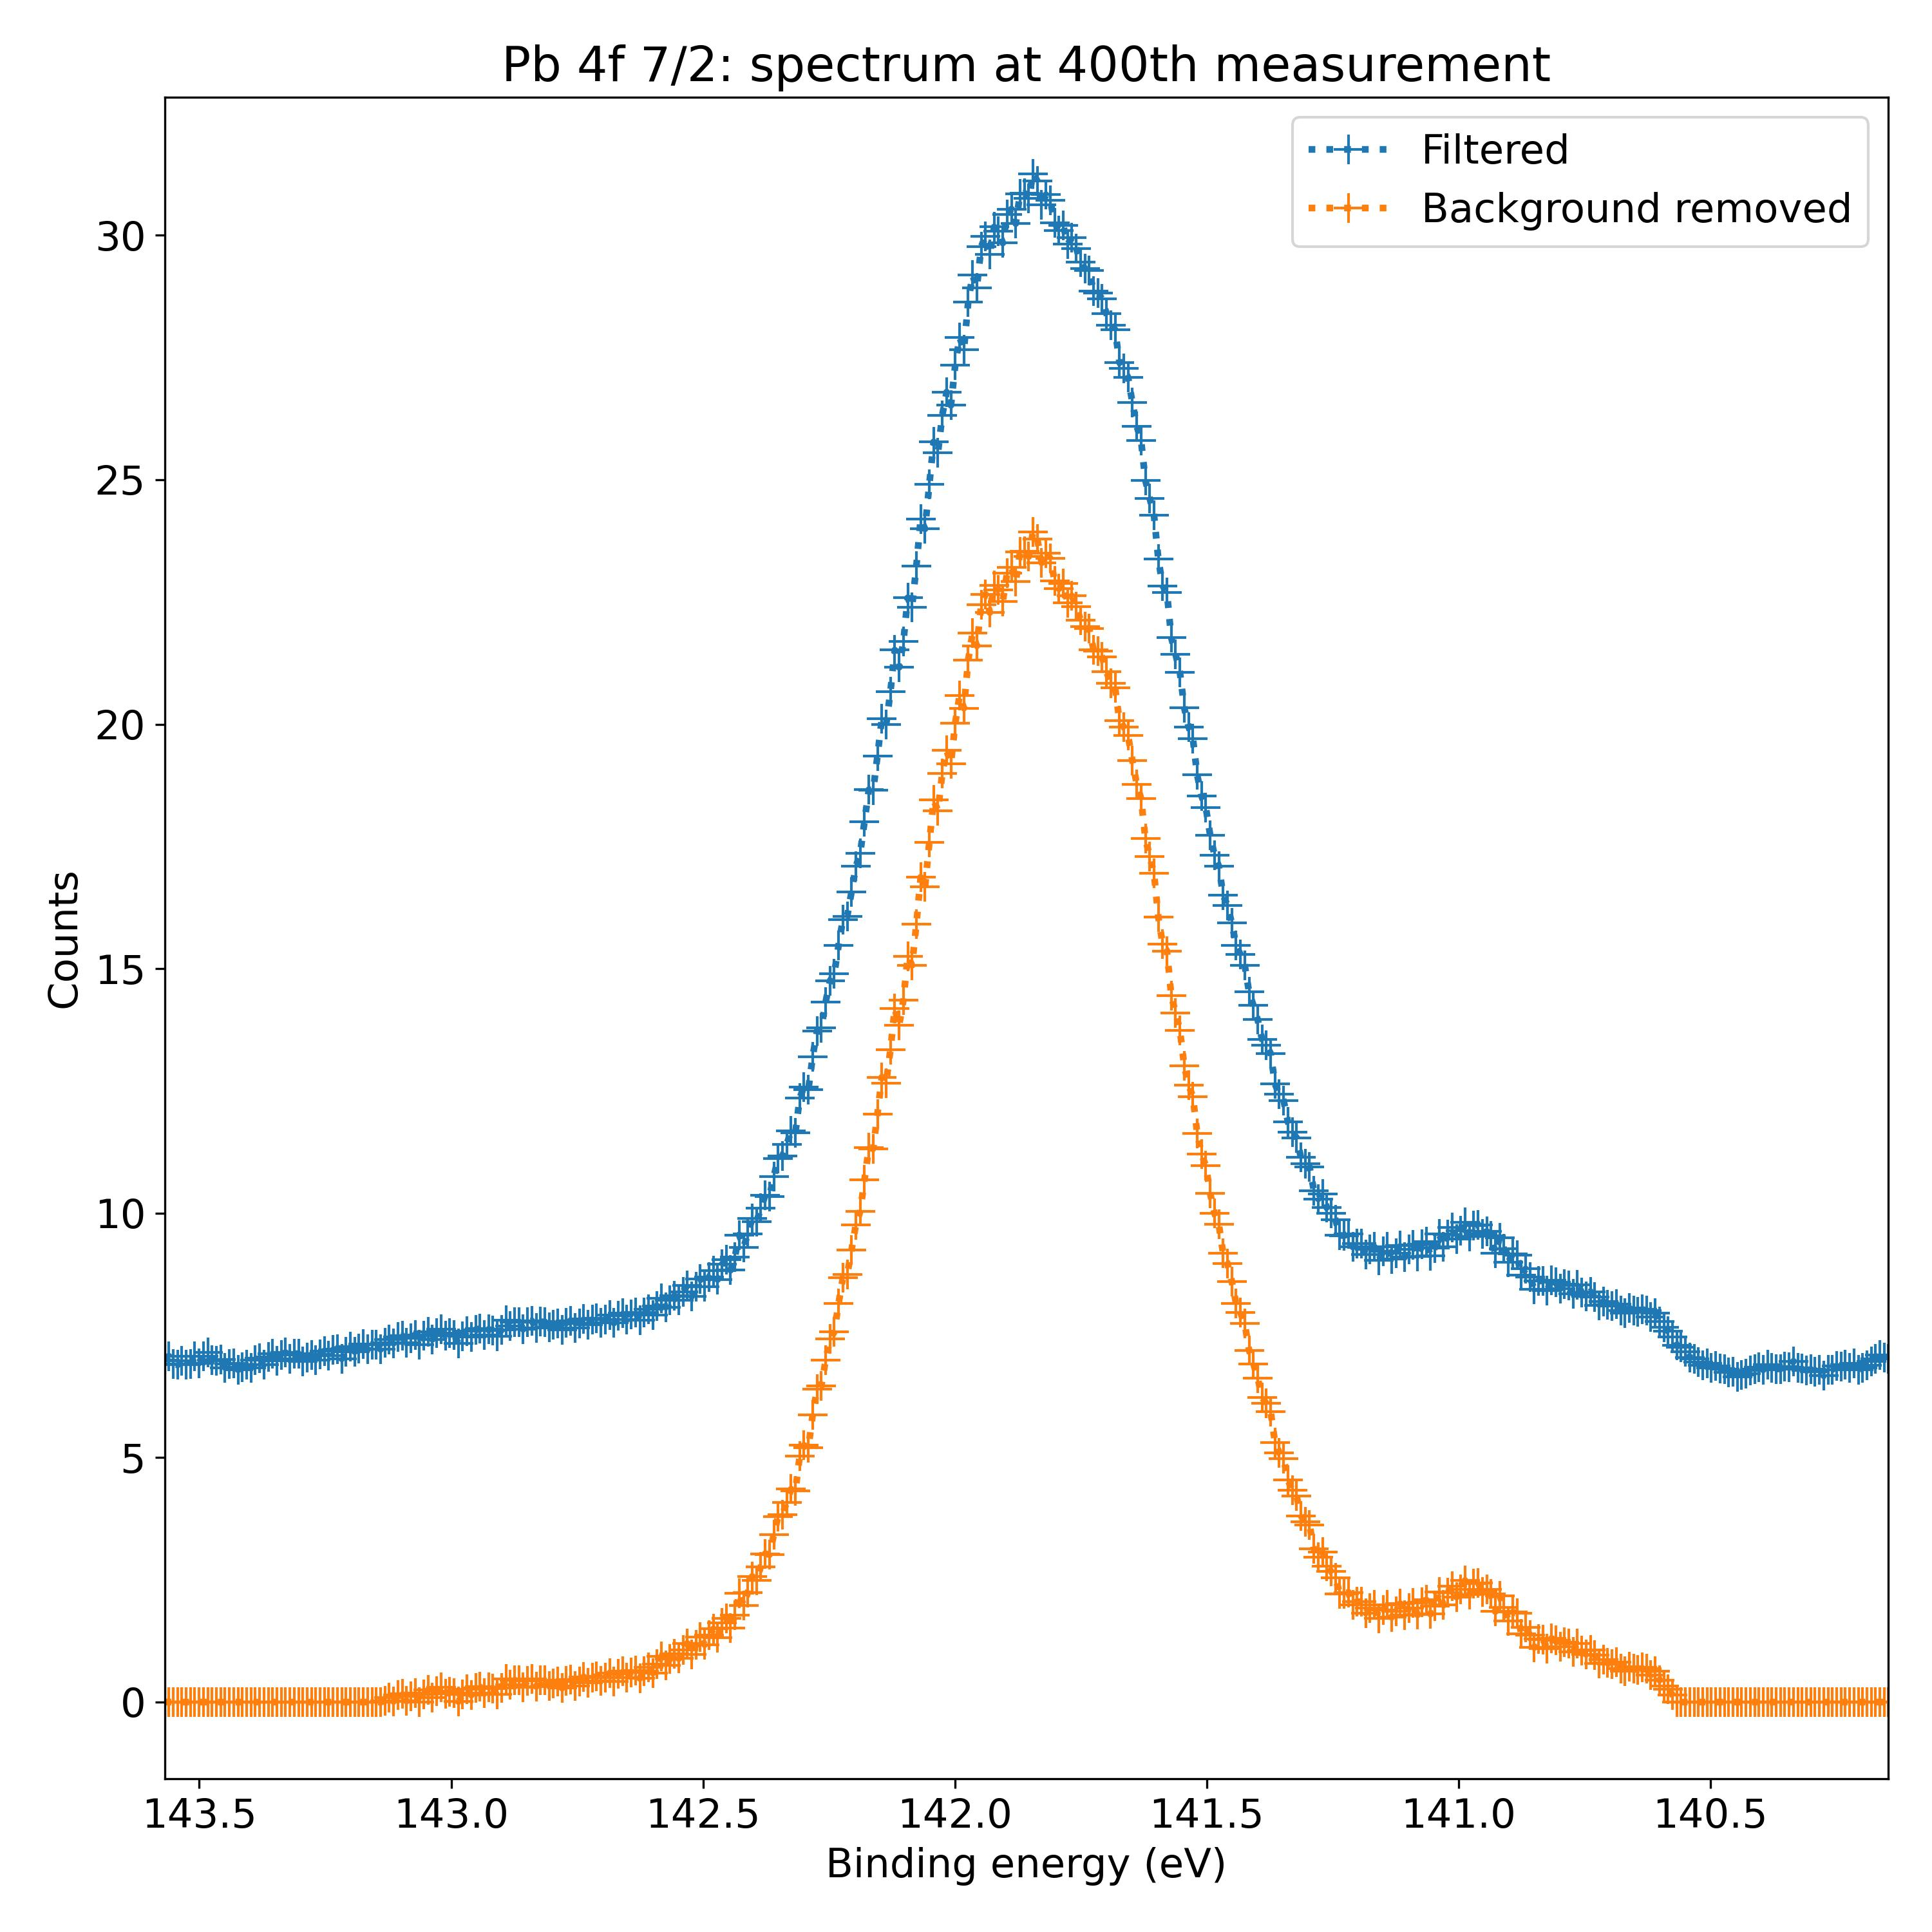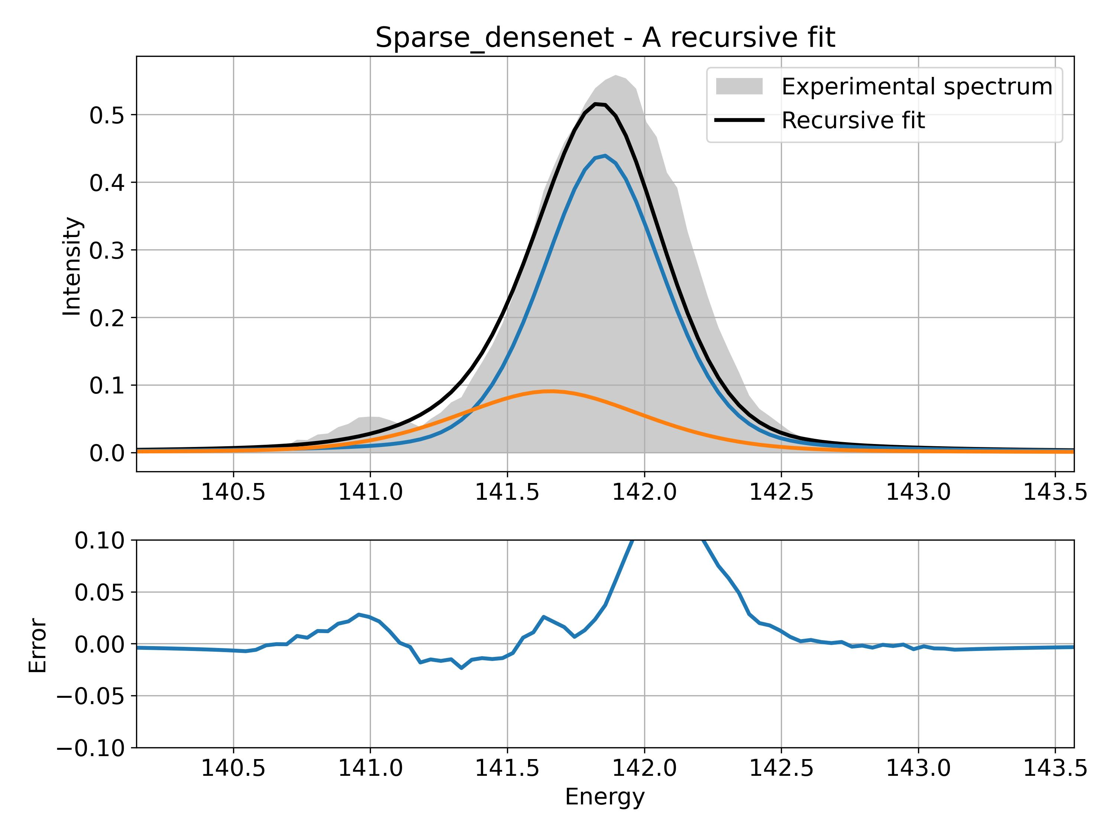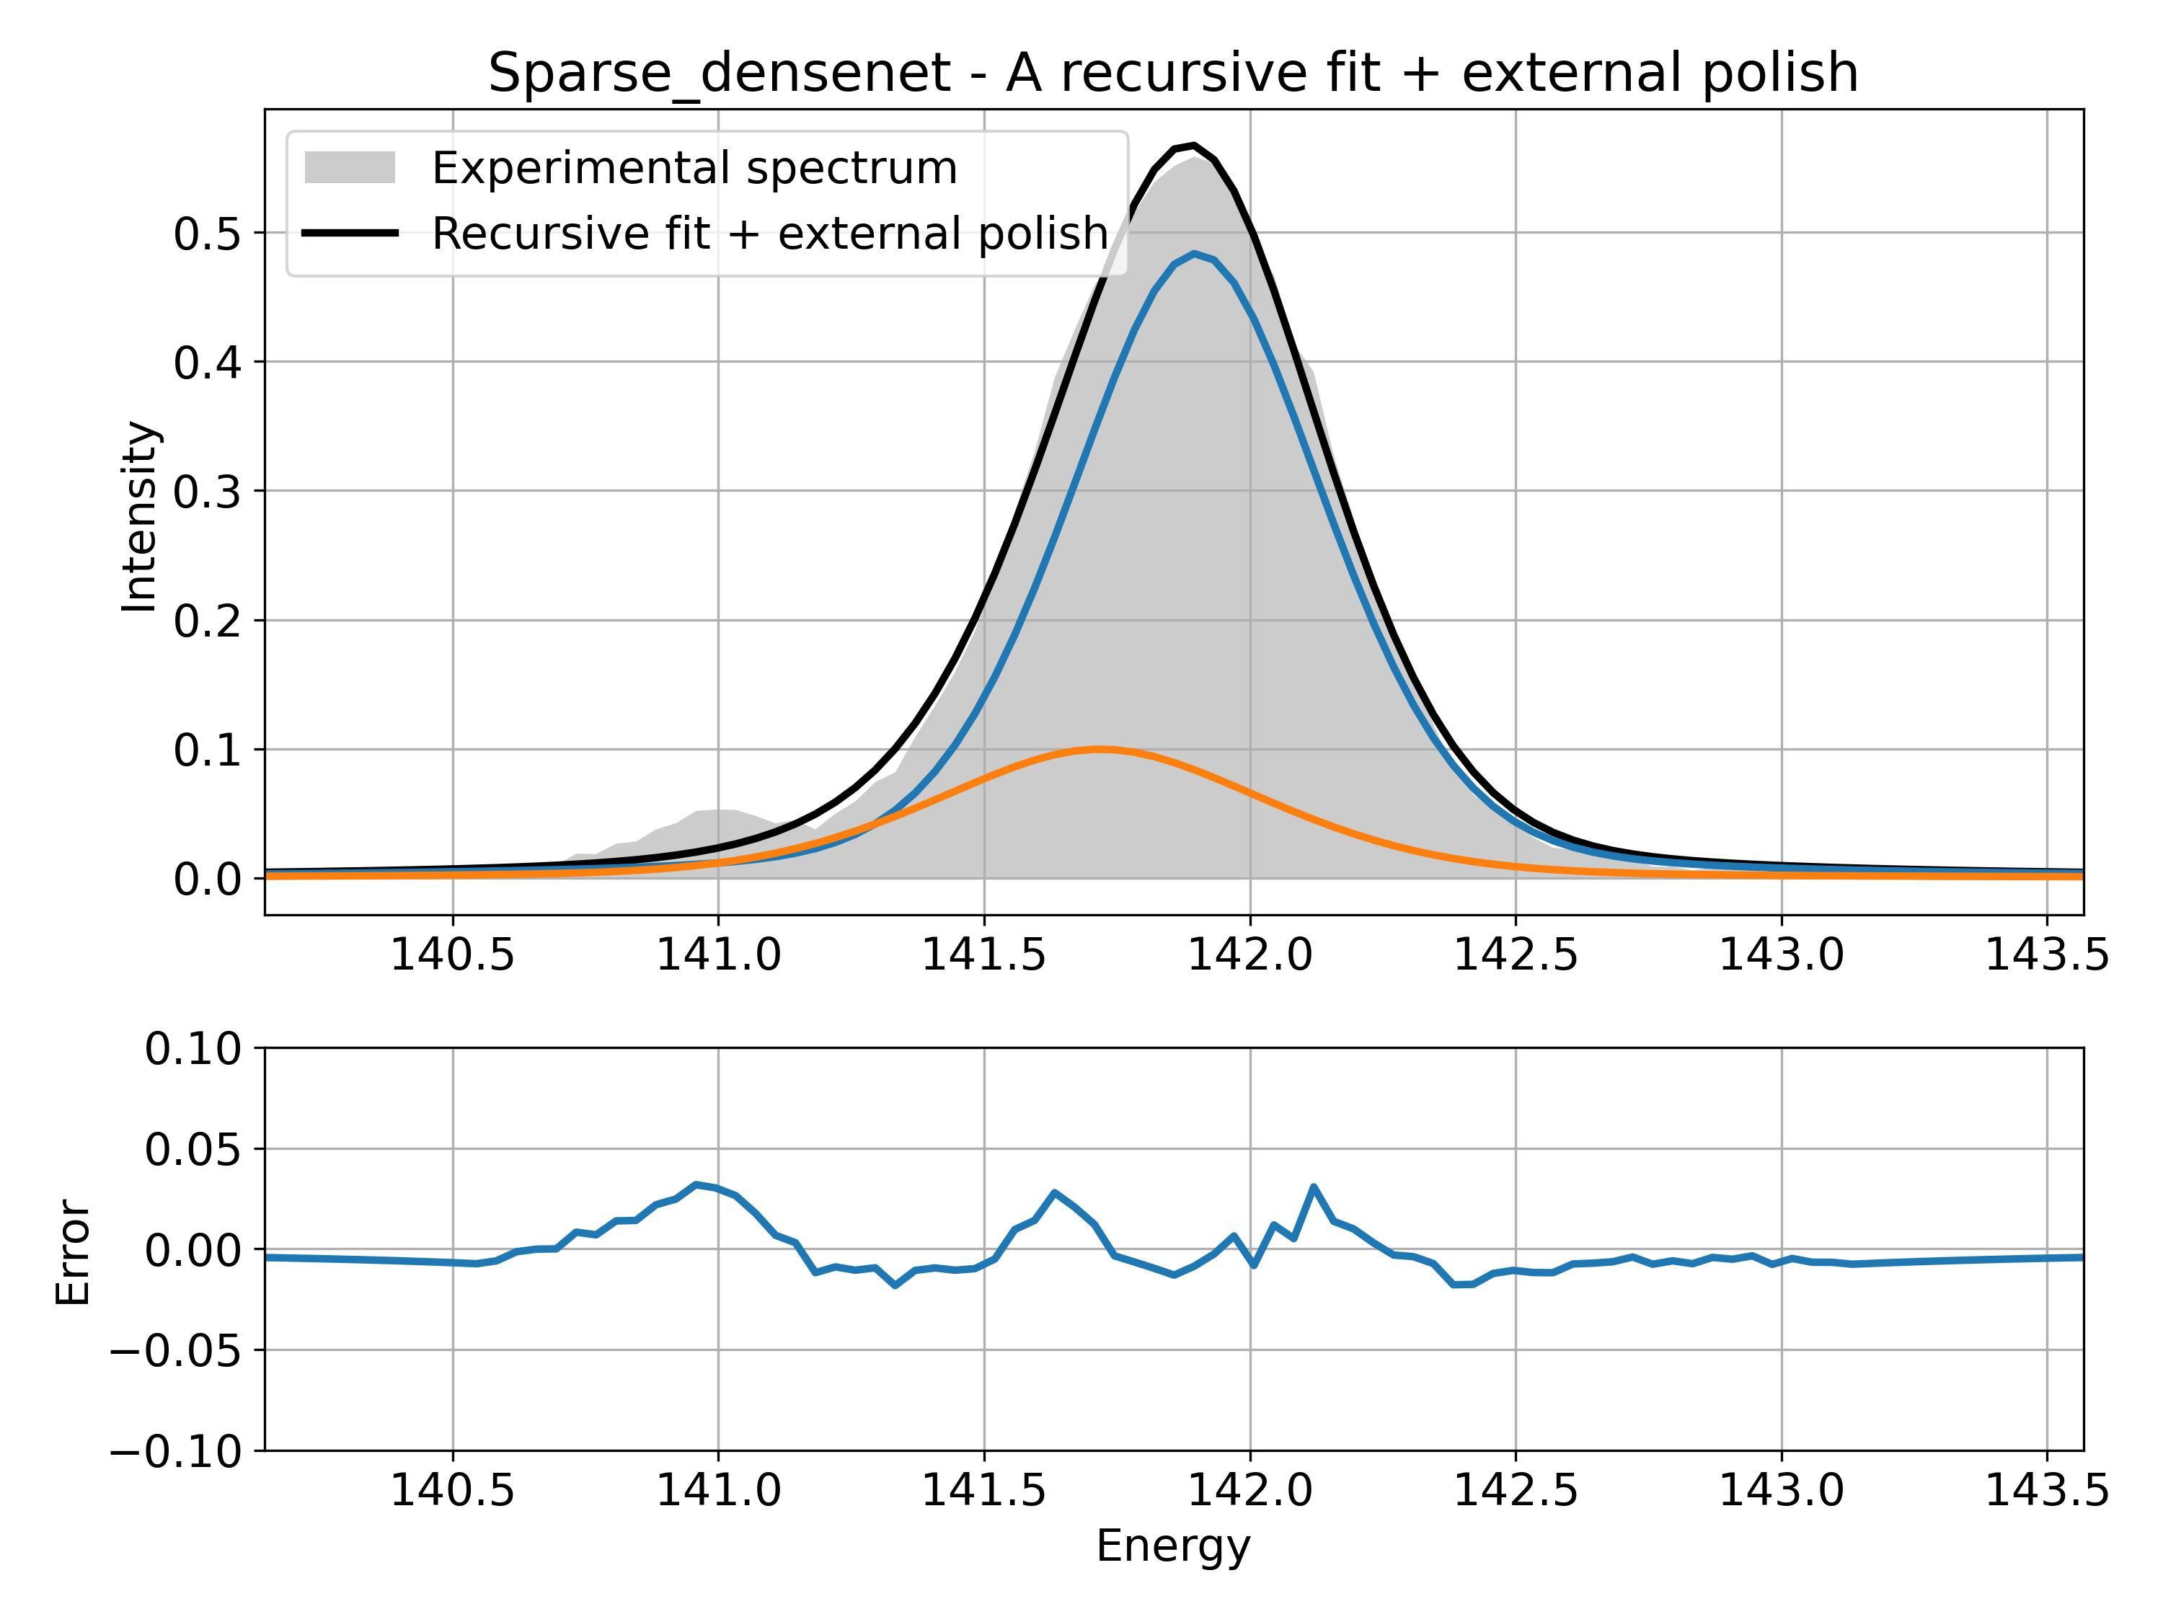

Still two contributions for the main peak.

The potential second peak at 141 eV is not detected.

**Example 2**

|  |  |  |  |  |
| --- | --- | --- | --- | --- |
| November 2021 | CTF1 | 1 mW | I 3d 5/2 | 20211126_TR CTF1 I3d 1 mW_0001_2 |

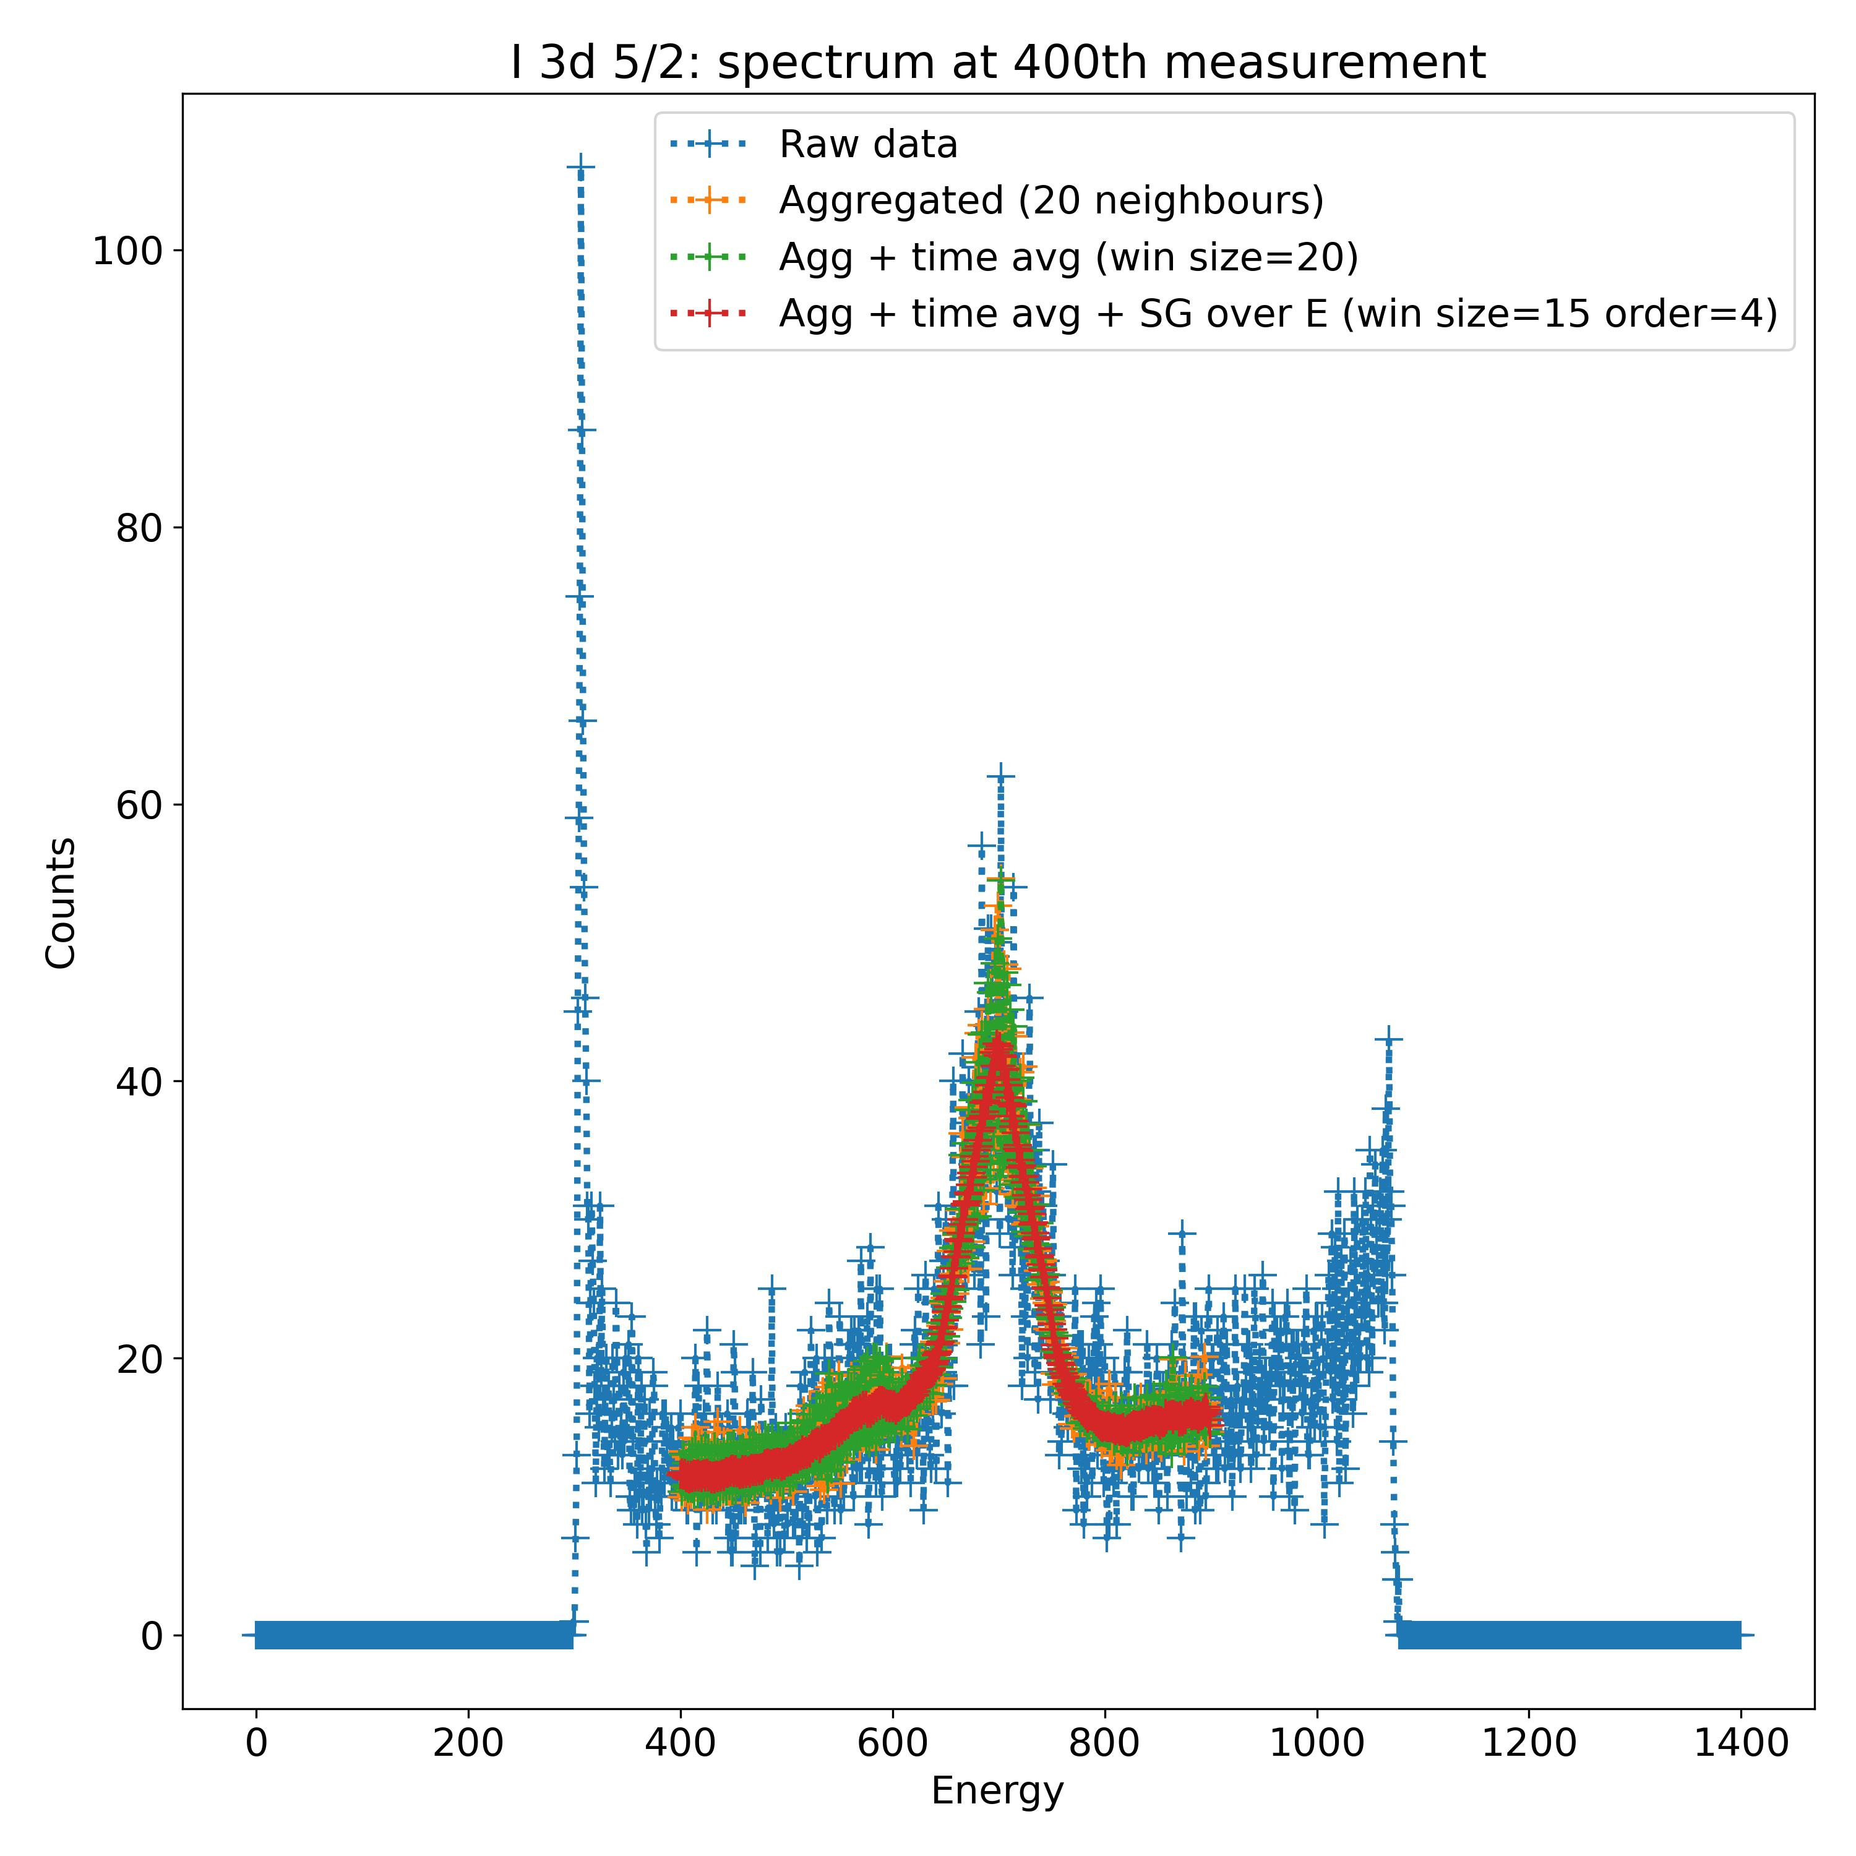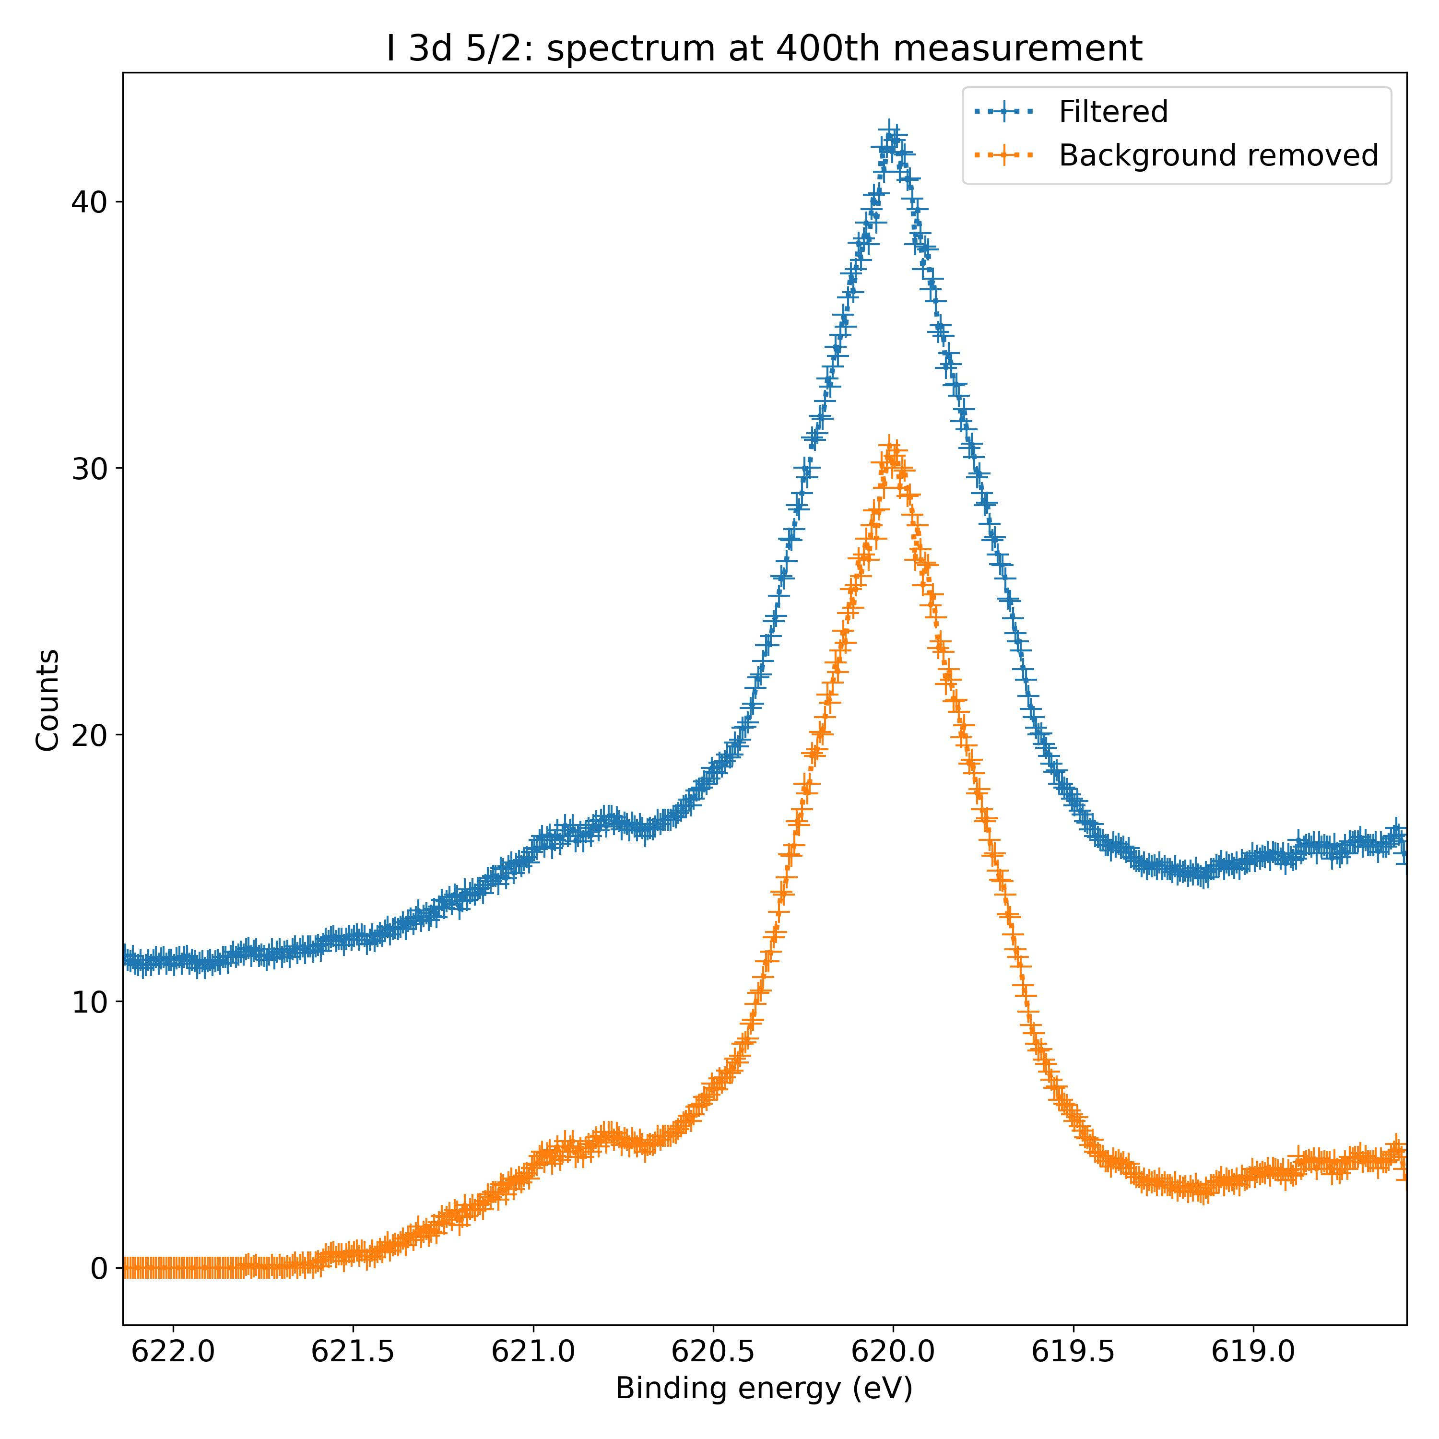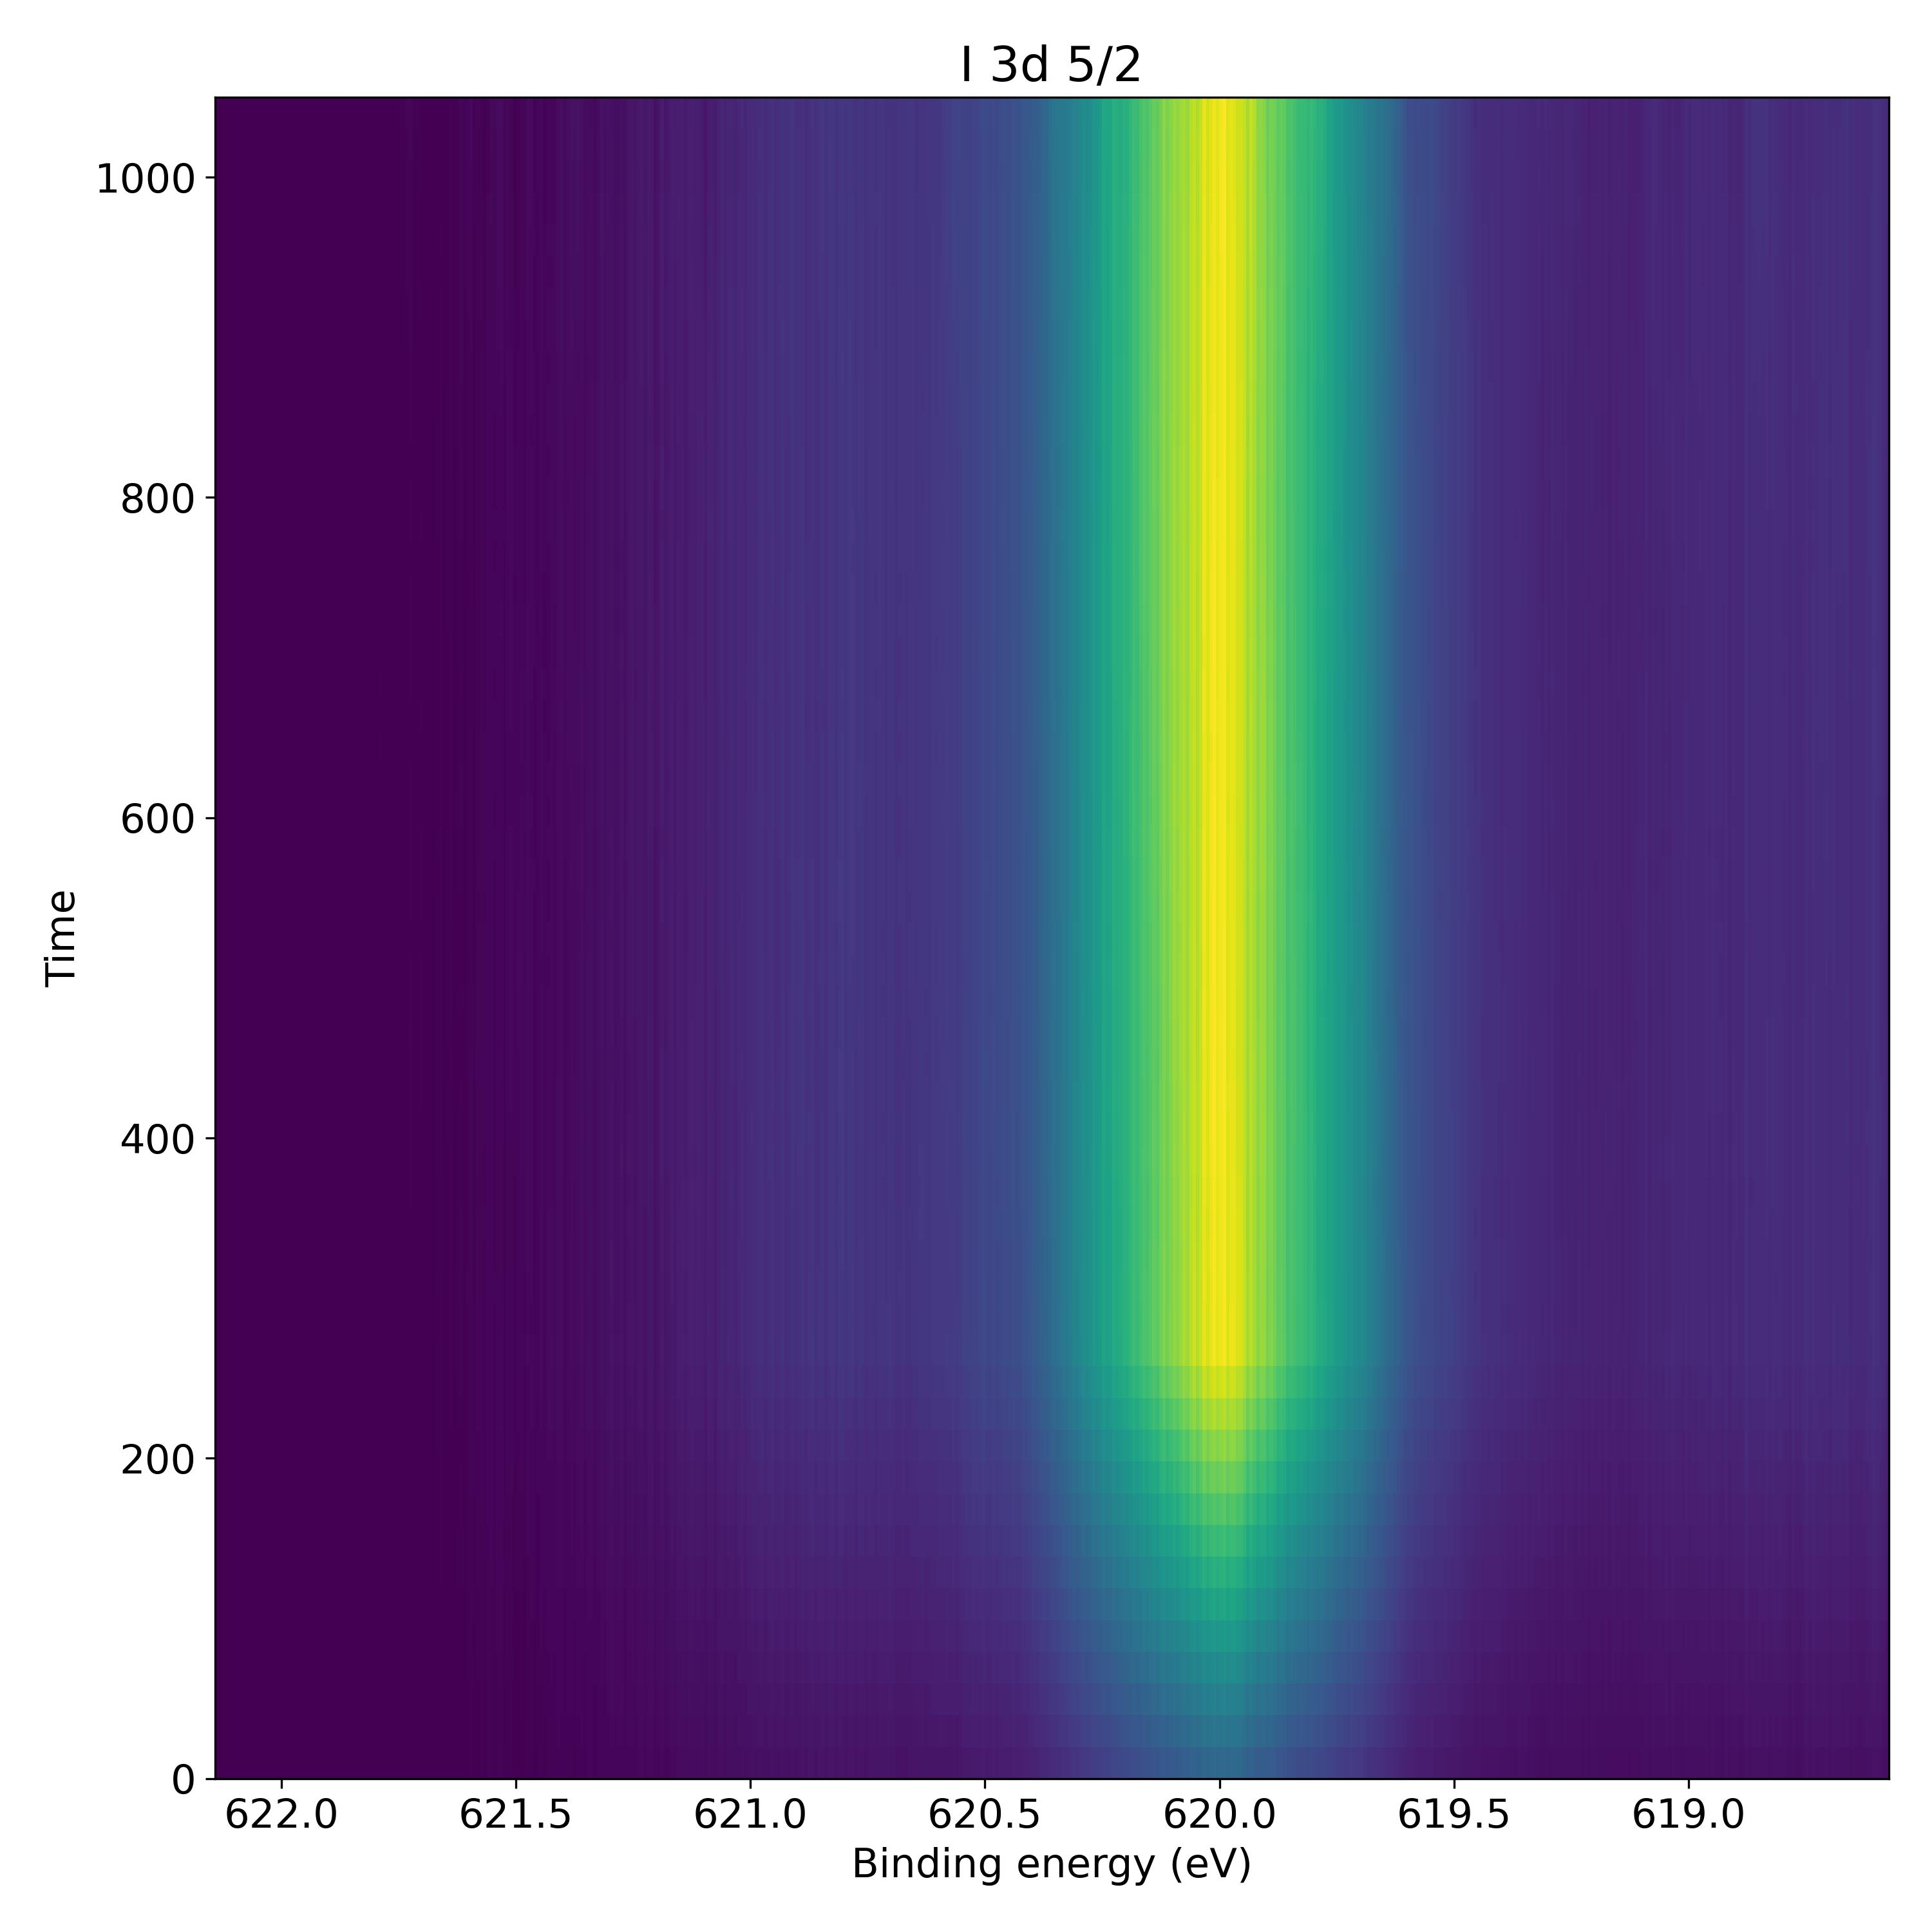

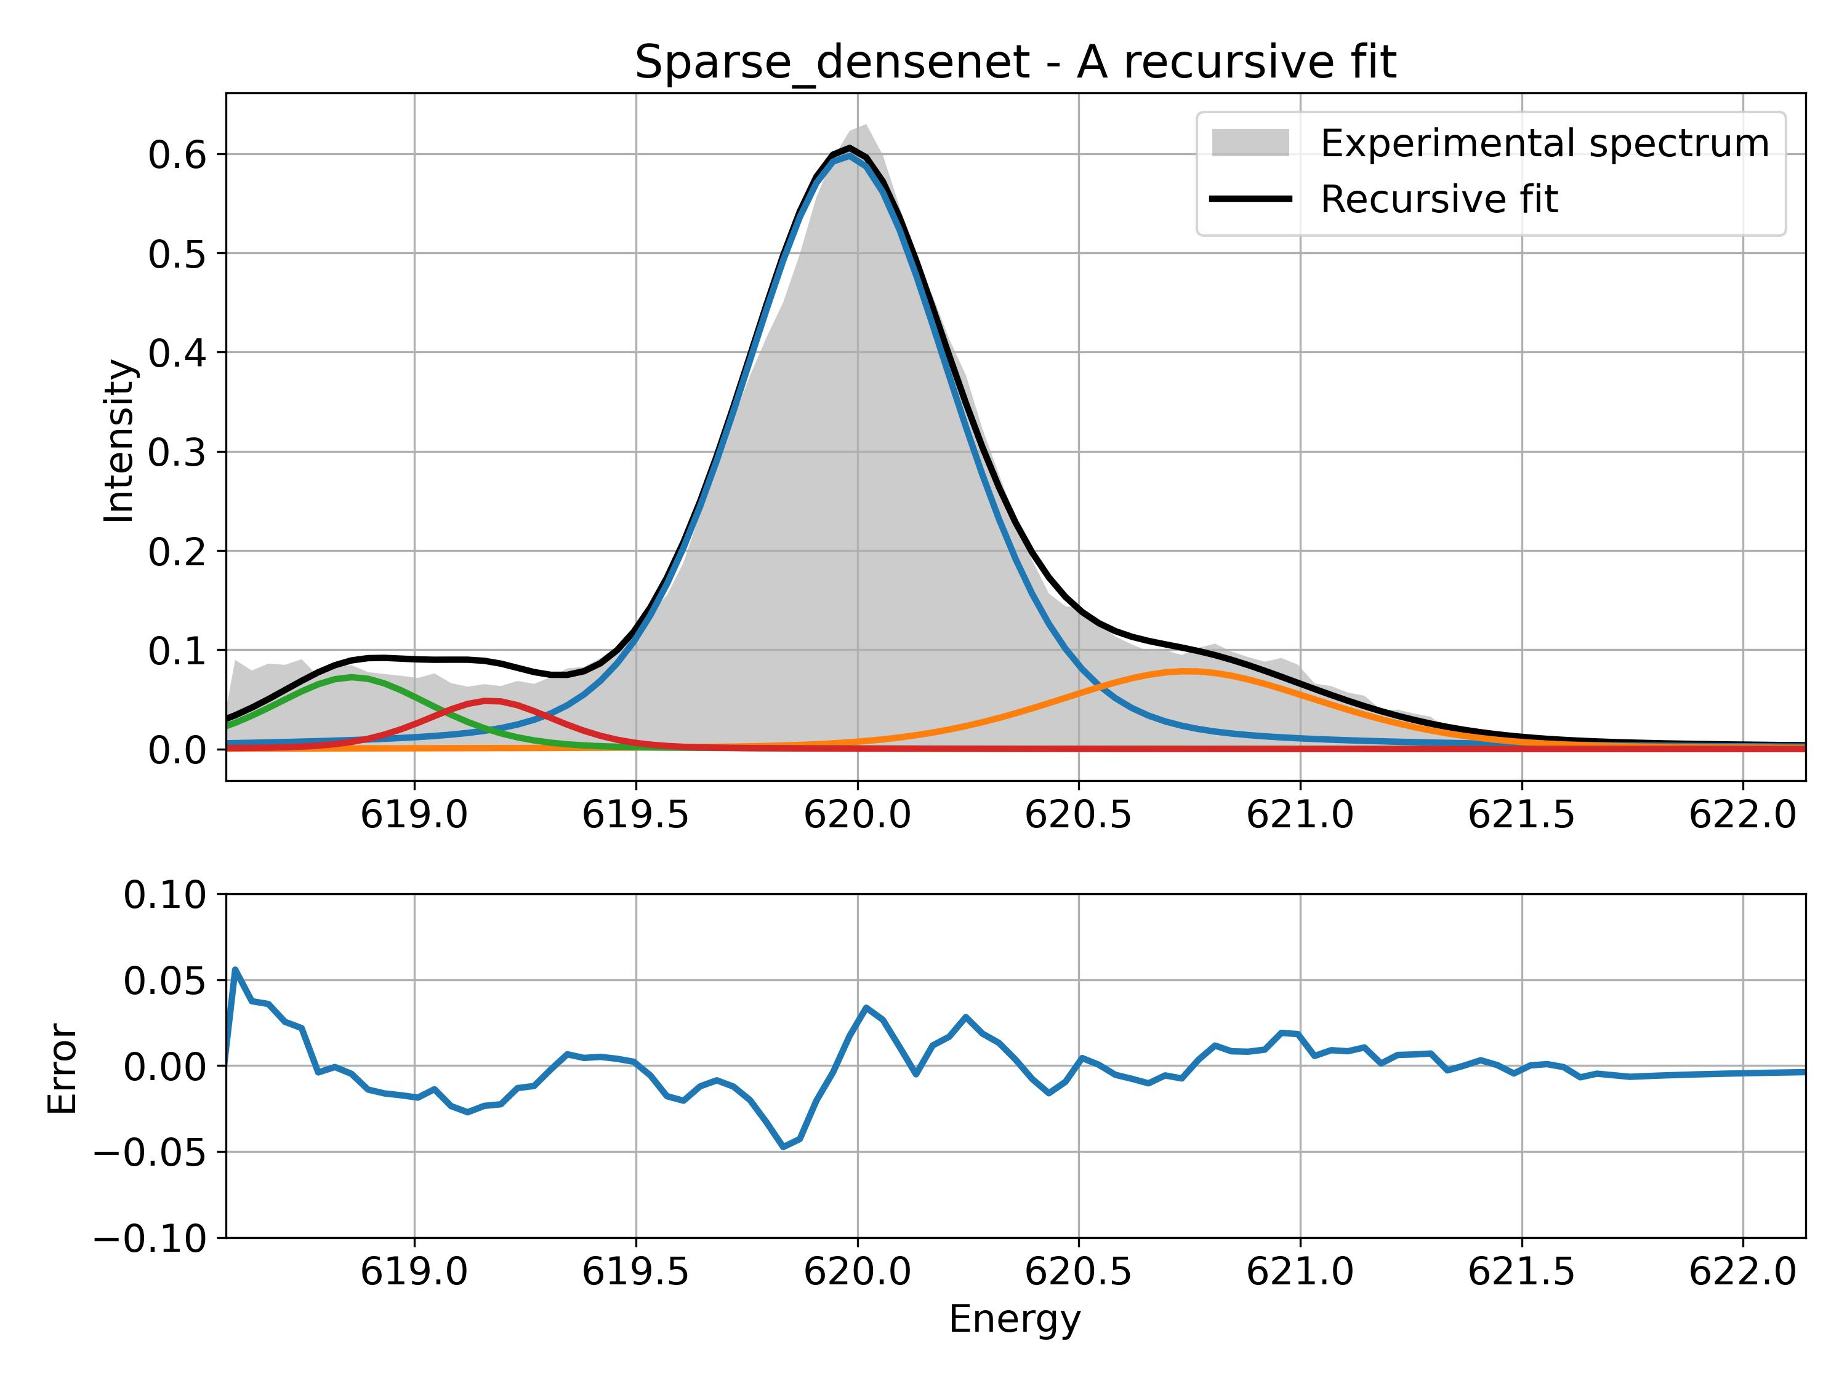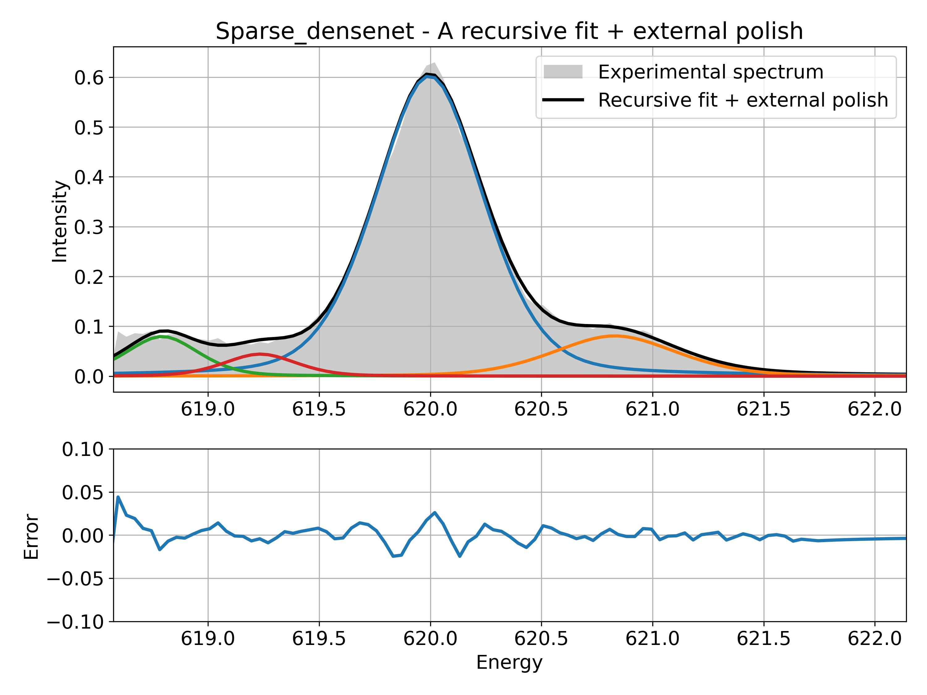

Additional wrong contributions due to background.

# Data pre-treatment and linear background removal:

Sample: CTF1:



Measurement 2: Pb 4f measurement – 10 mW laser illumination

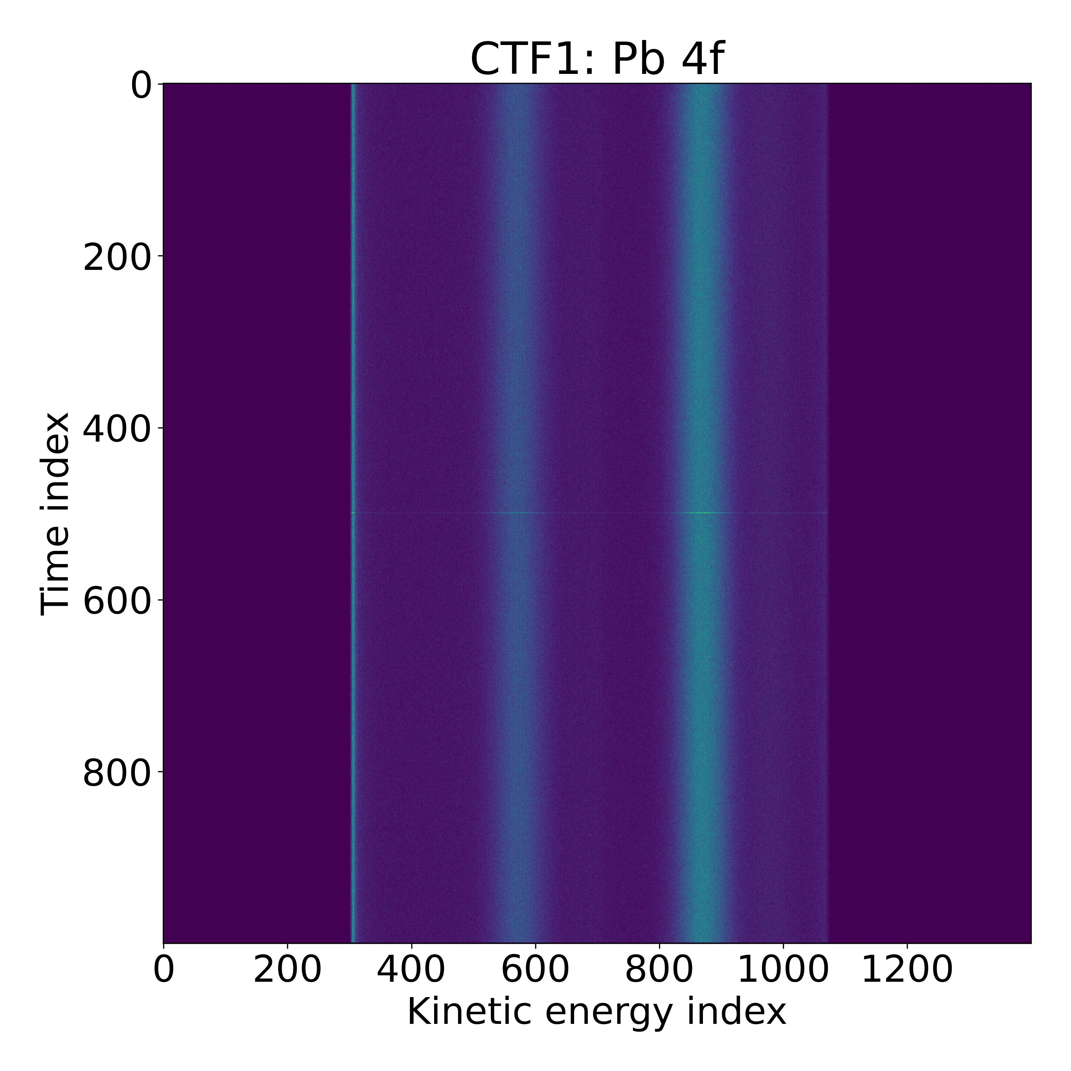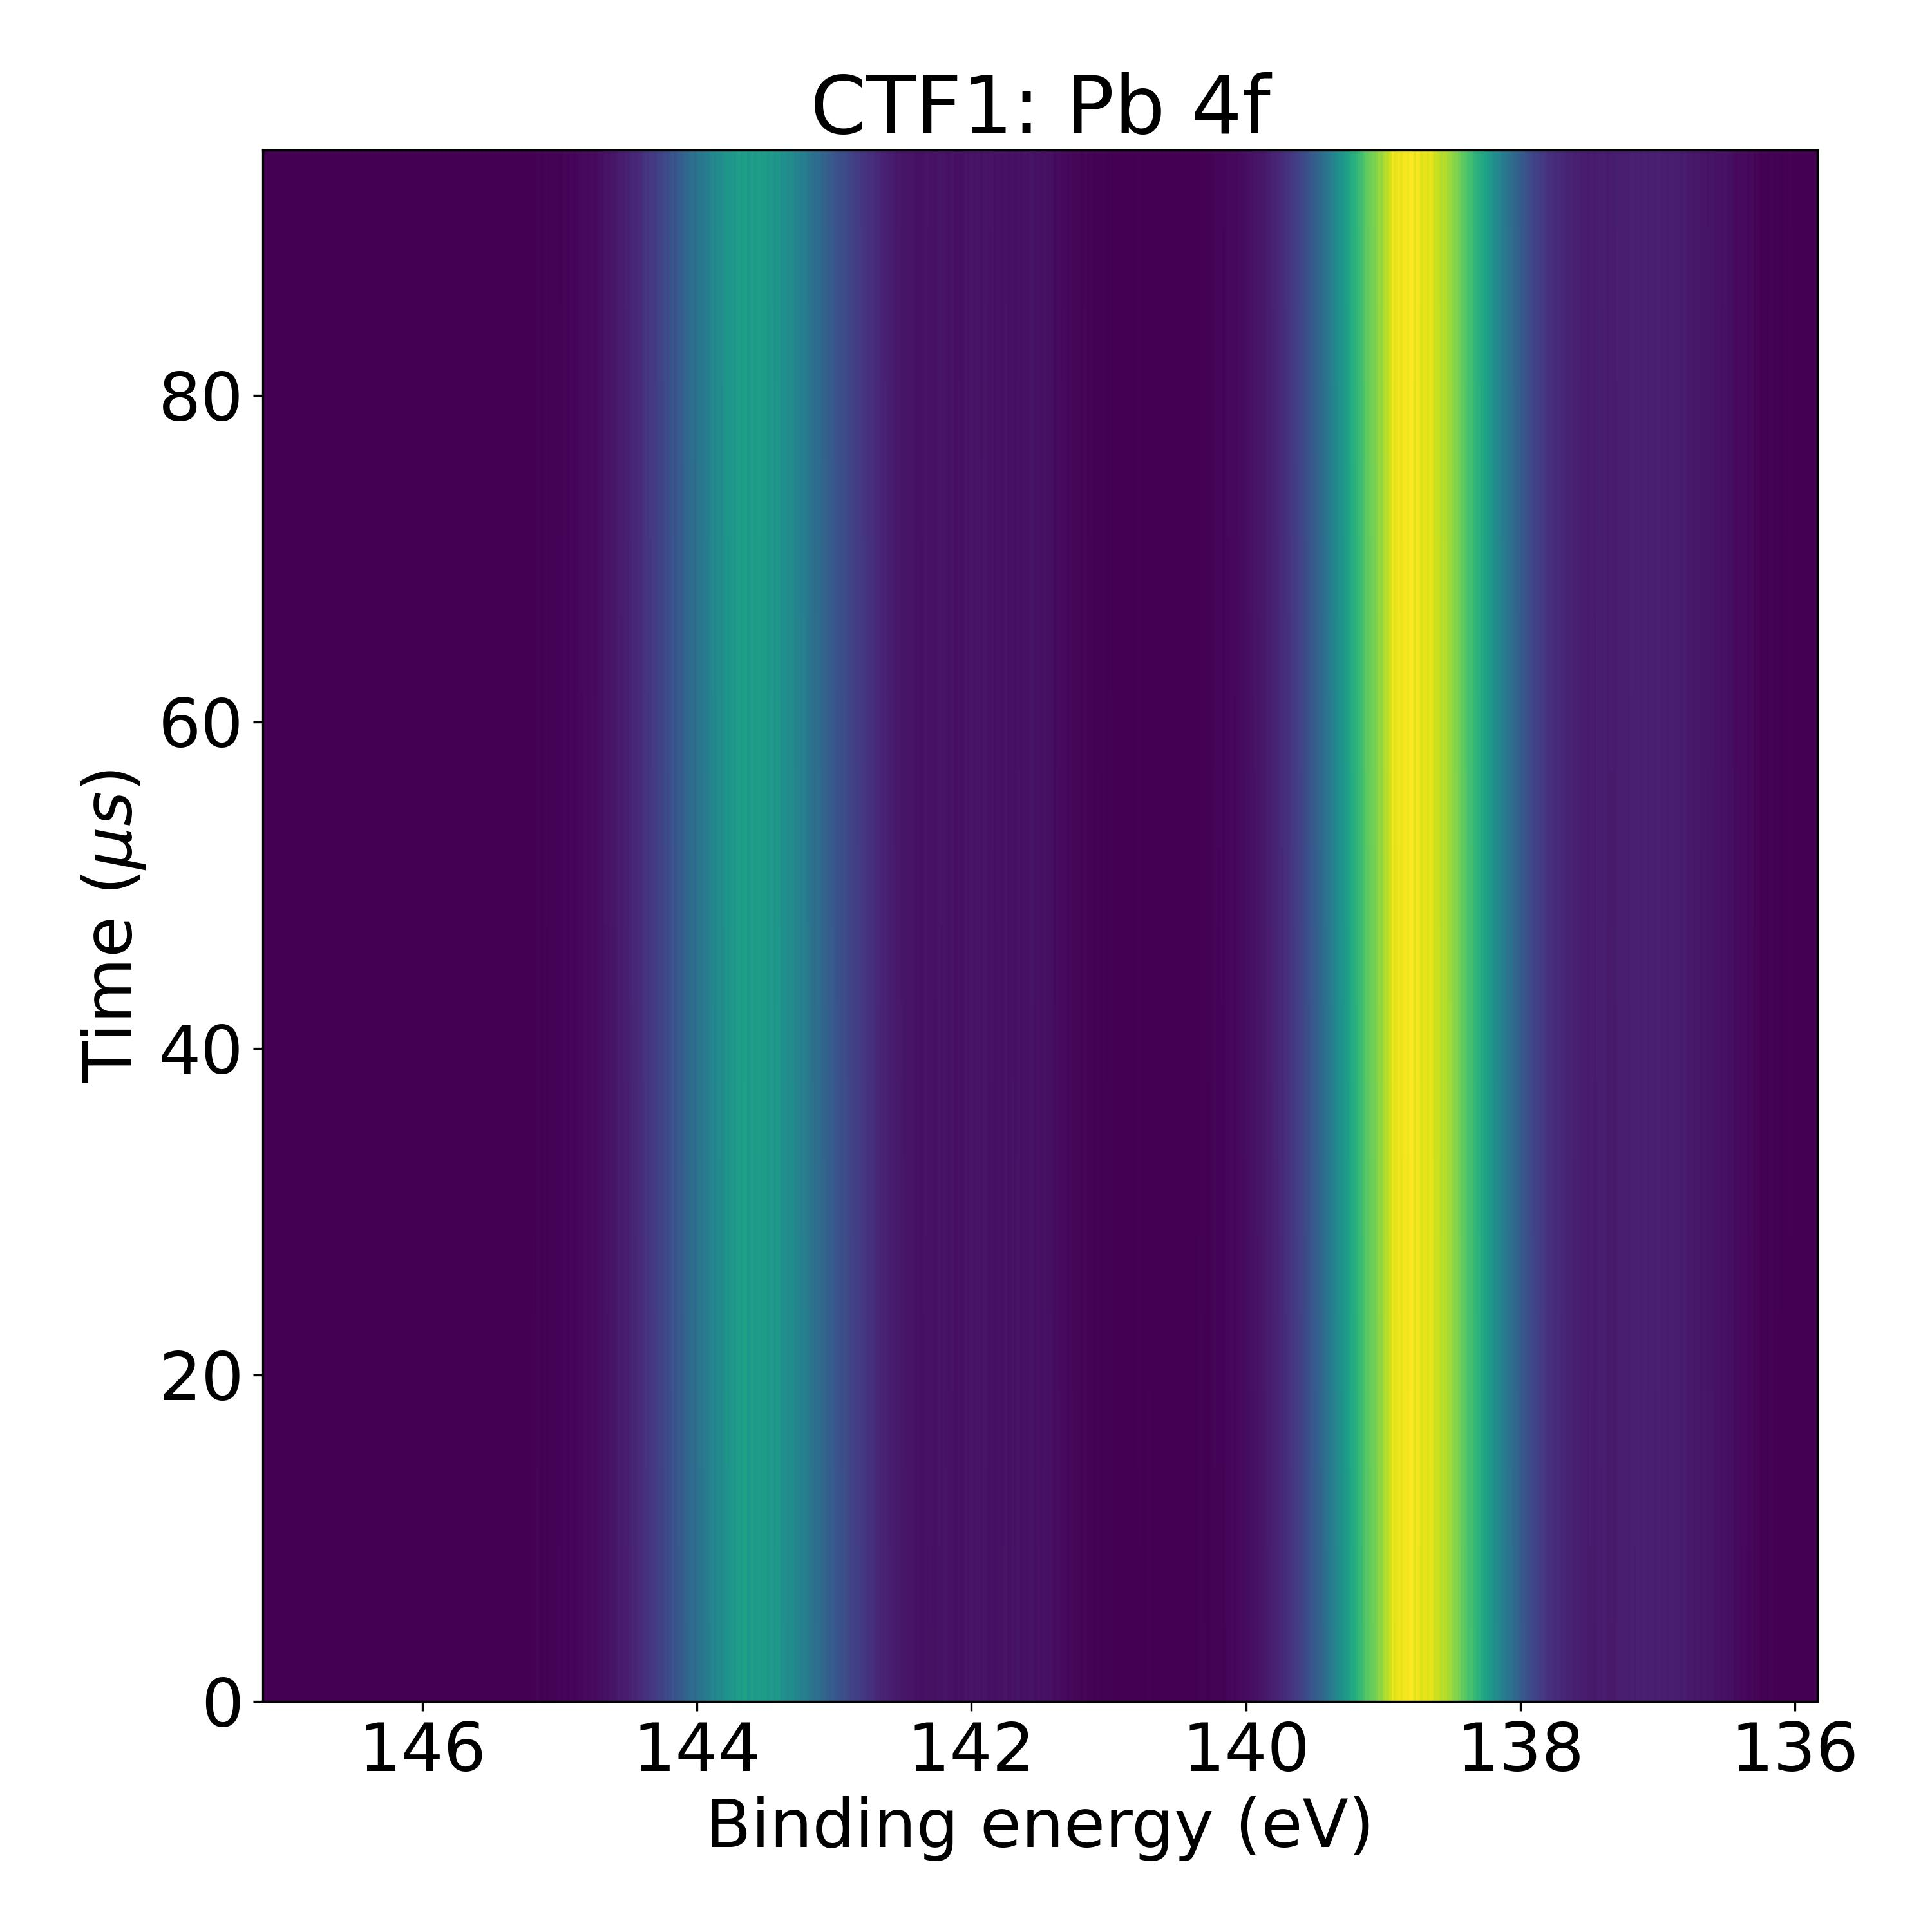

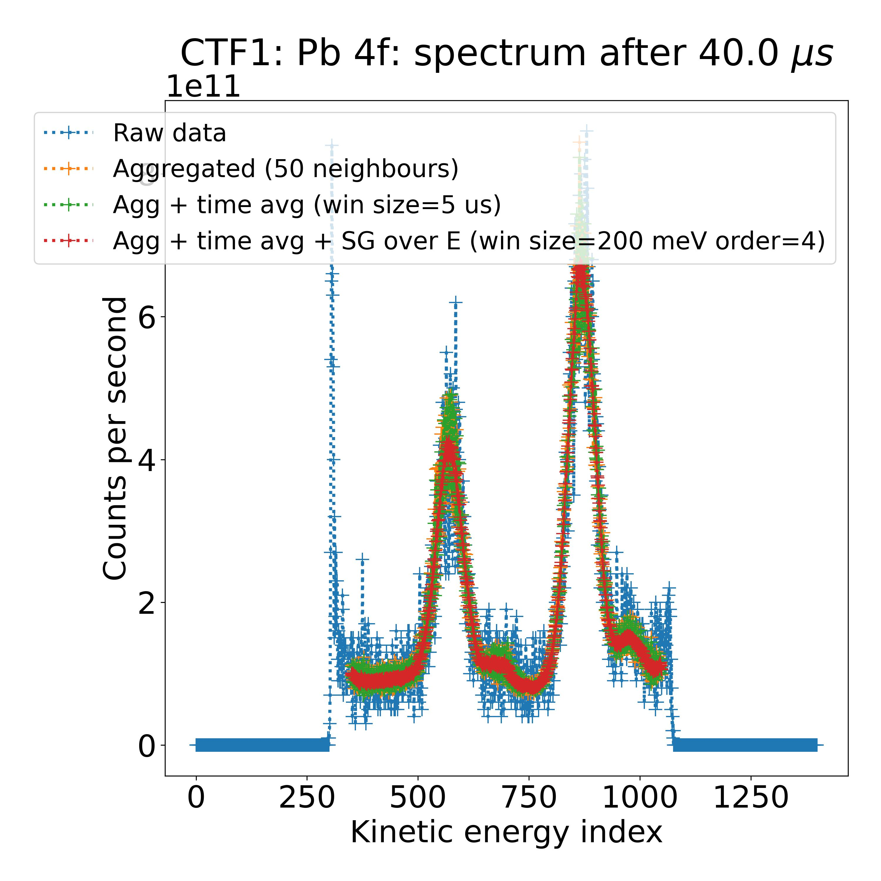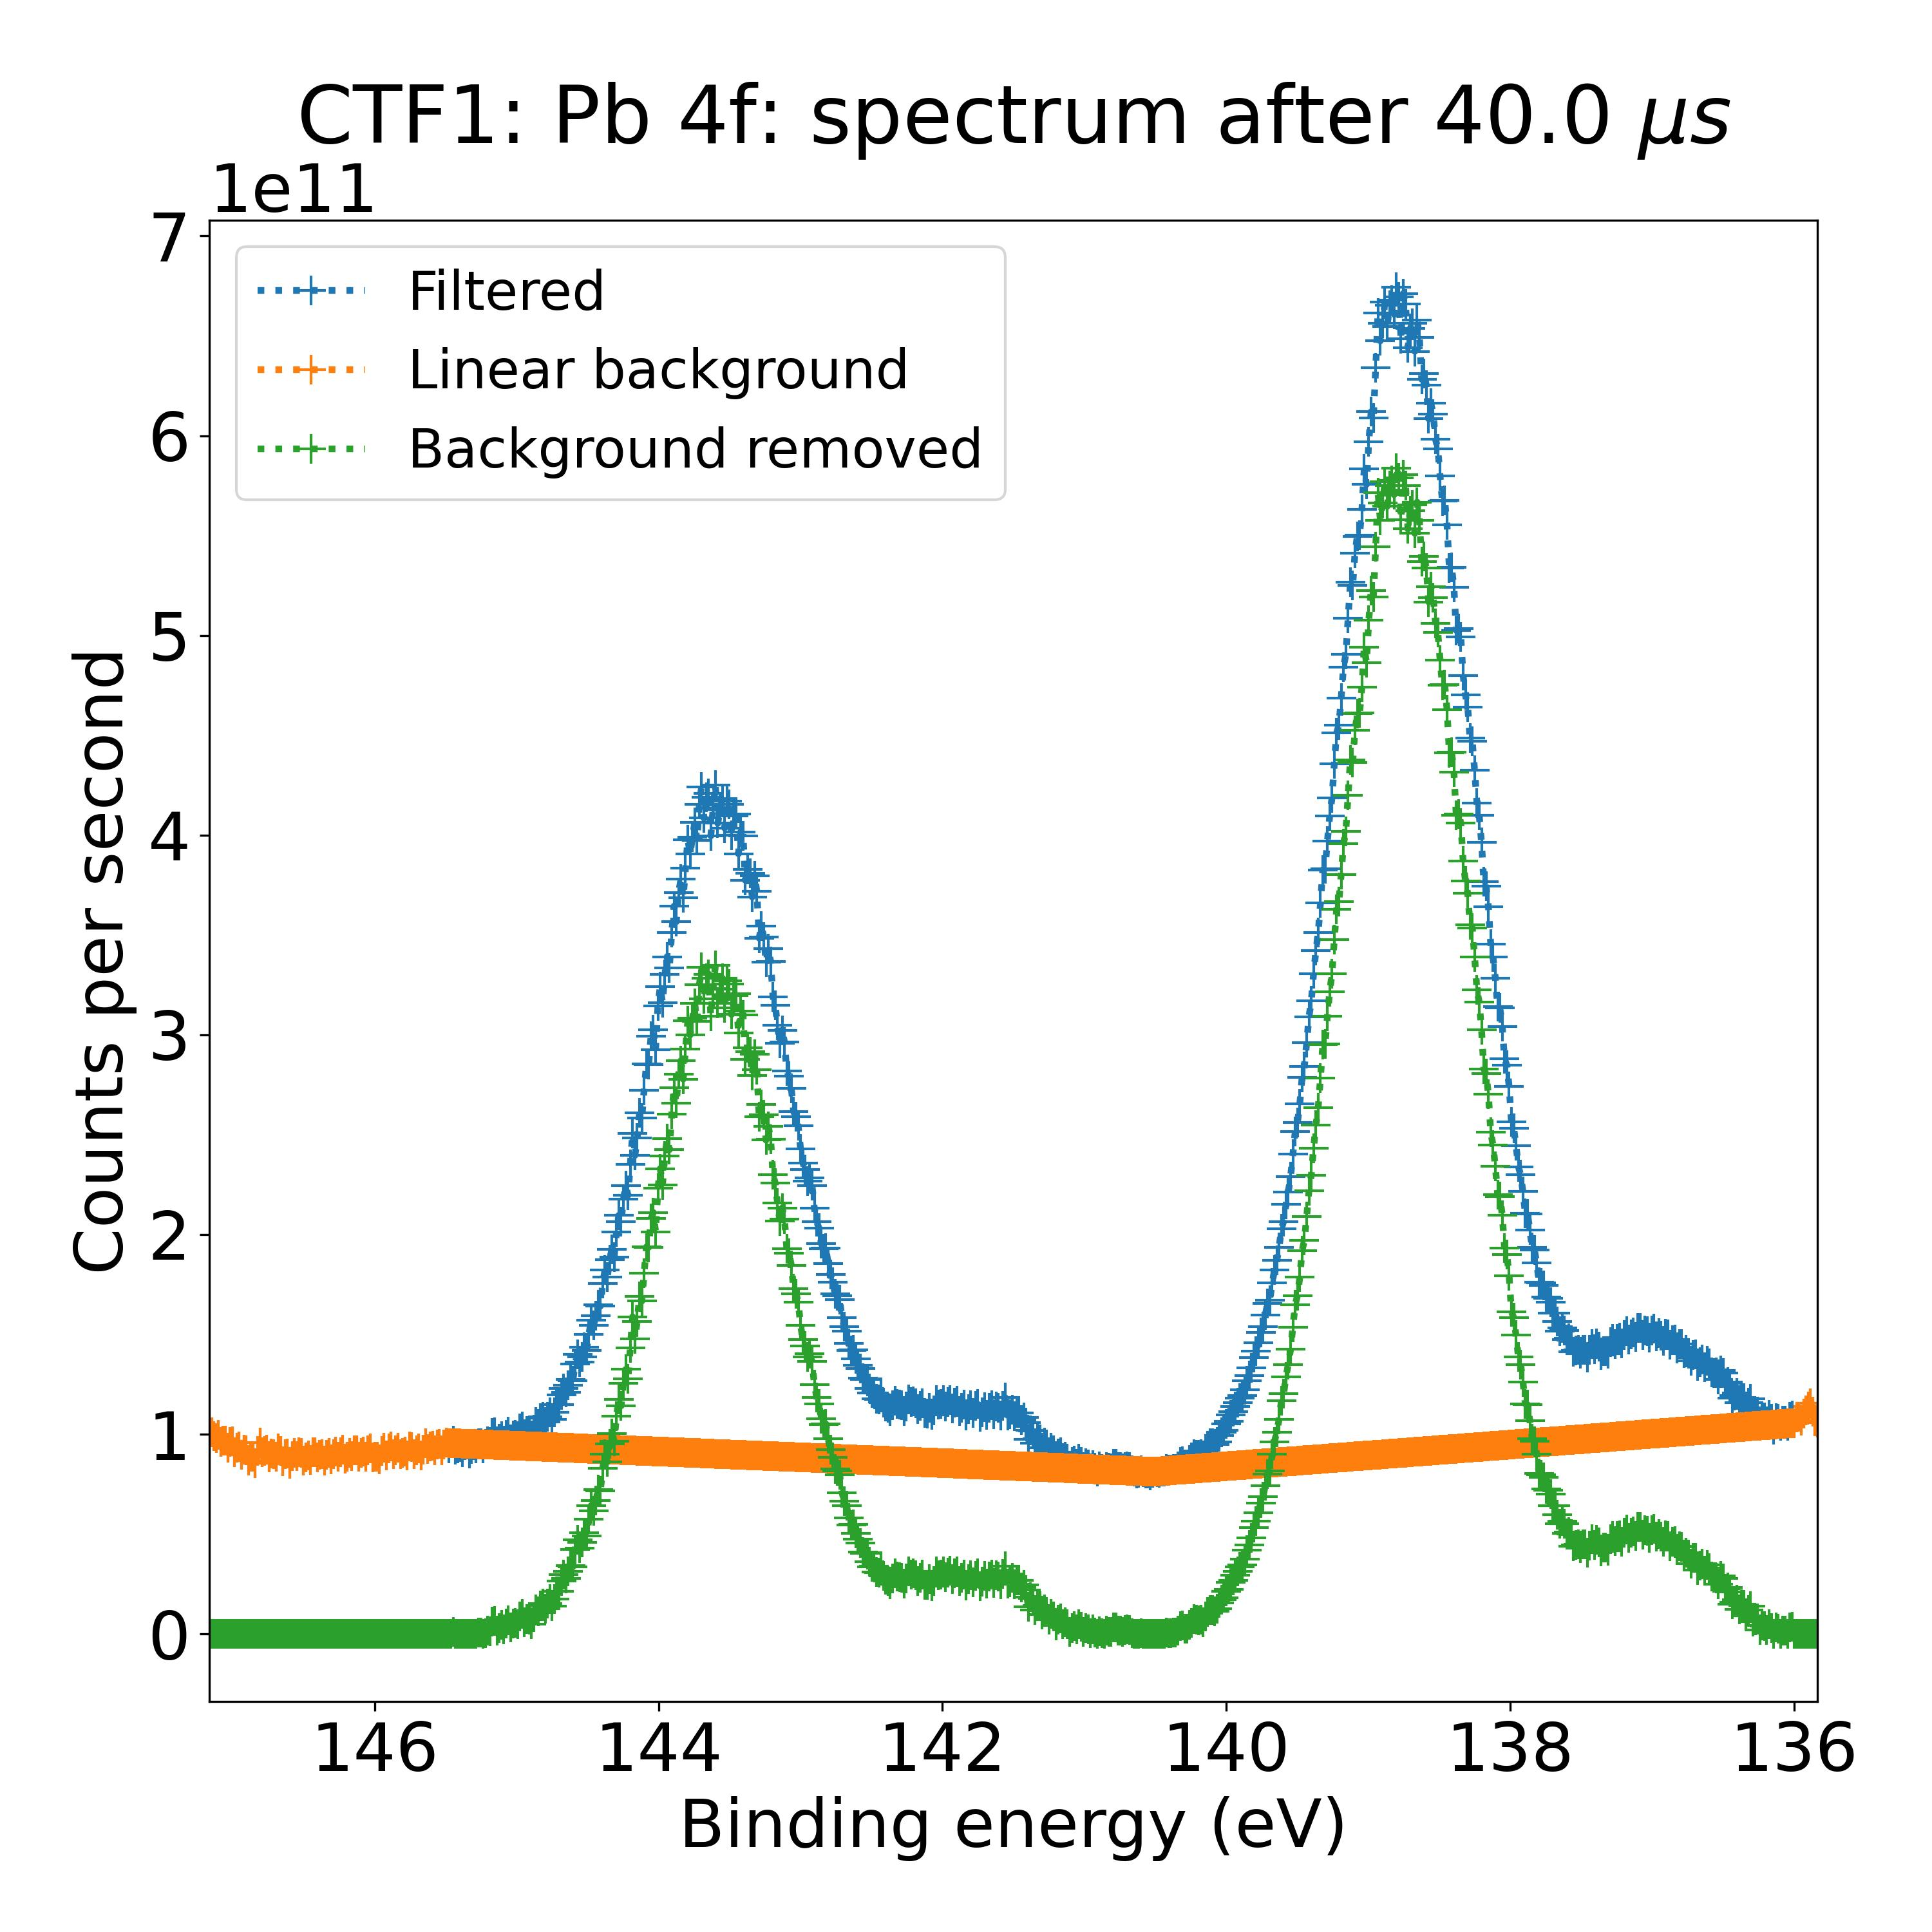

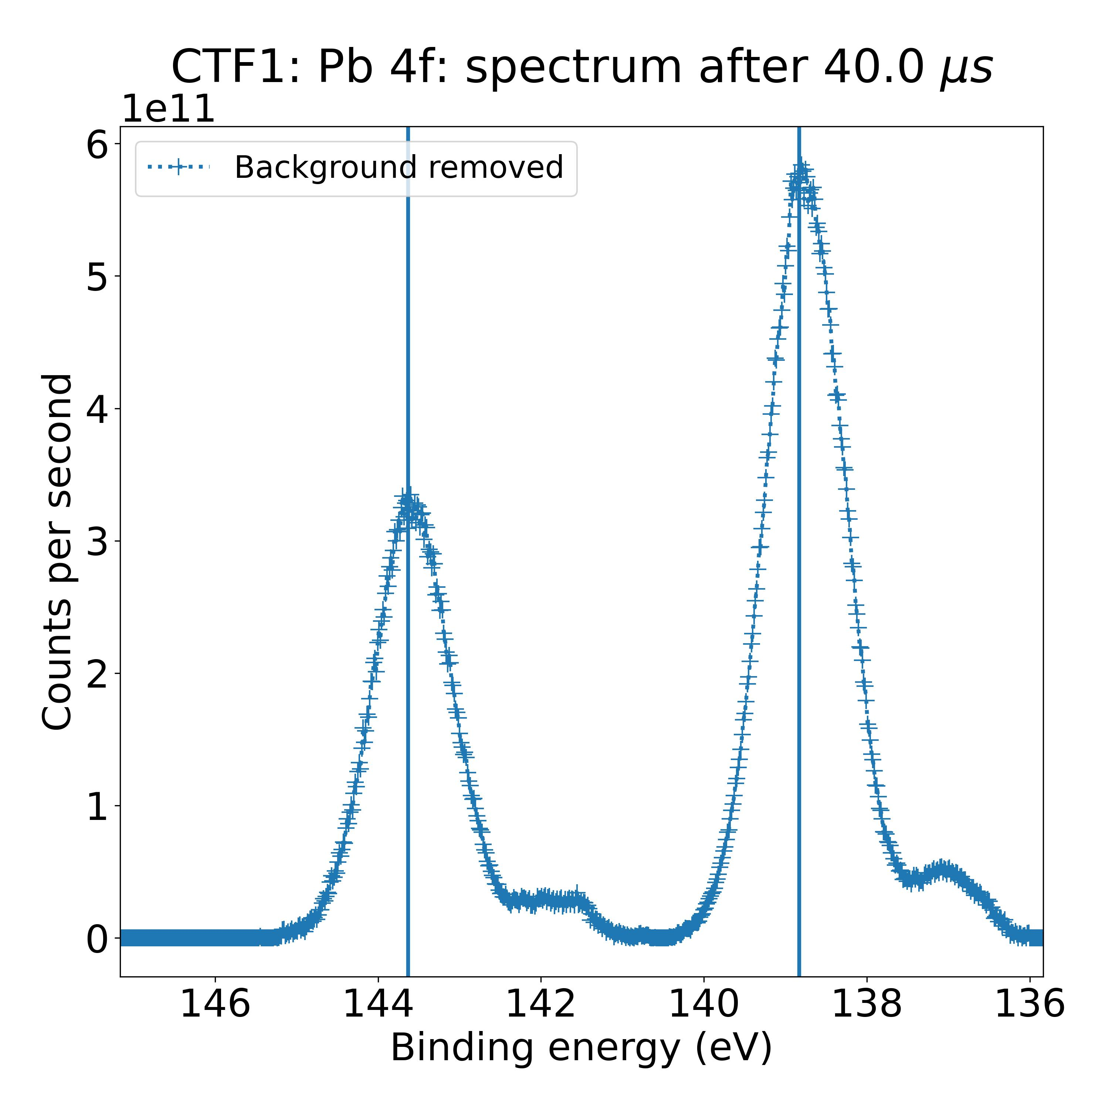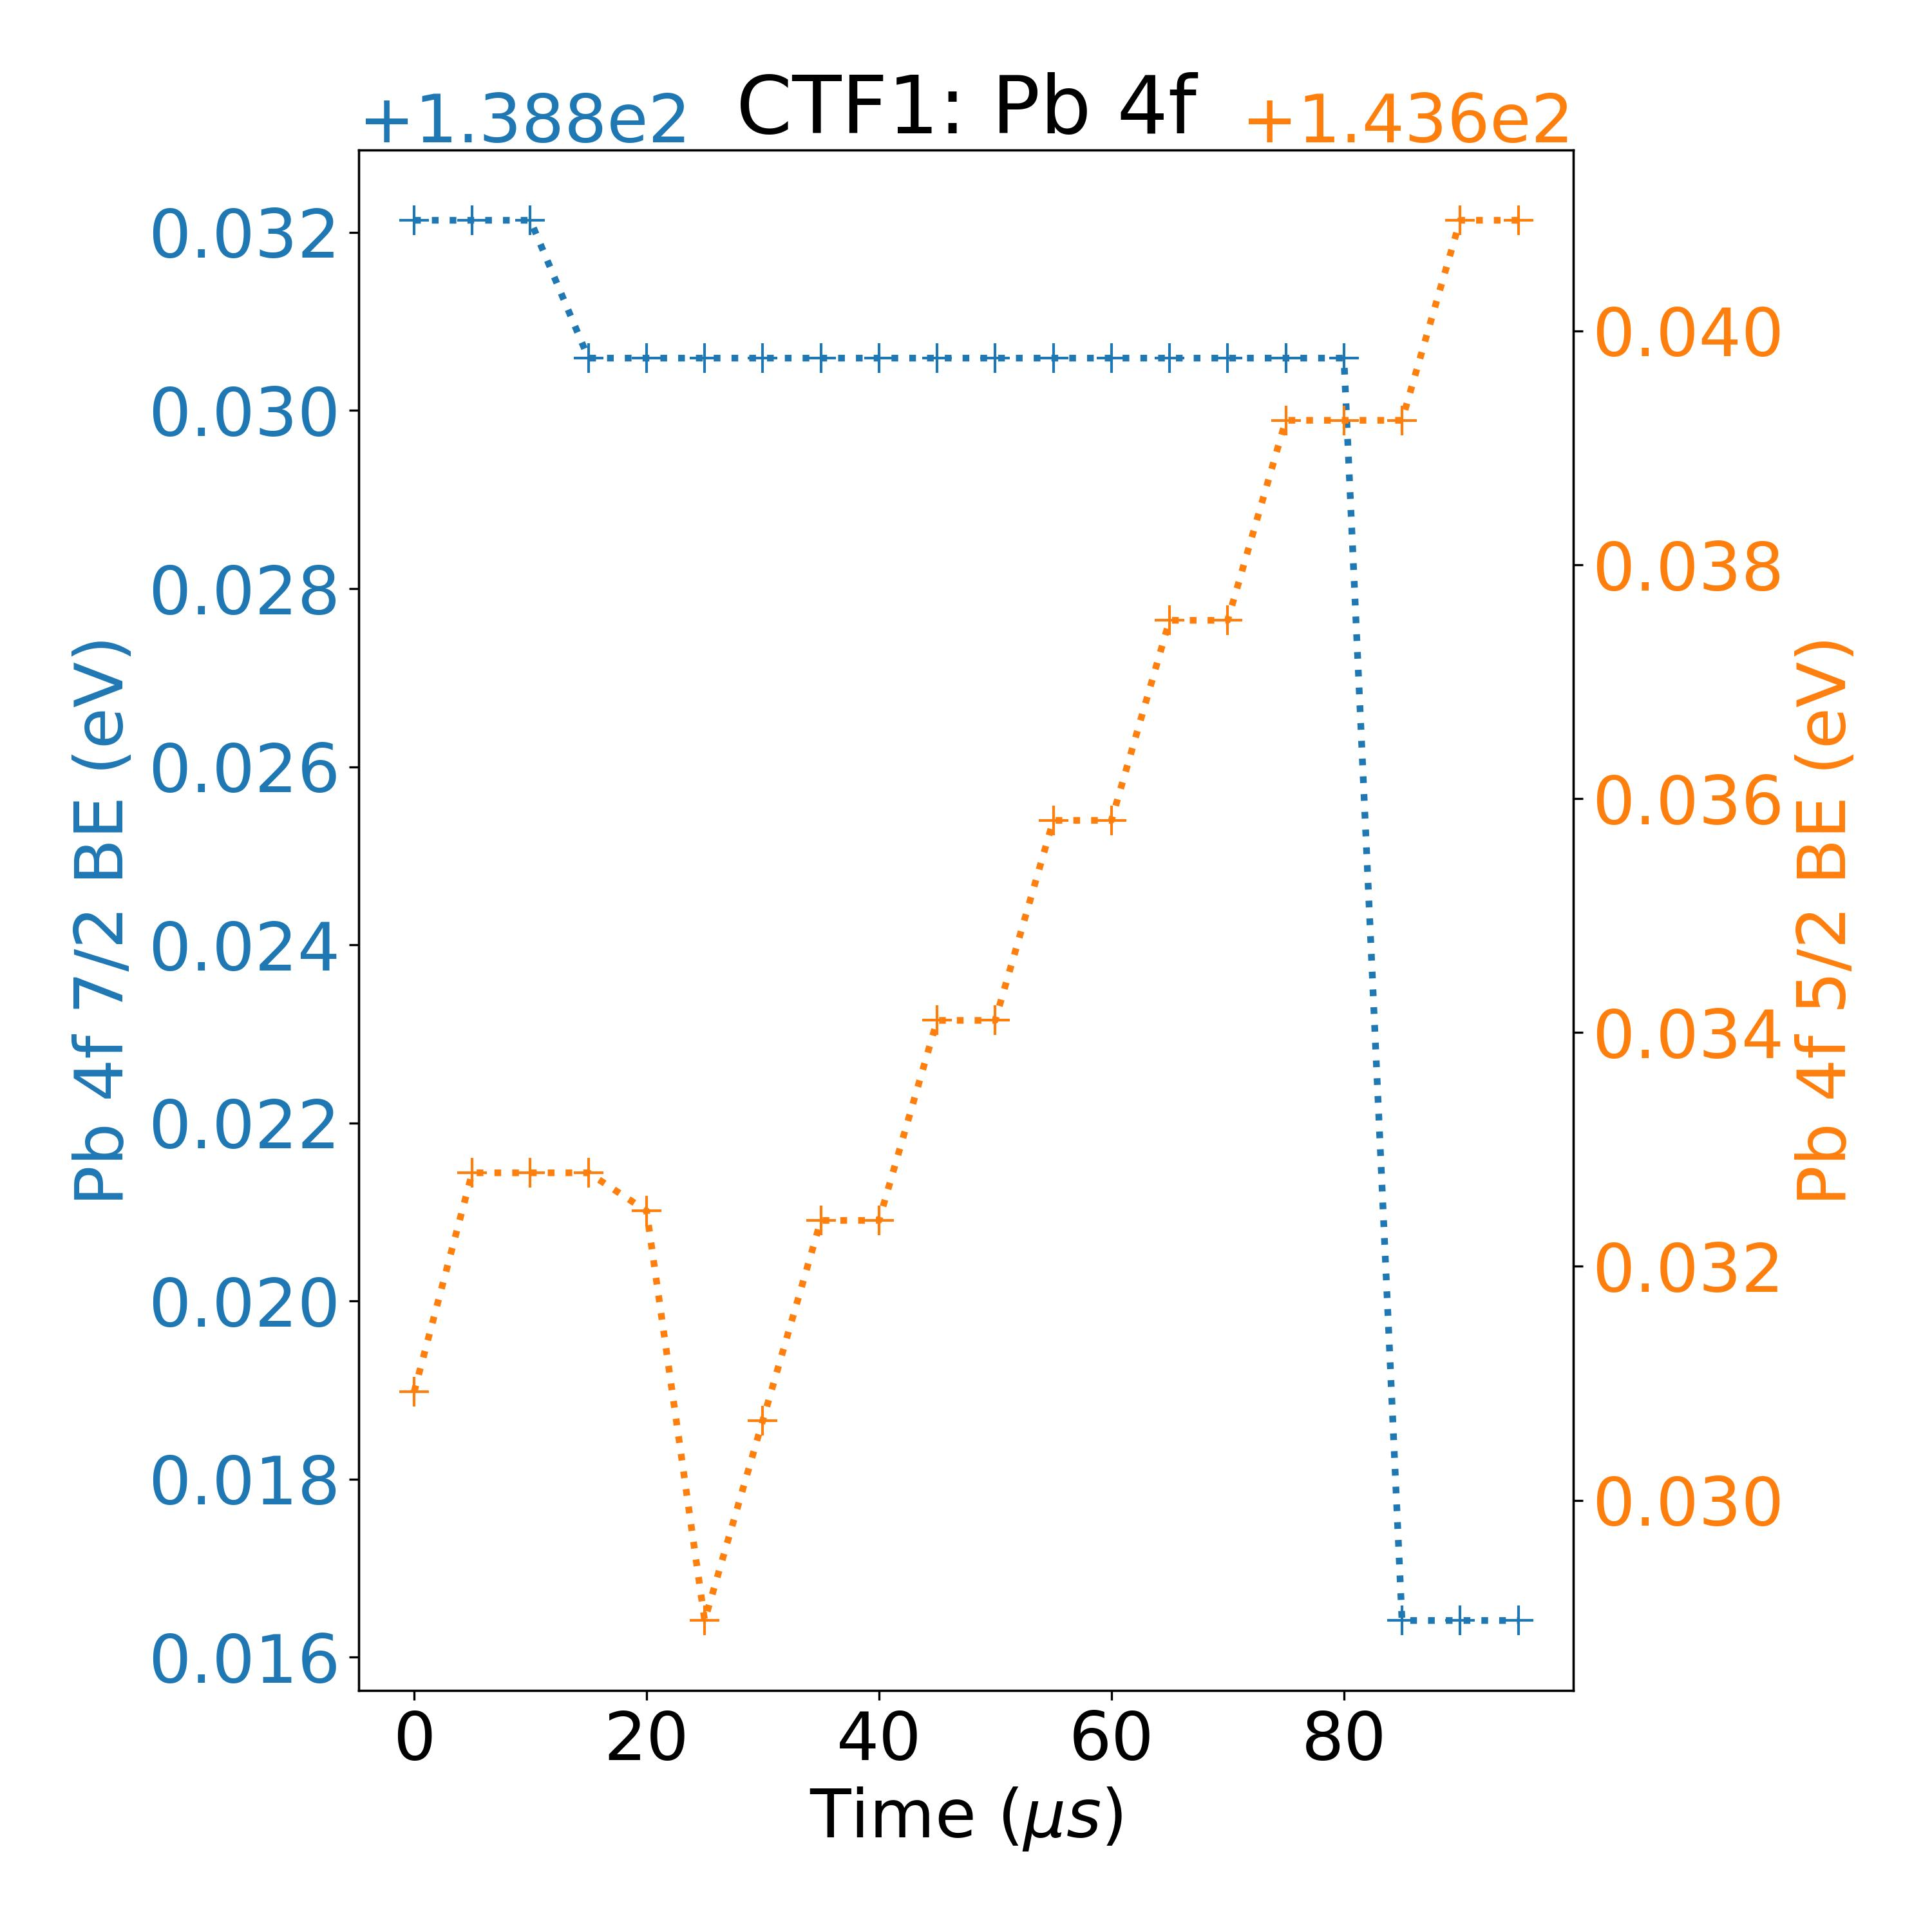

Measurement 3: I 3d 5/2 – 1 mW laser illumination

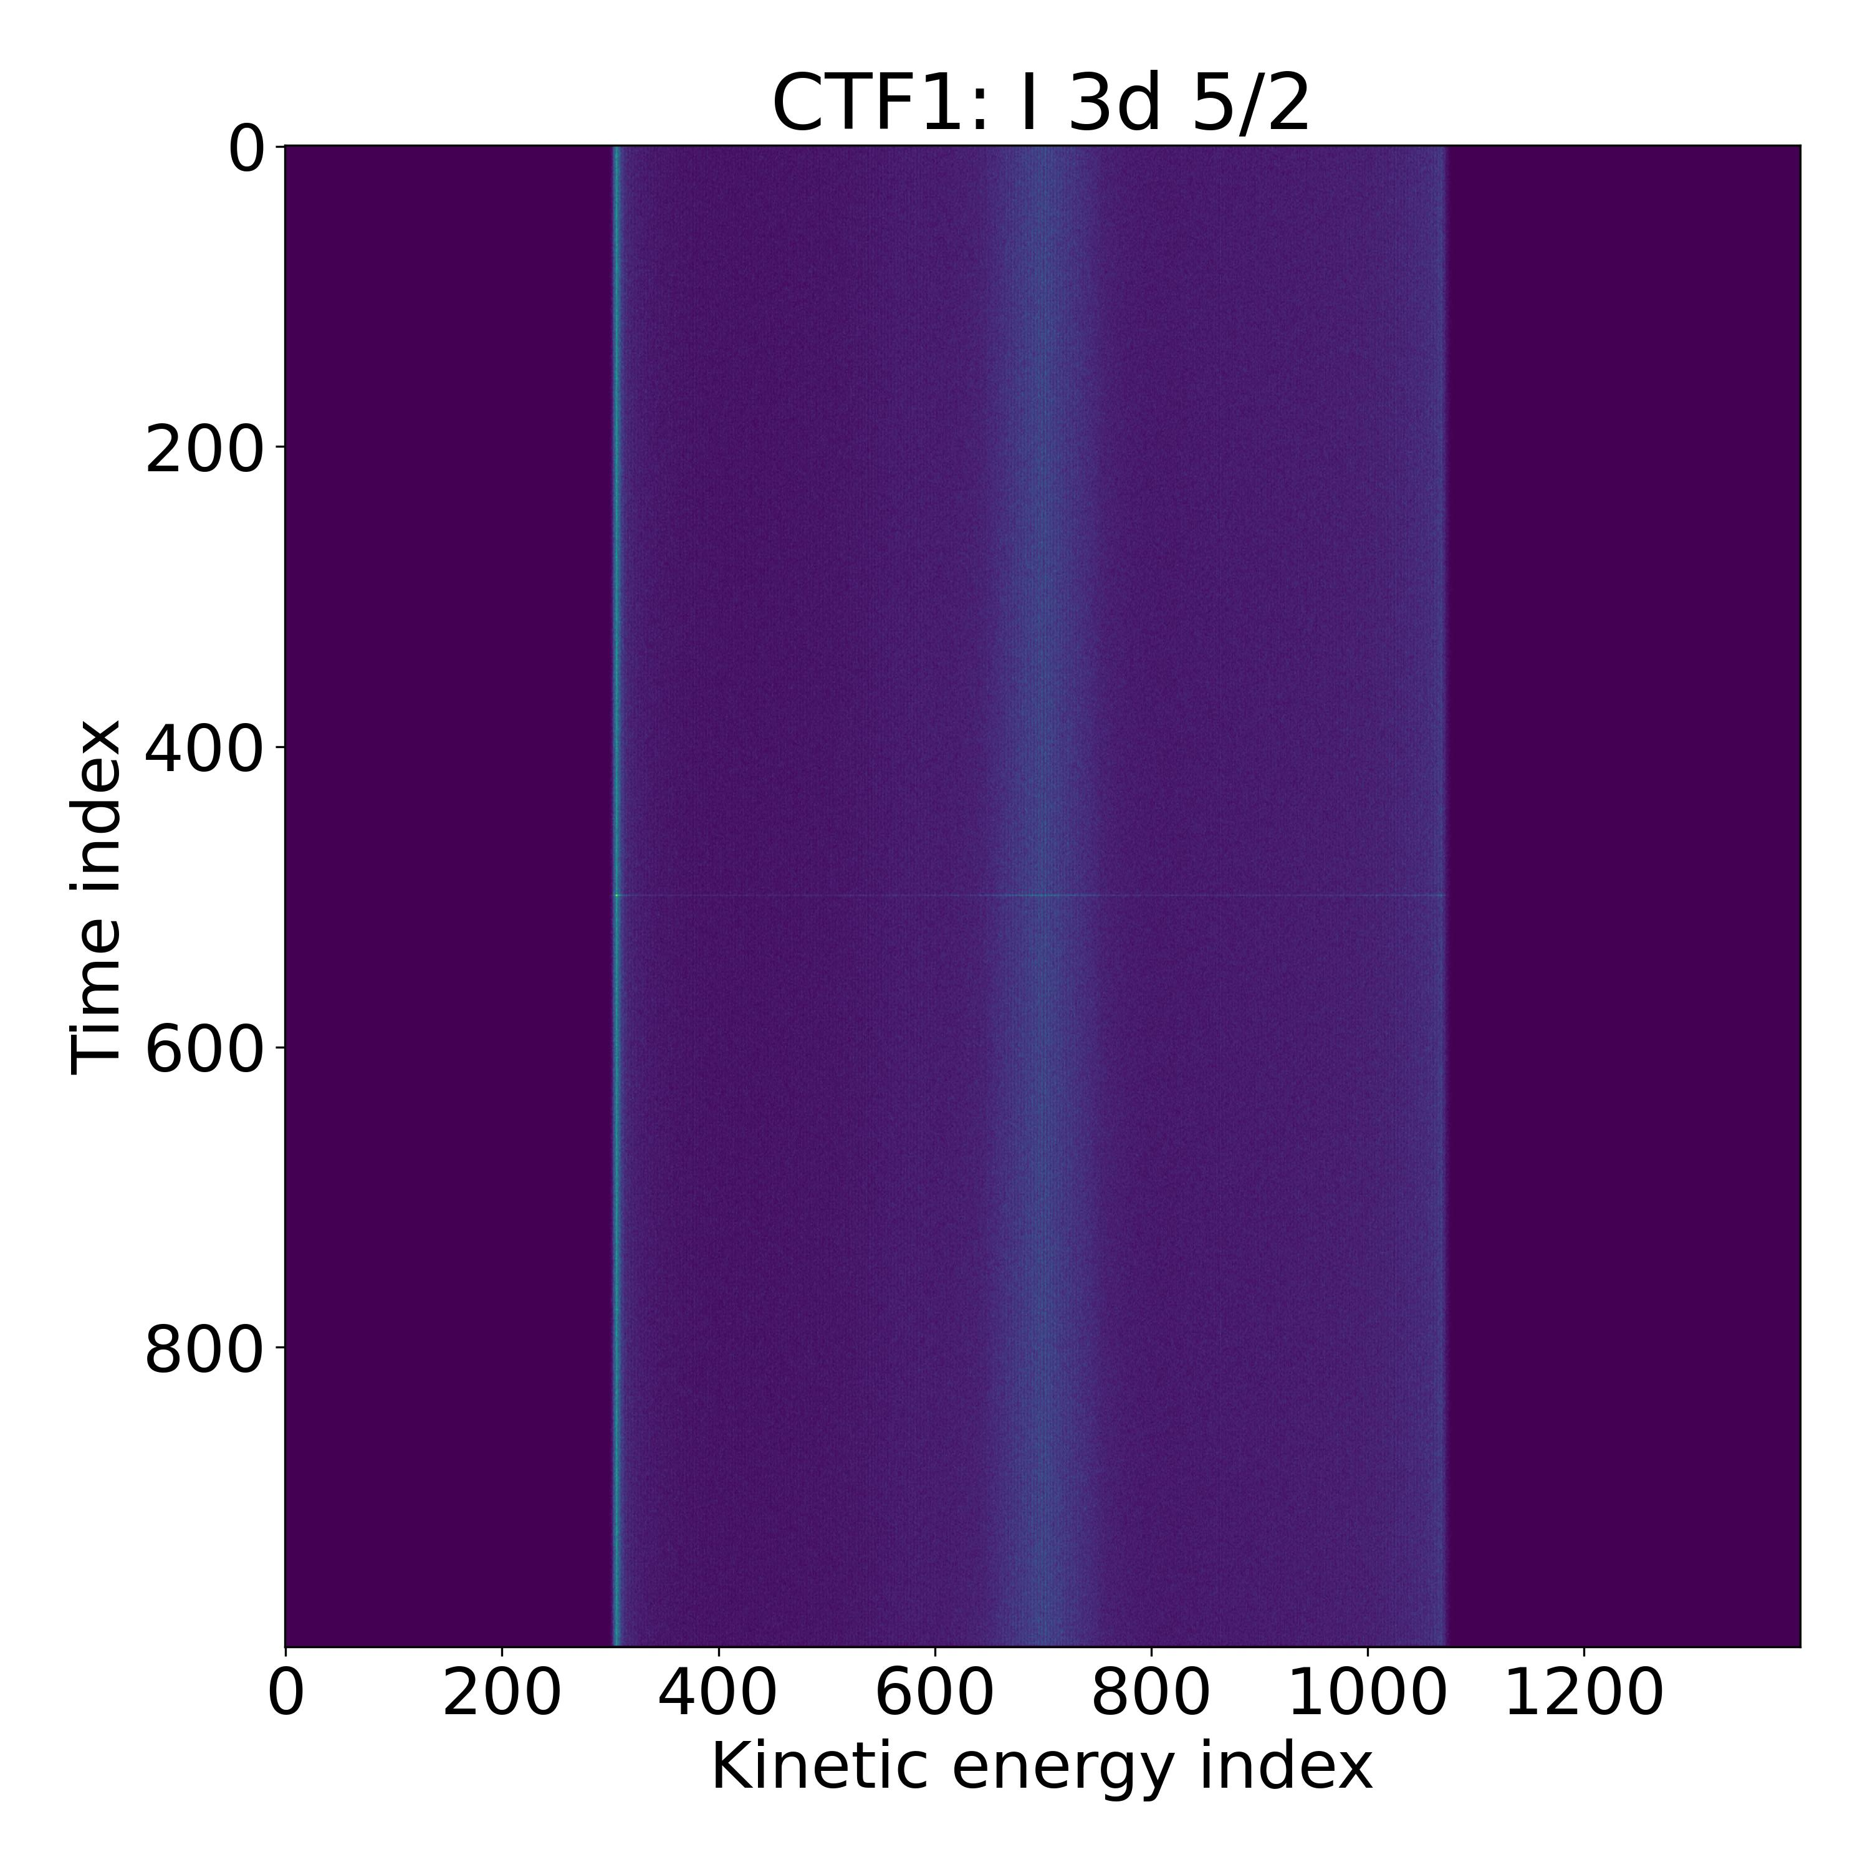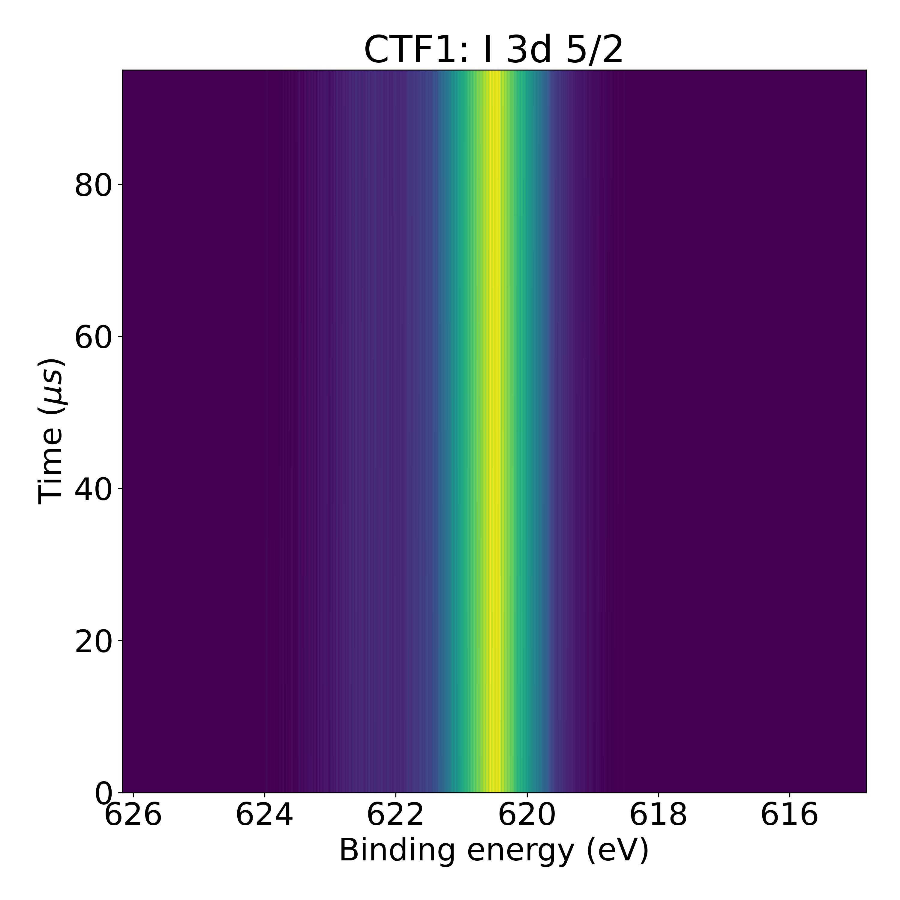

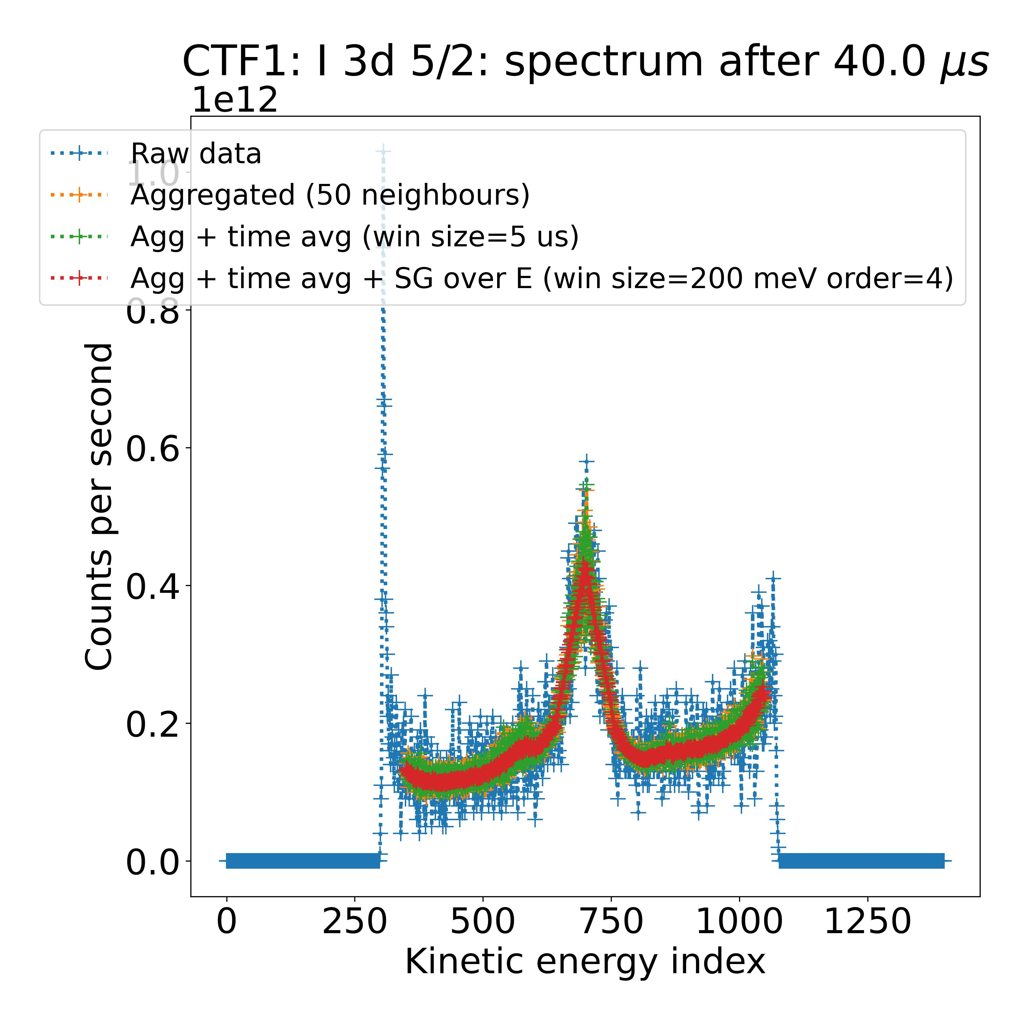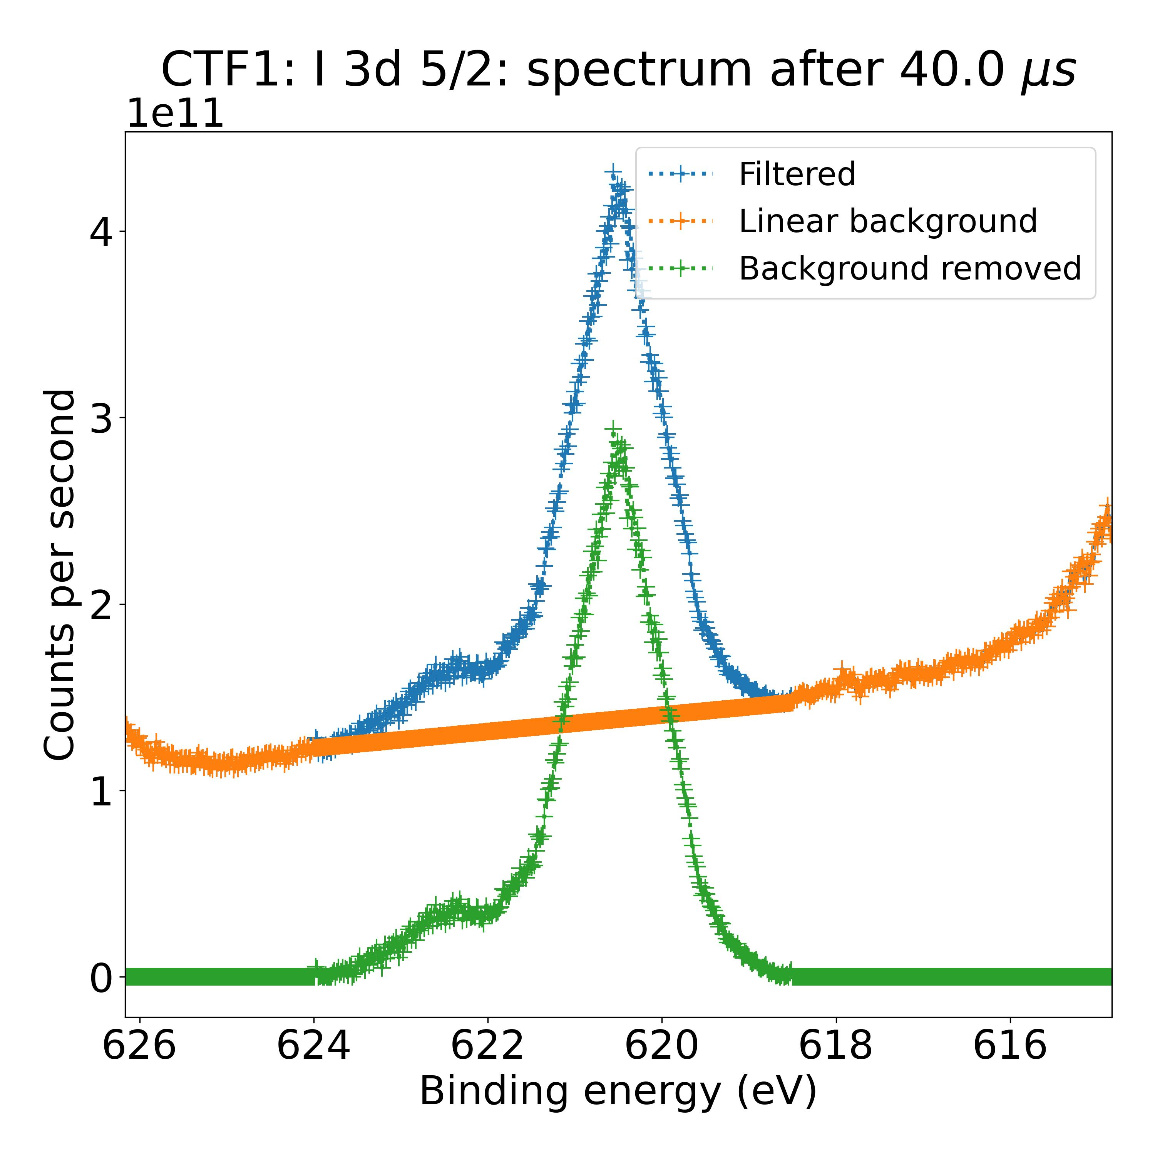

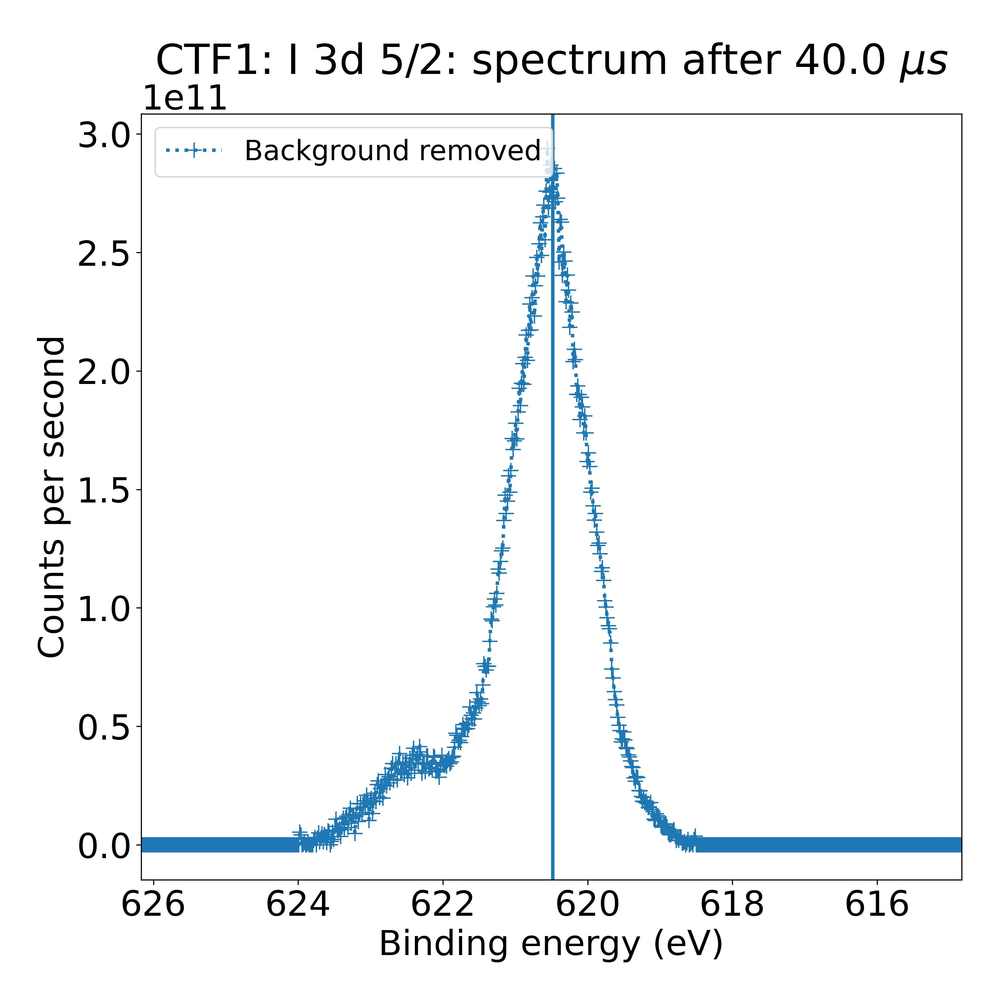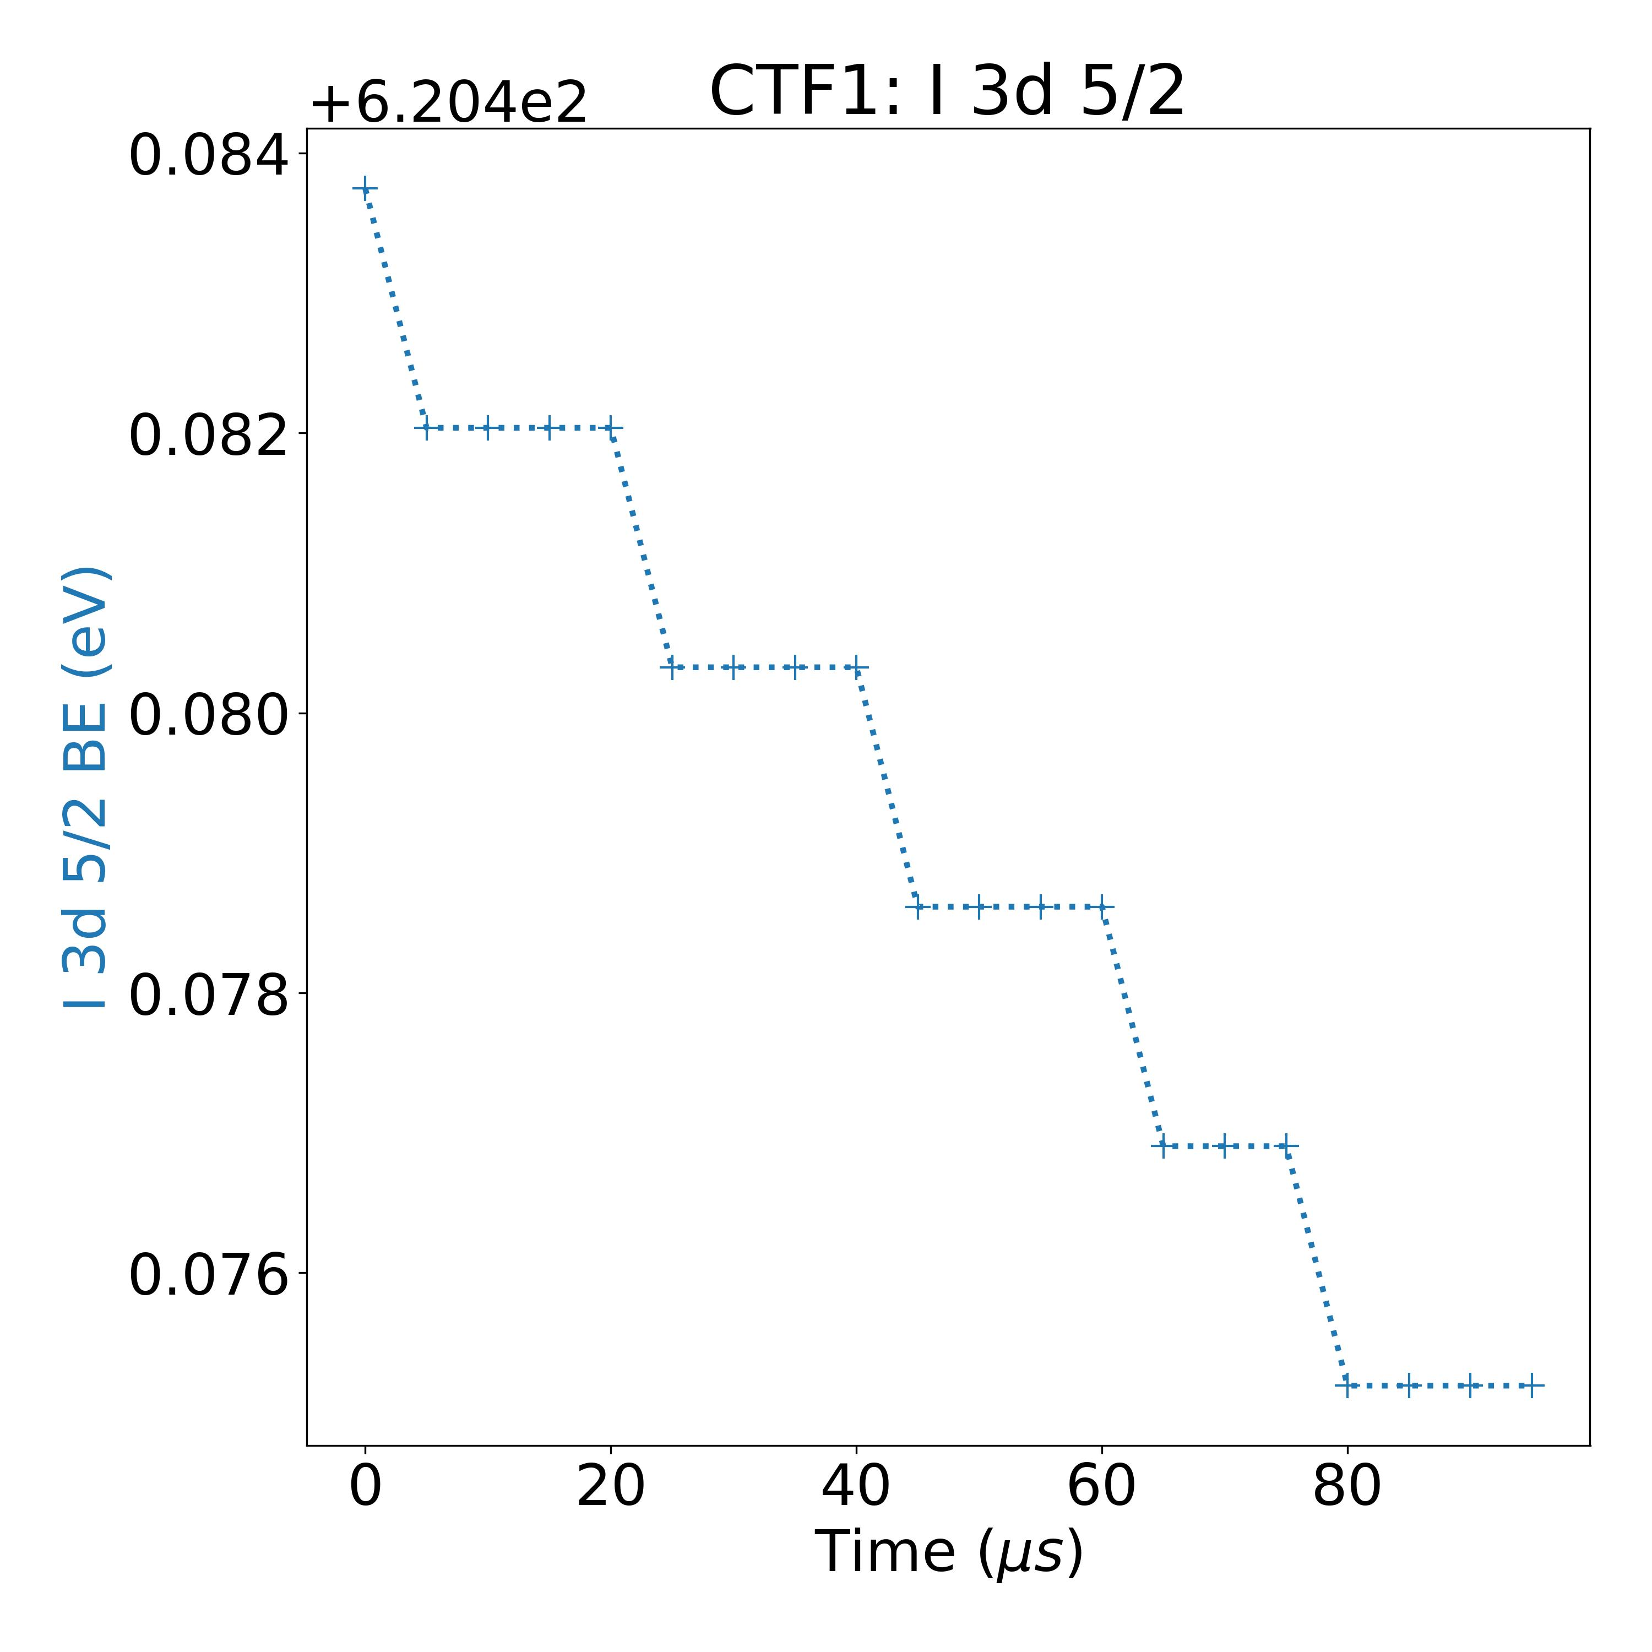

Measurement 4: I 3d 5/2 – 10 mW laser illumination

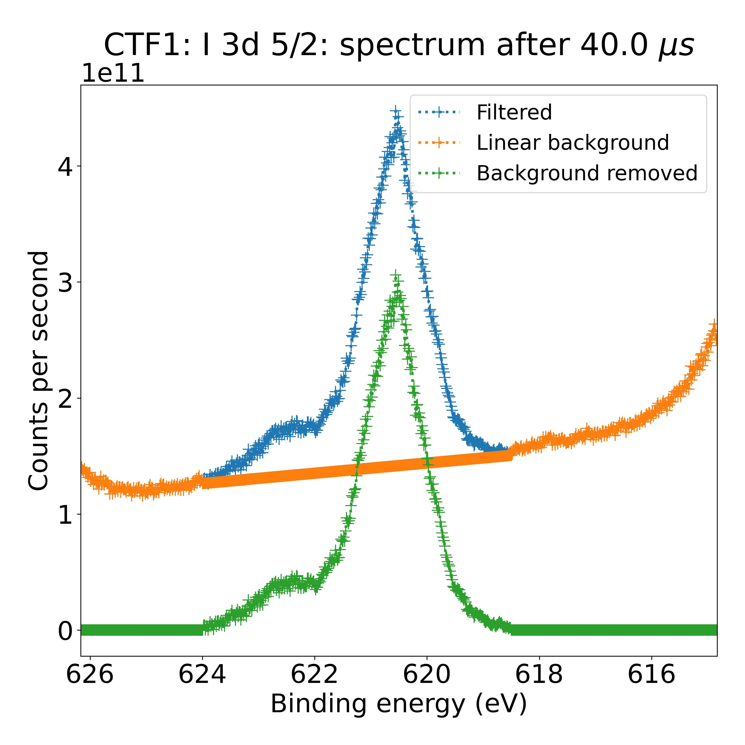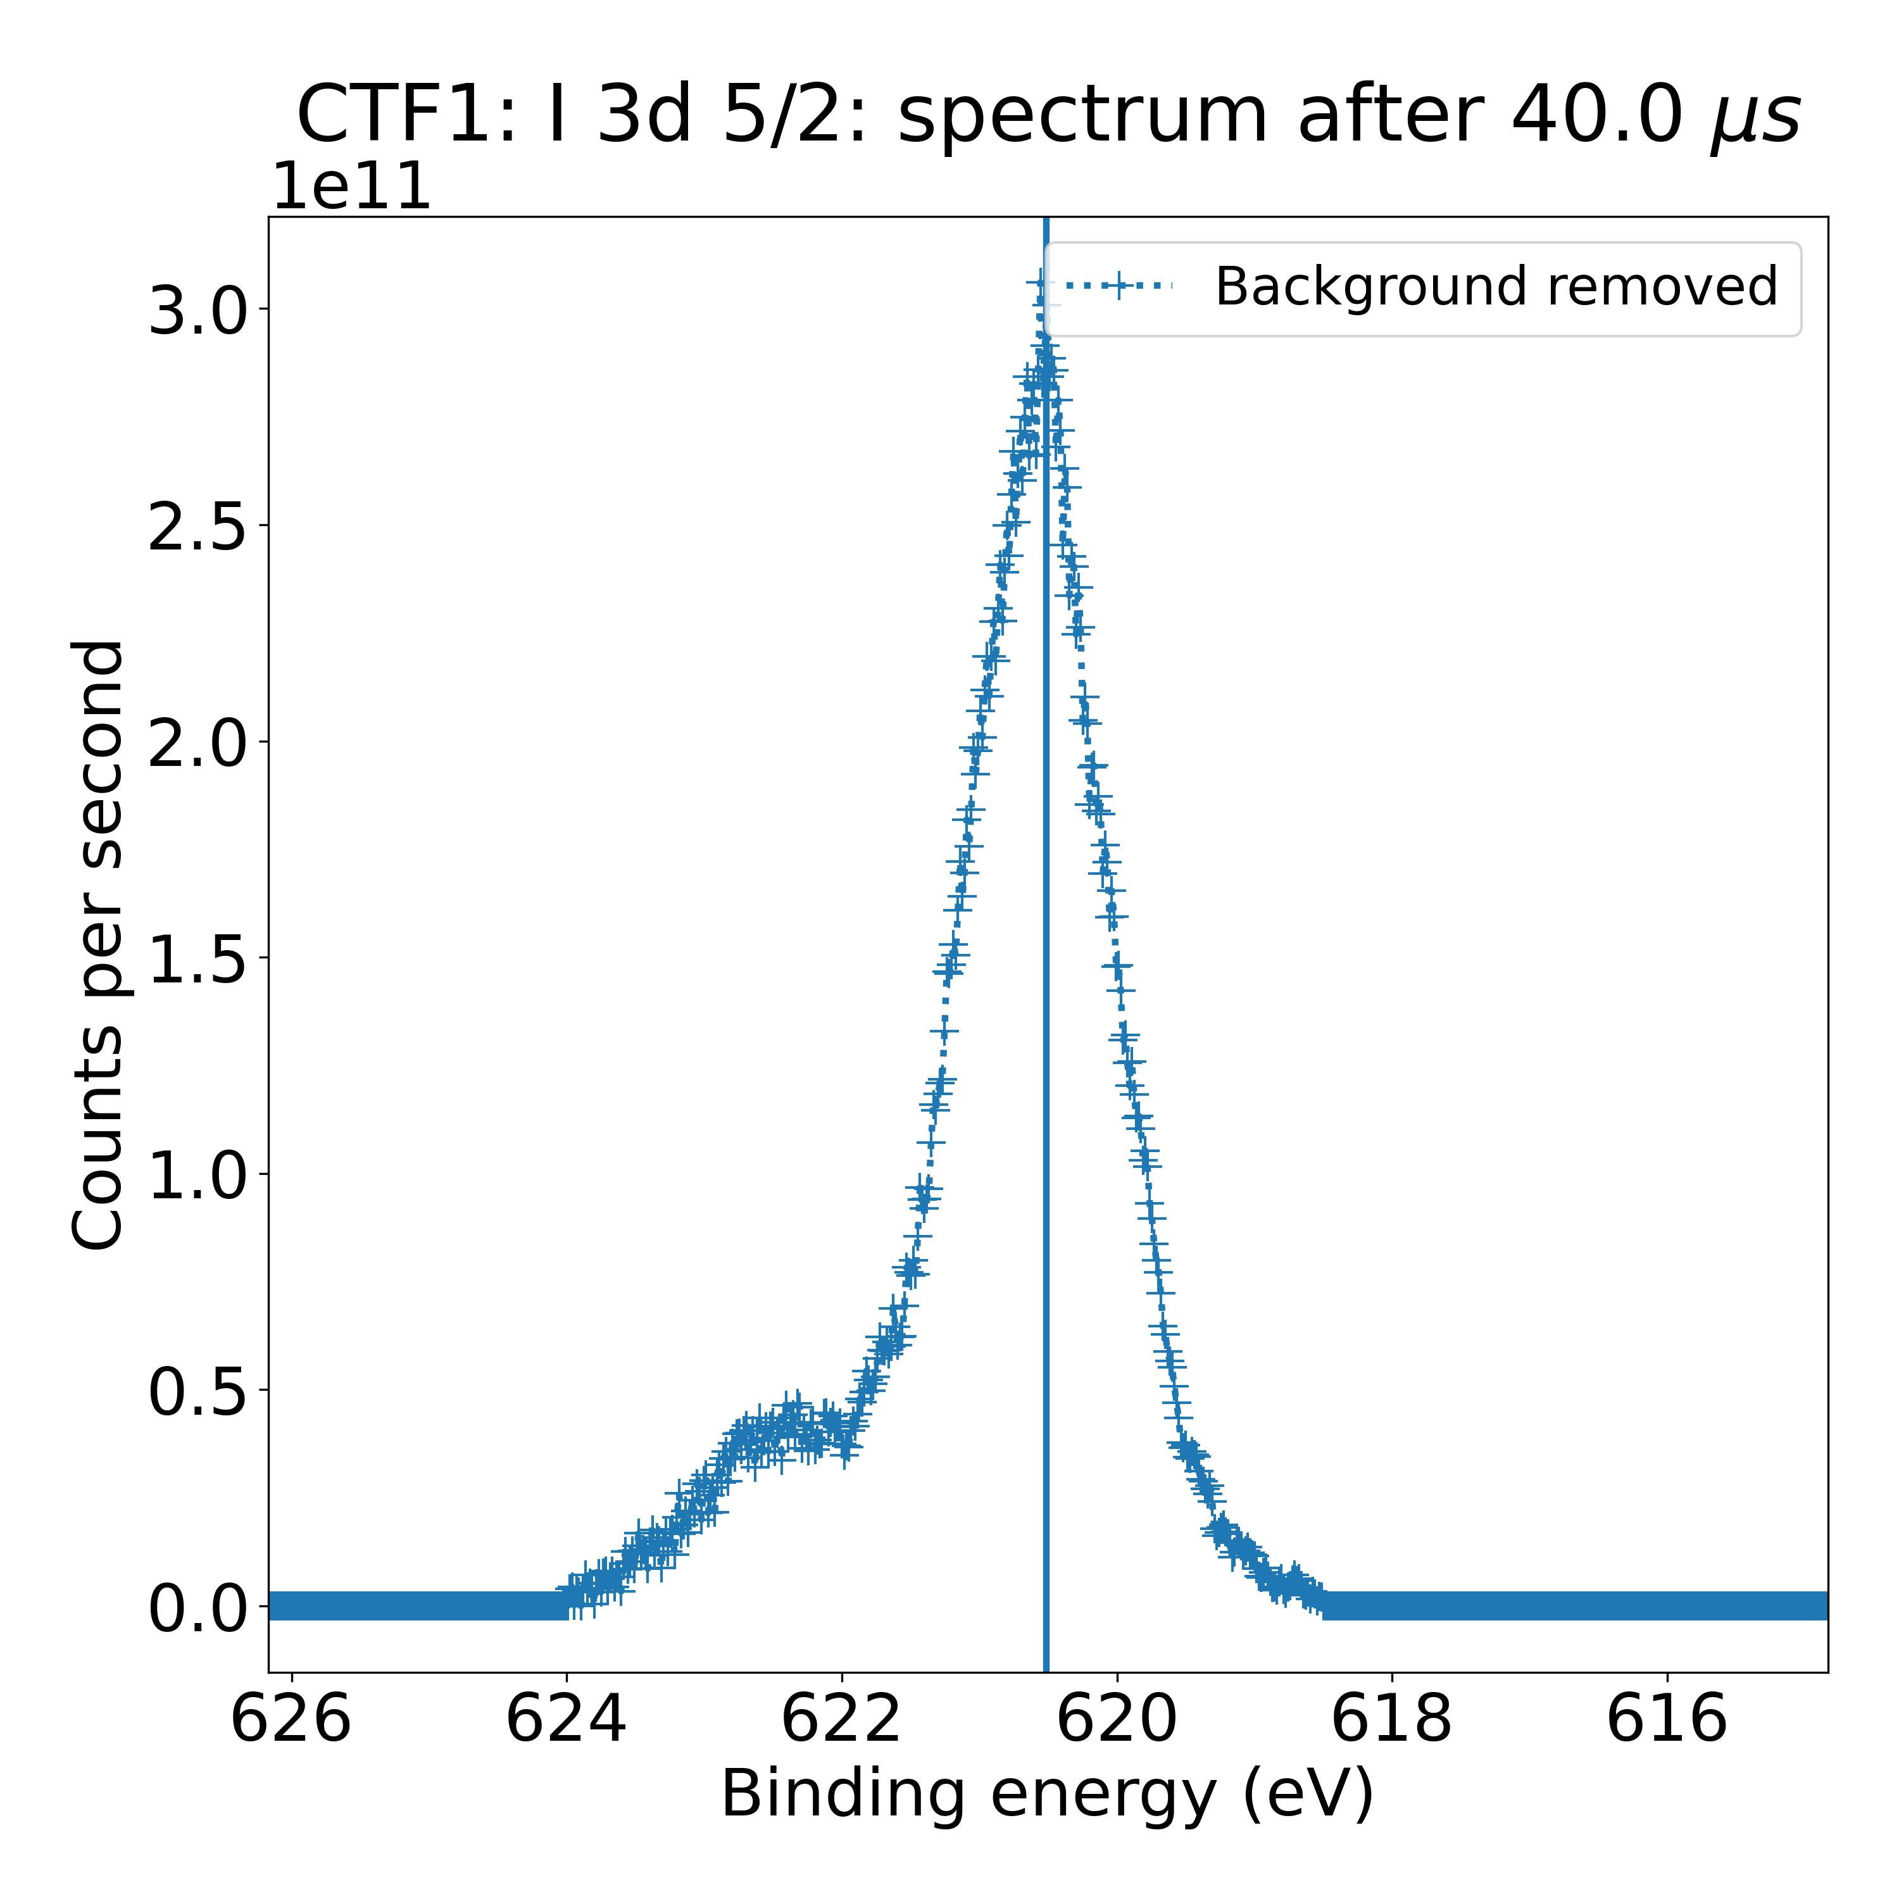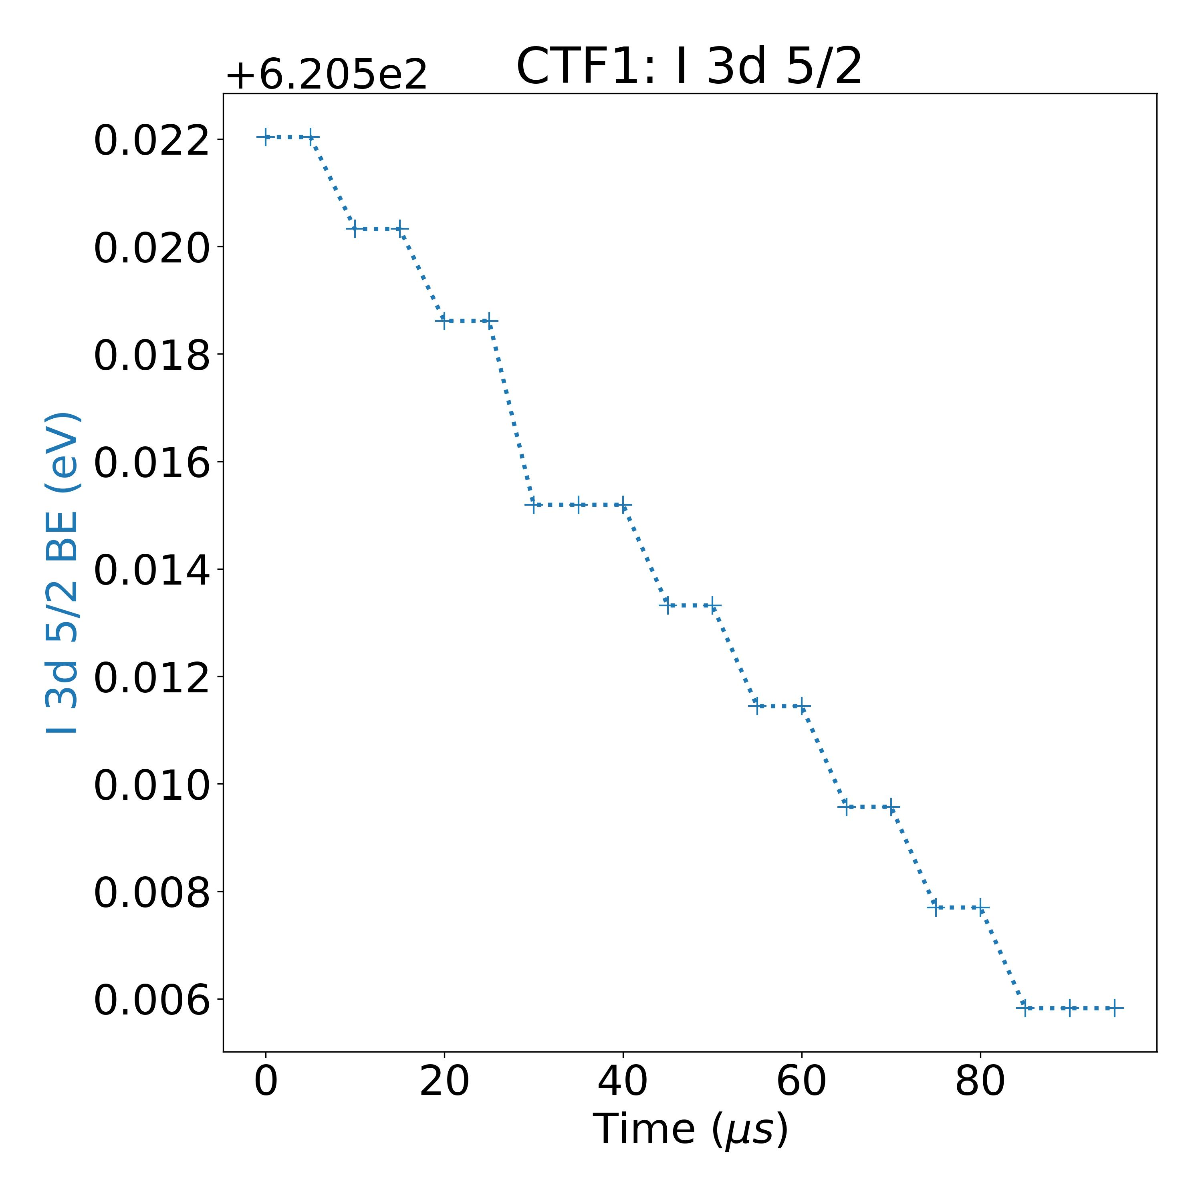

Sample: NREL 1:



Measurement 31:

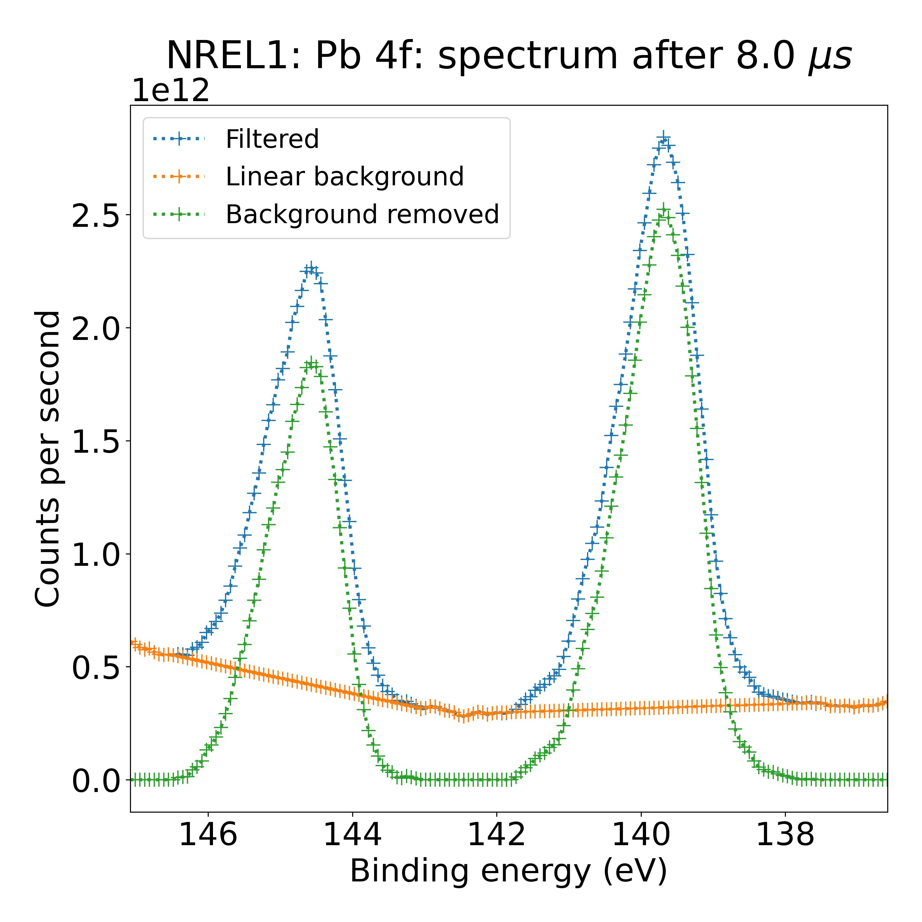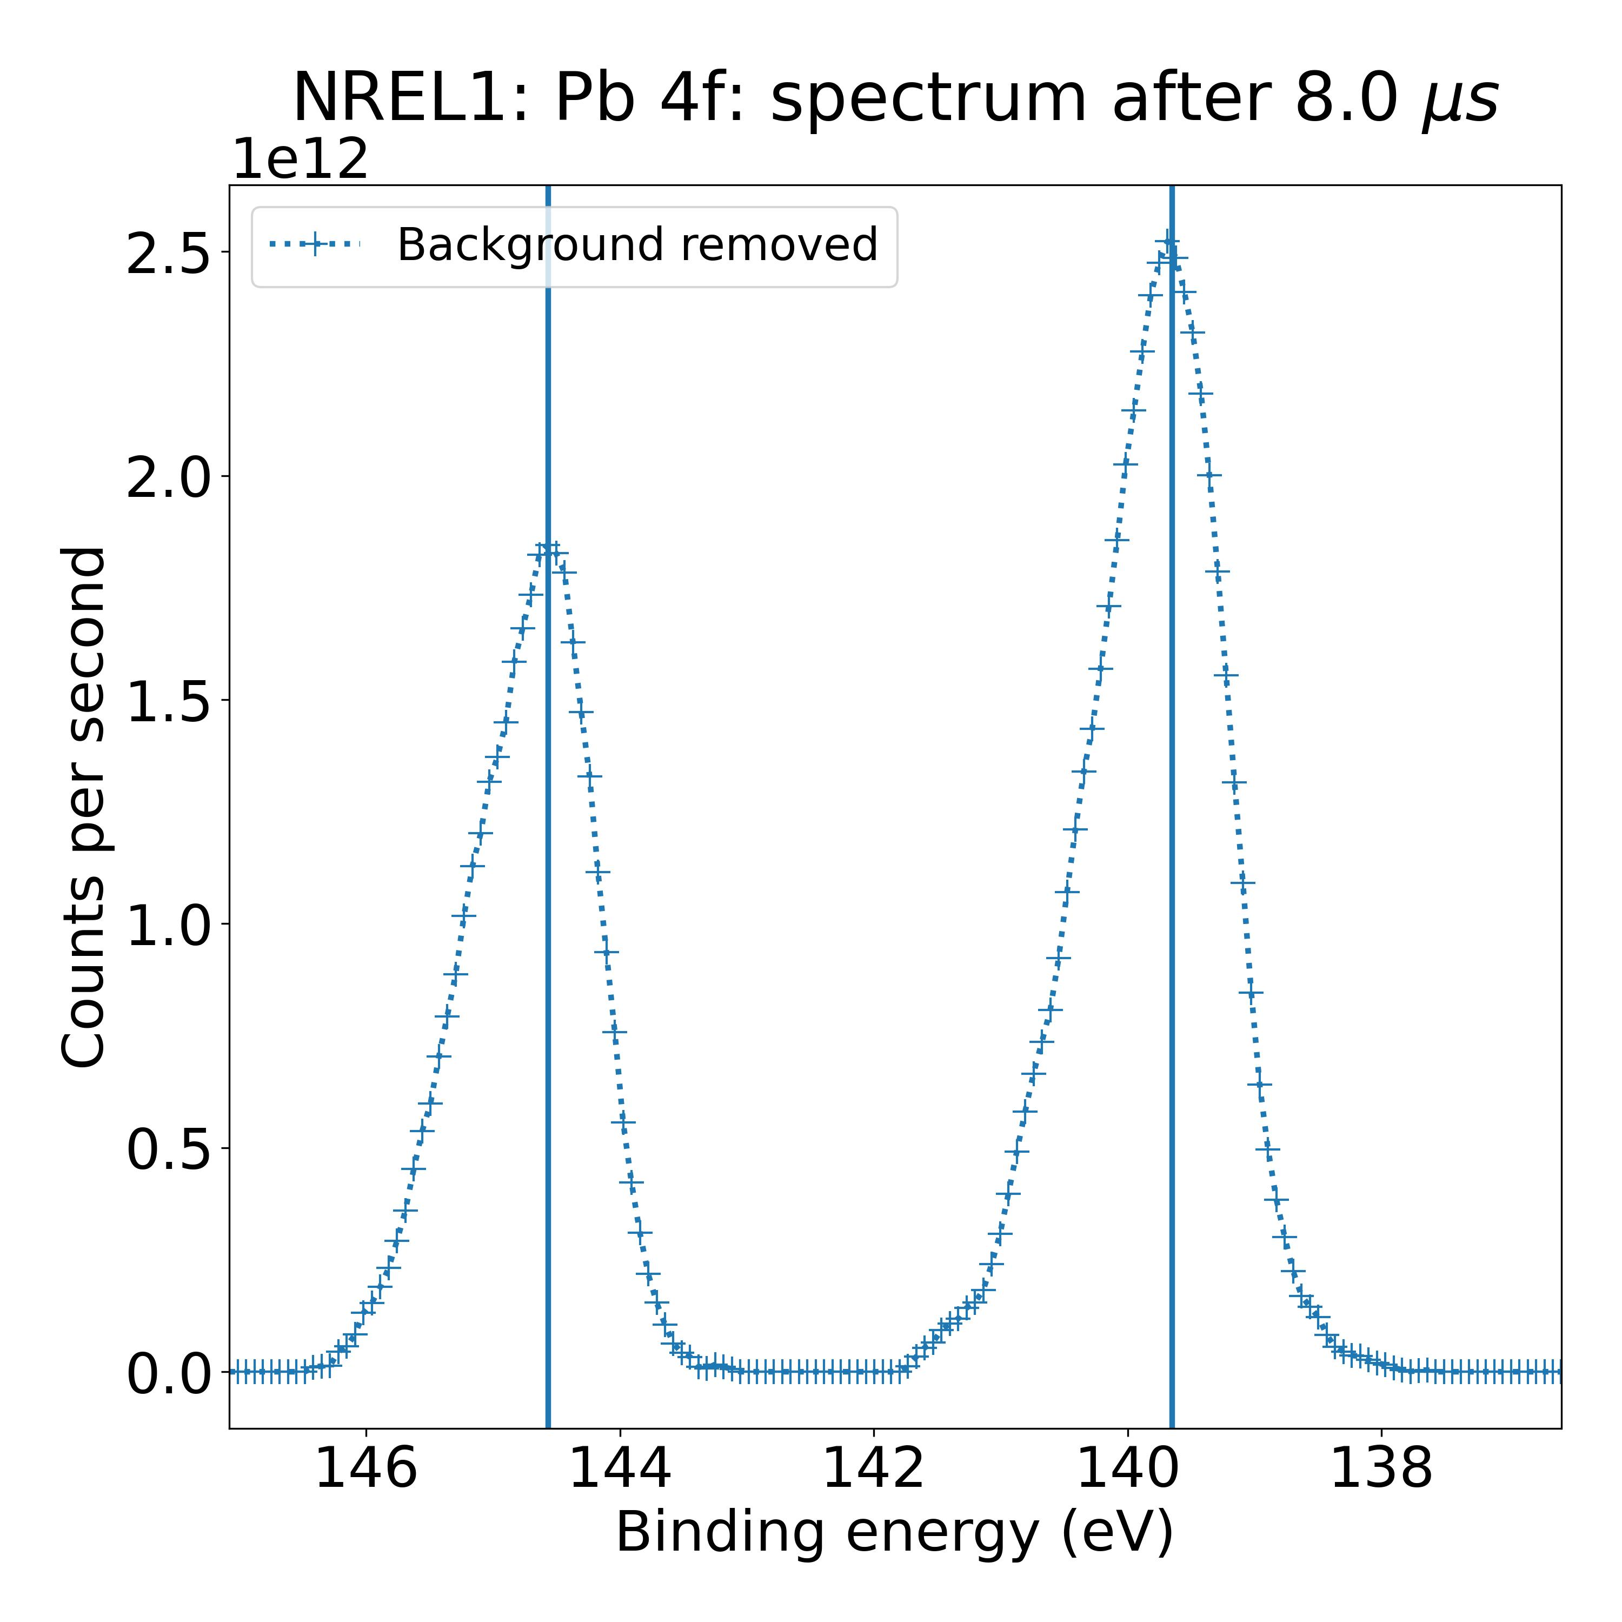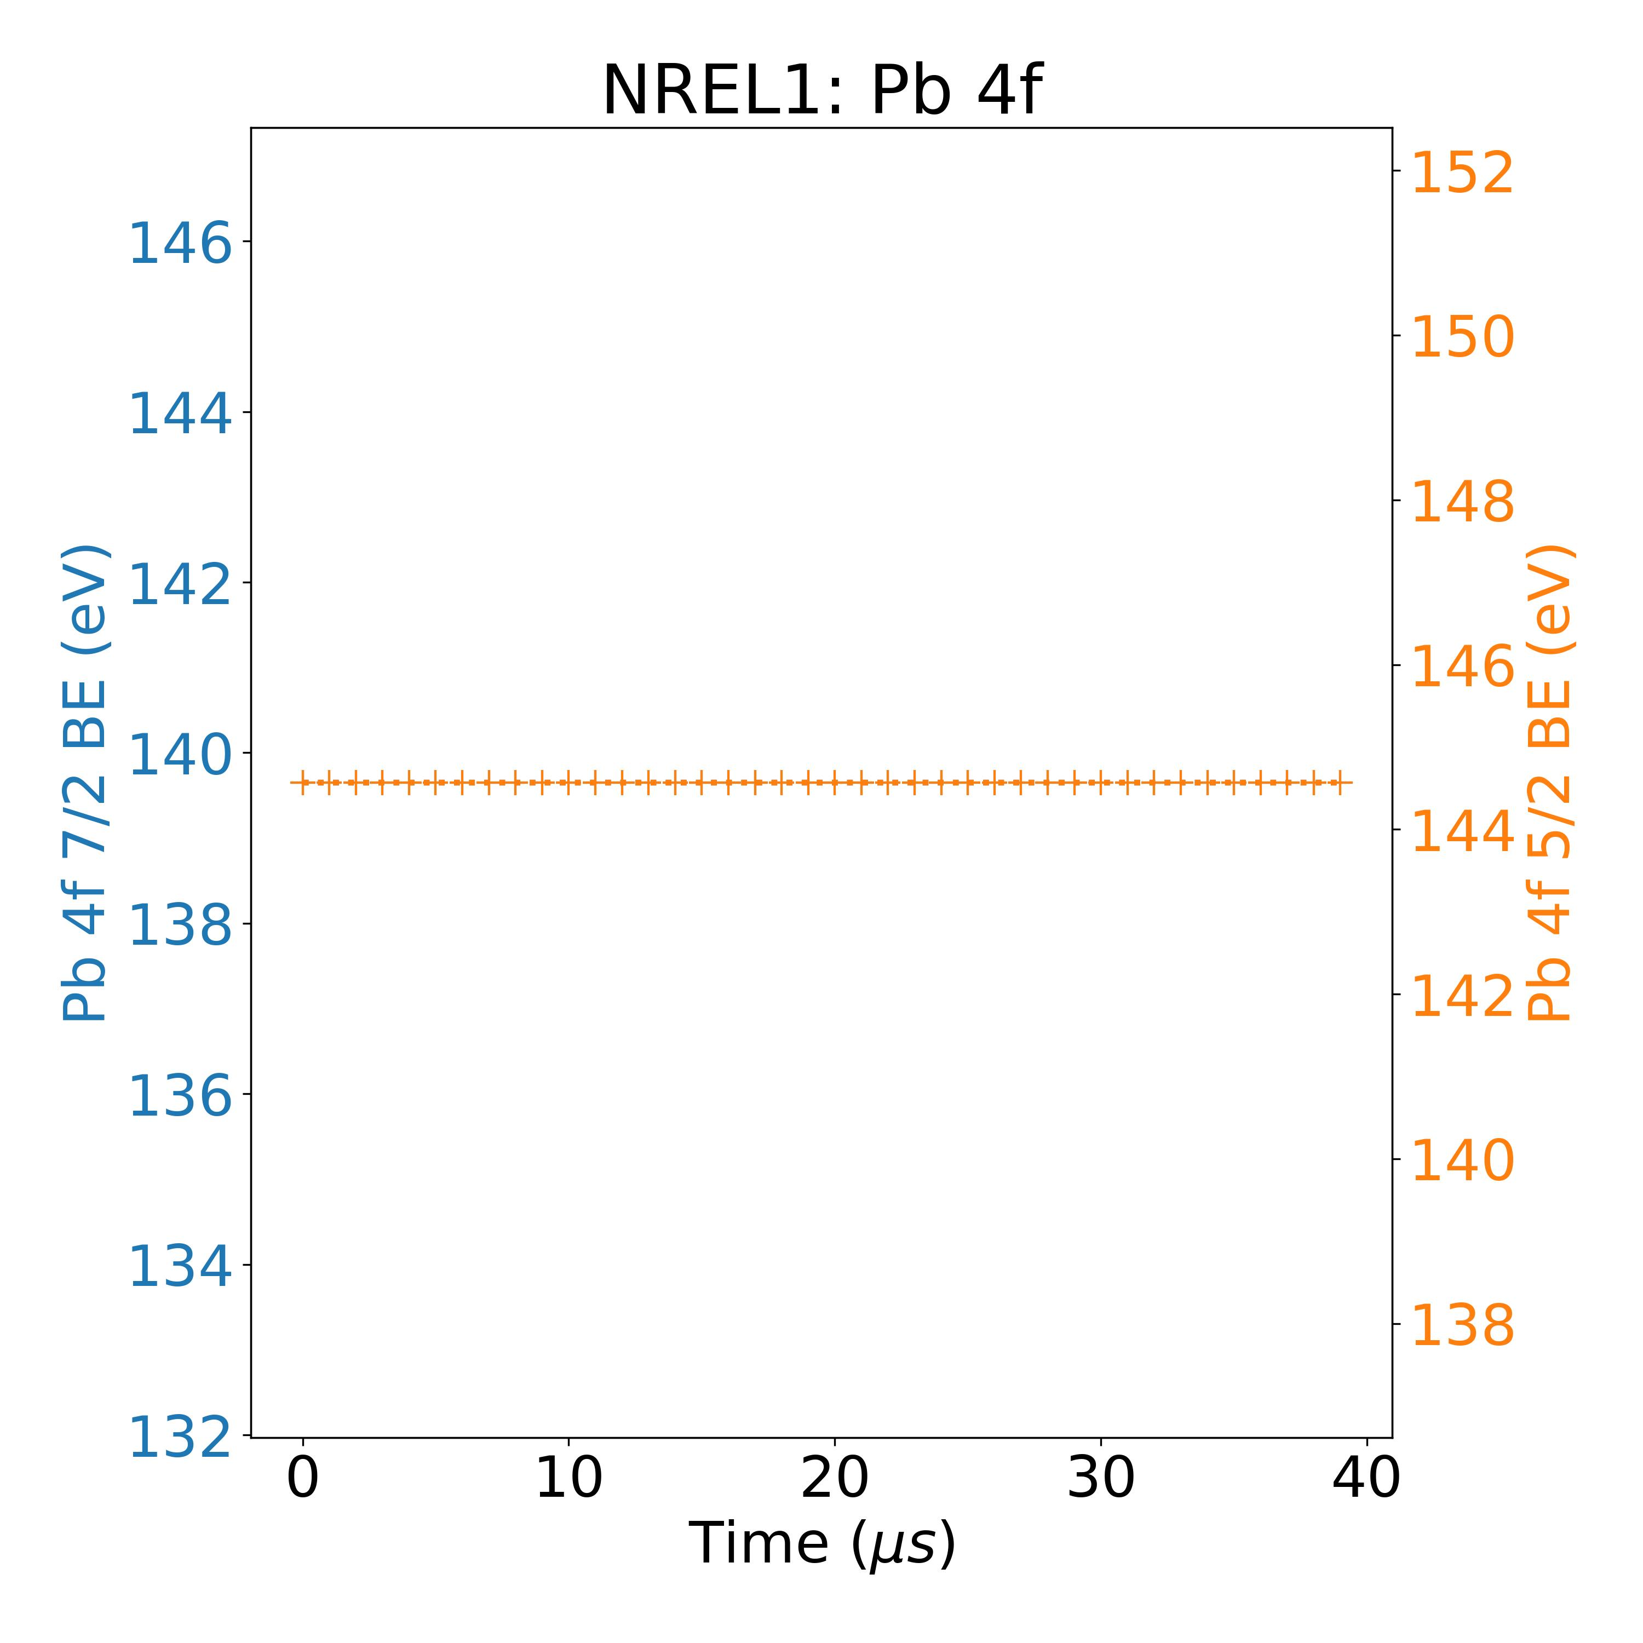

Measurement 51:

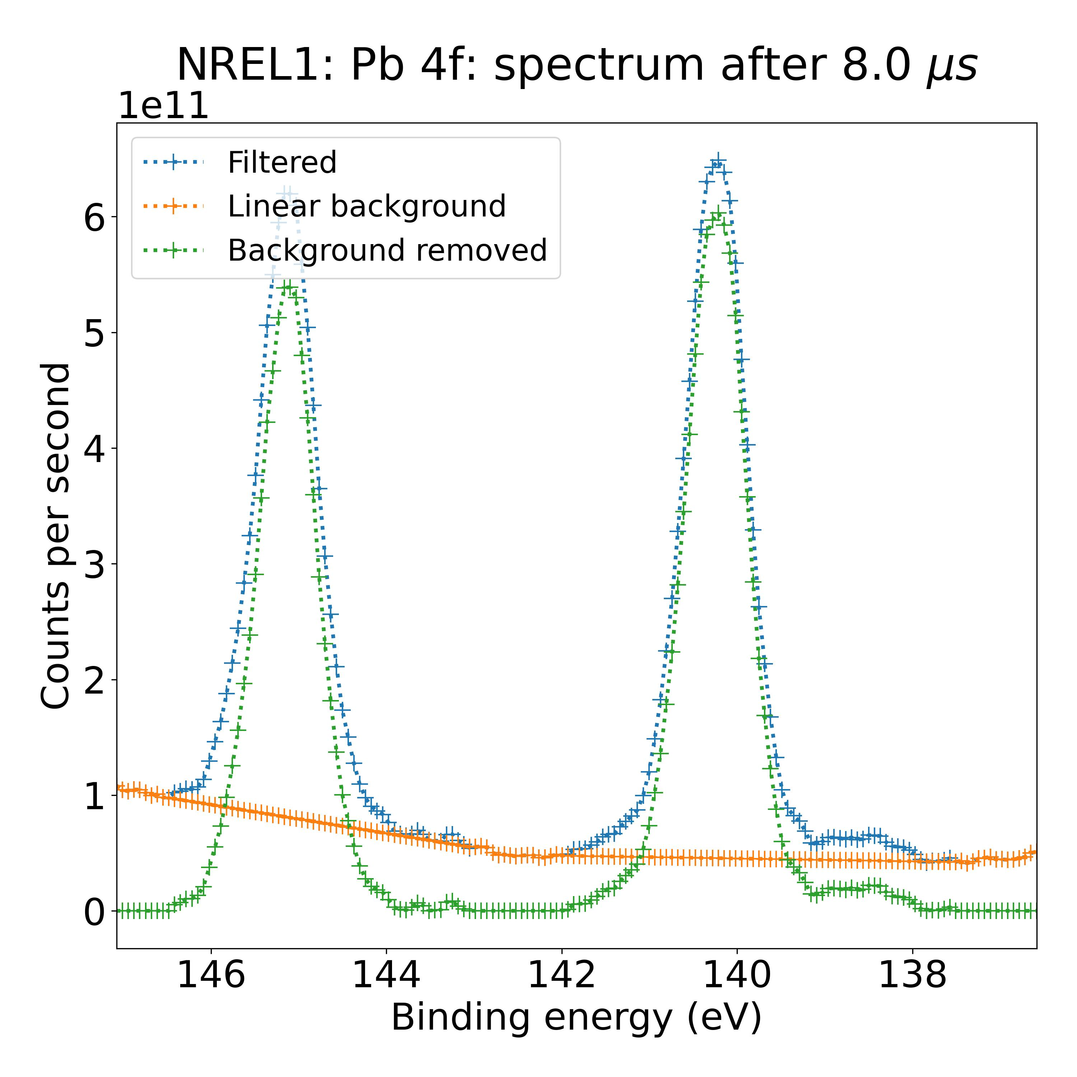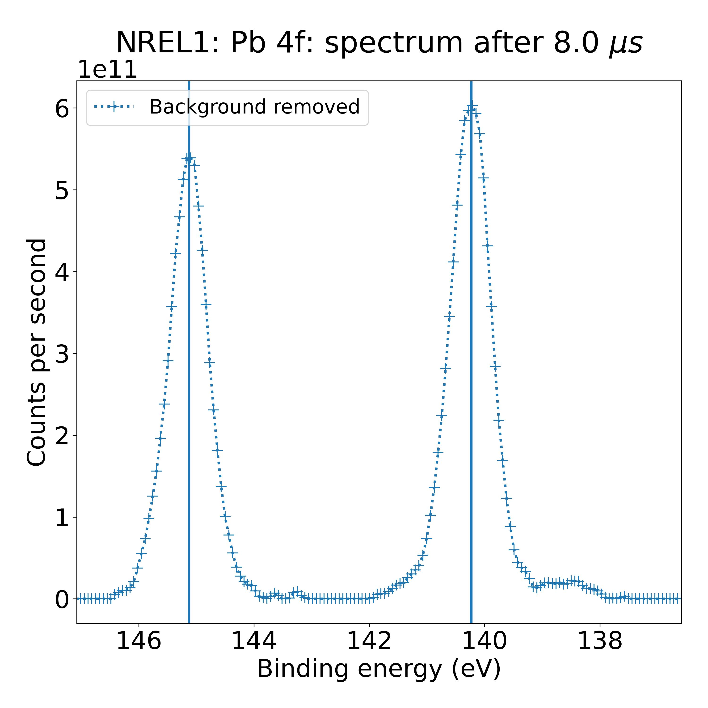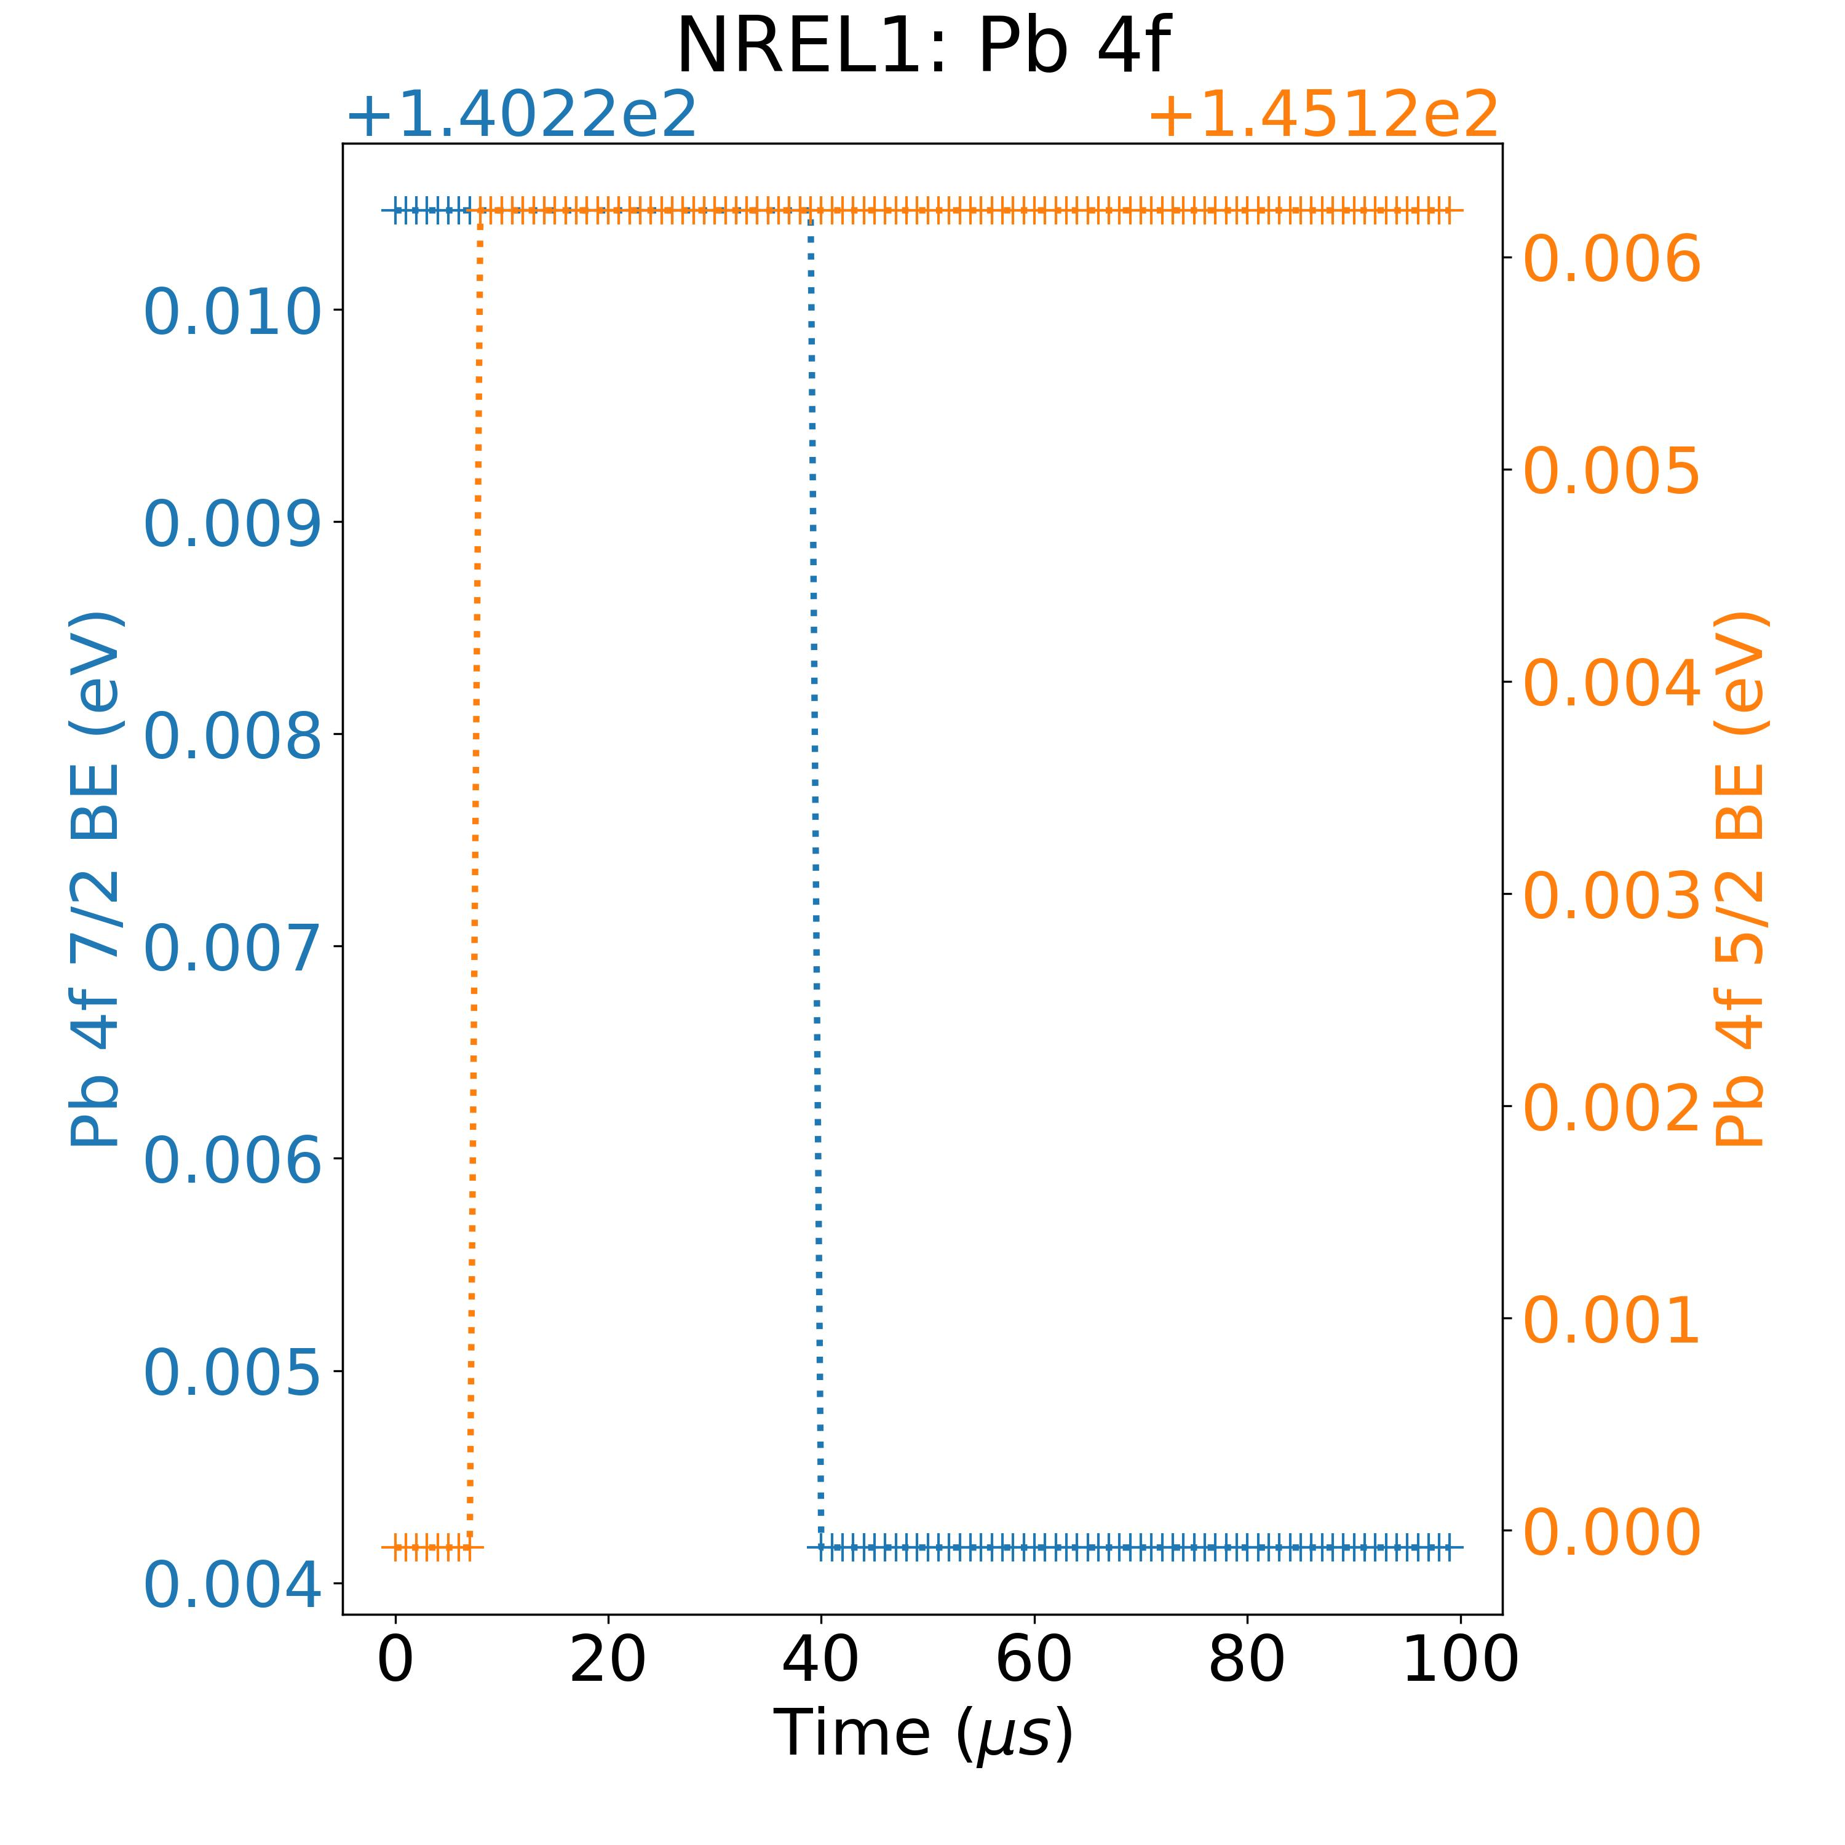

Measurement 60:

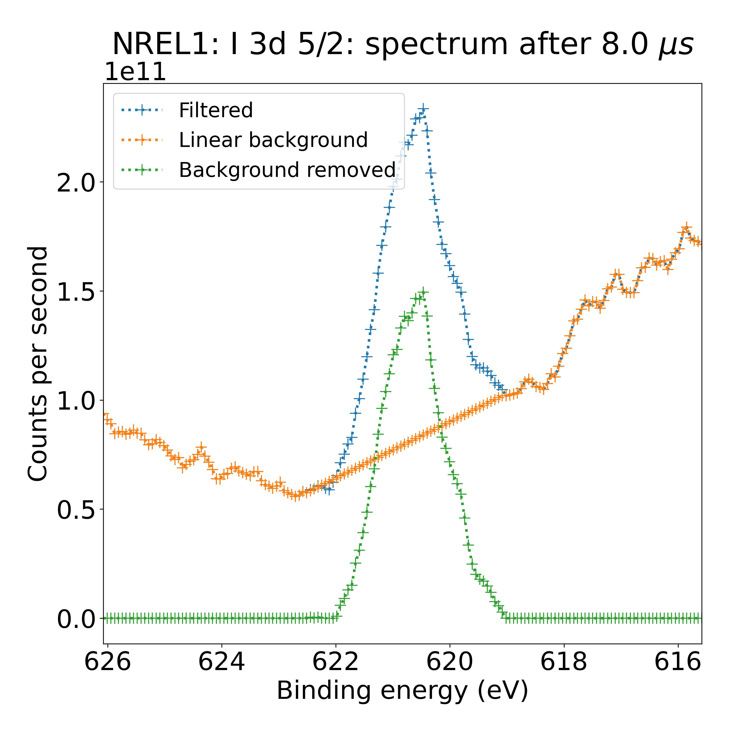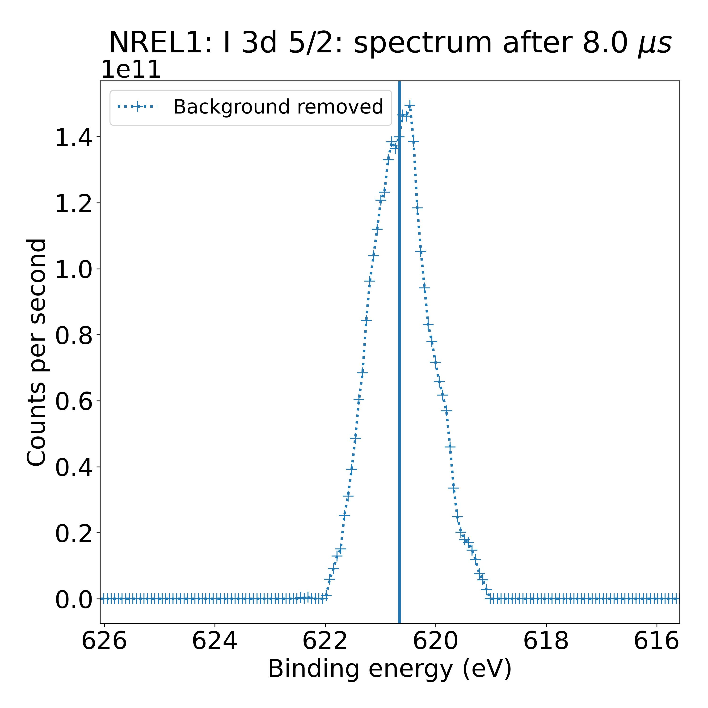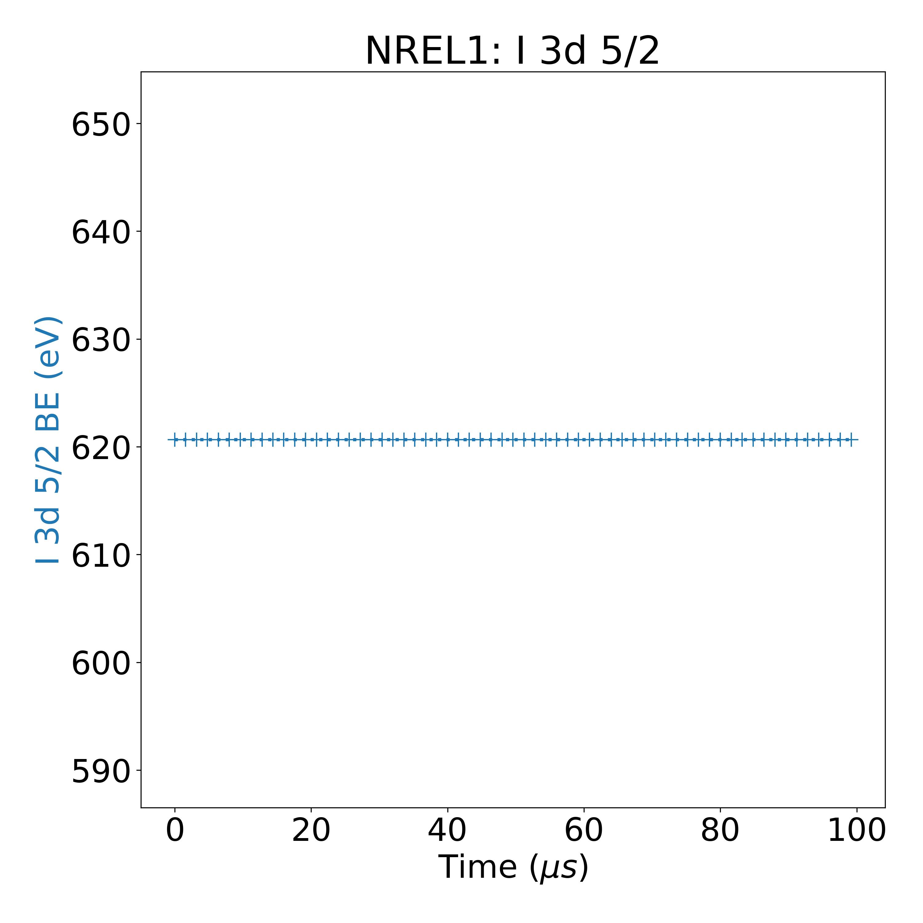

Measurement 64:

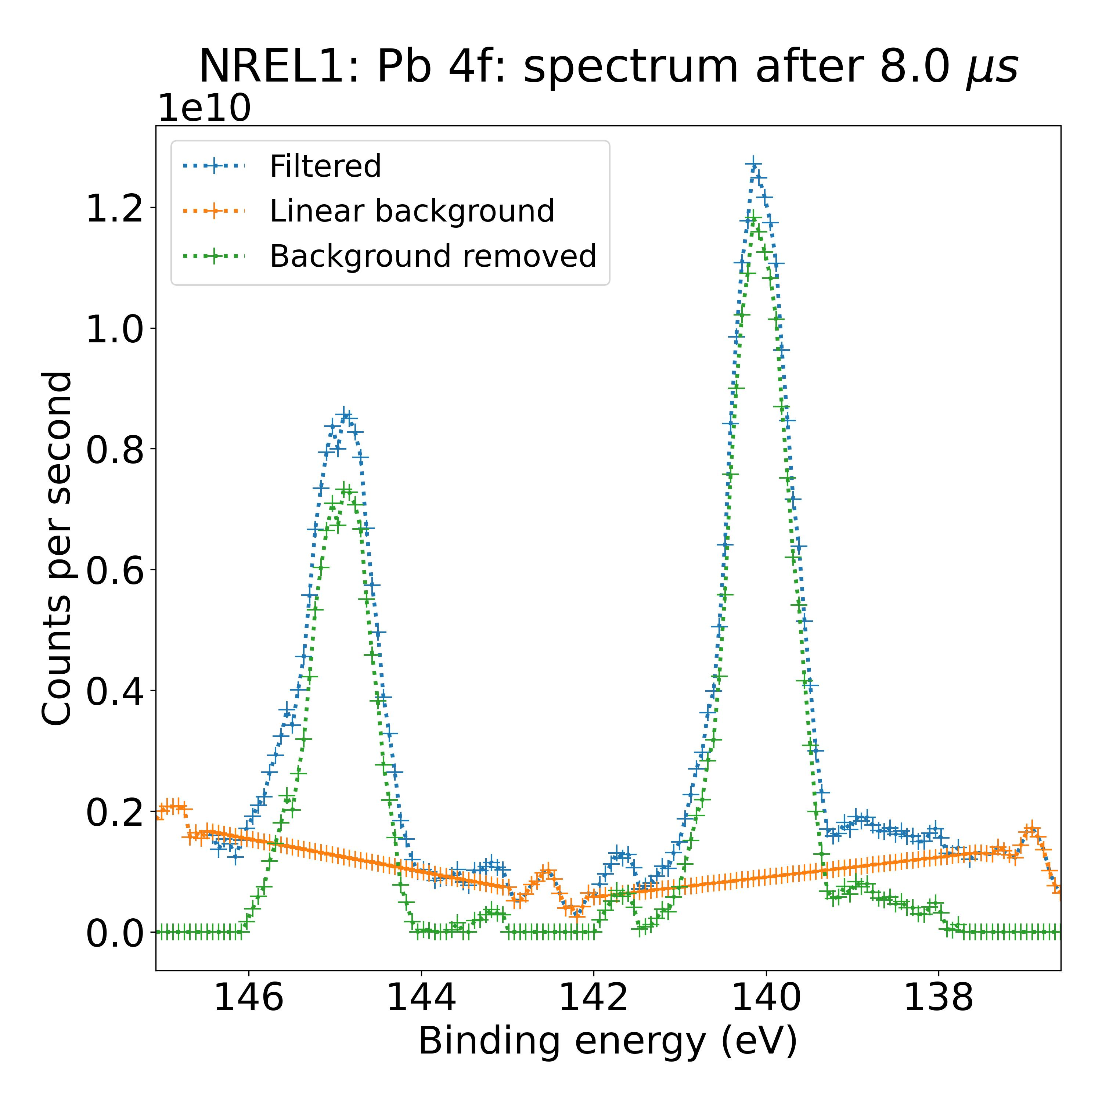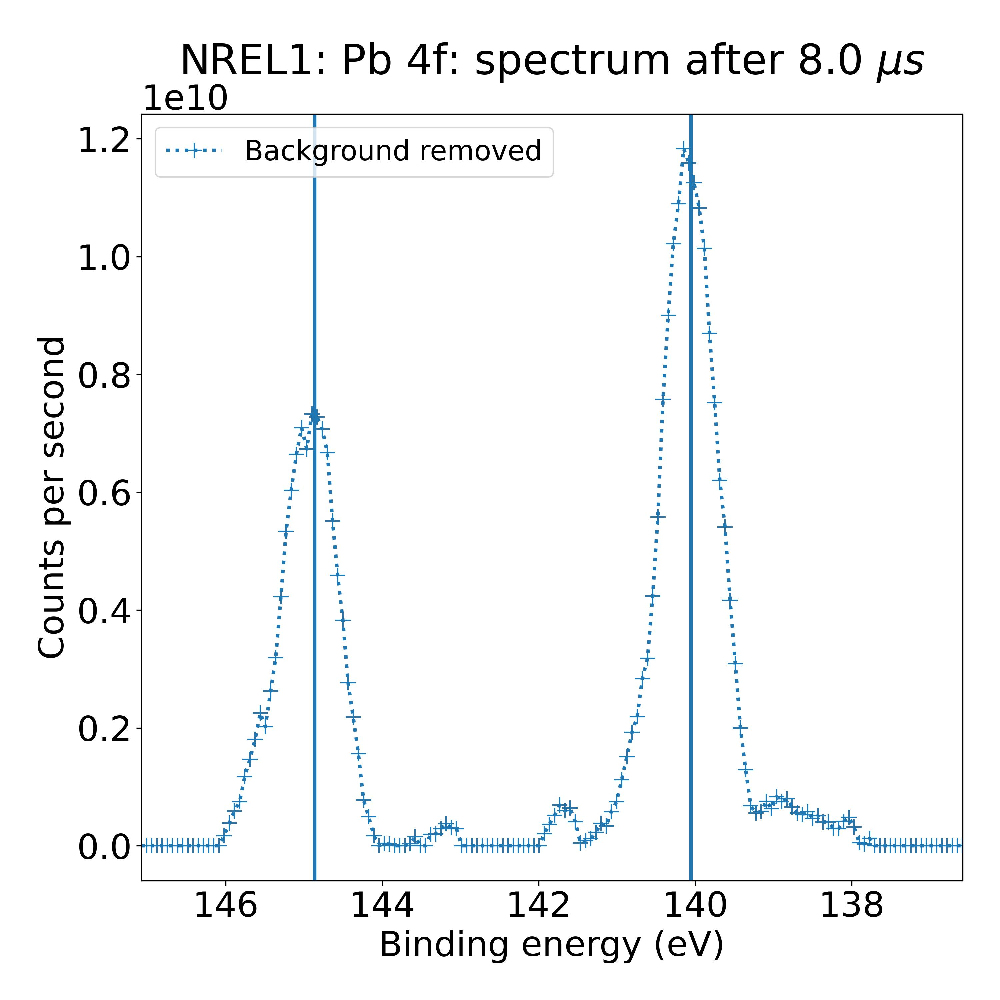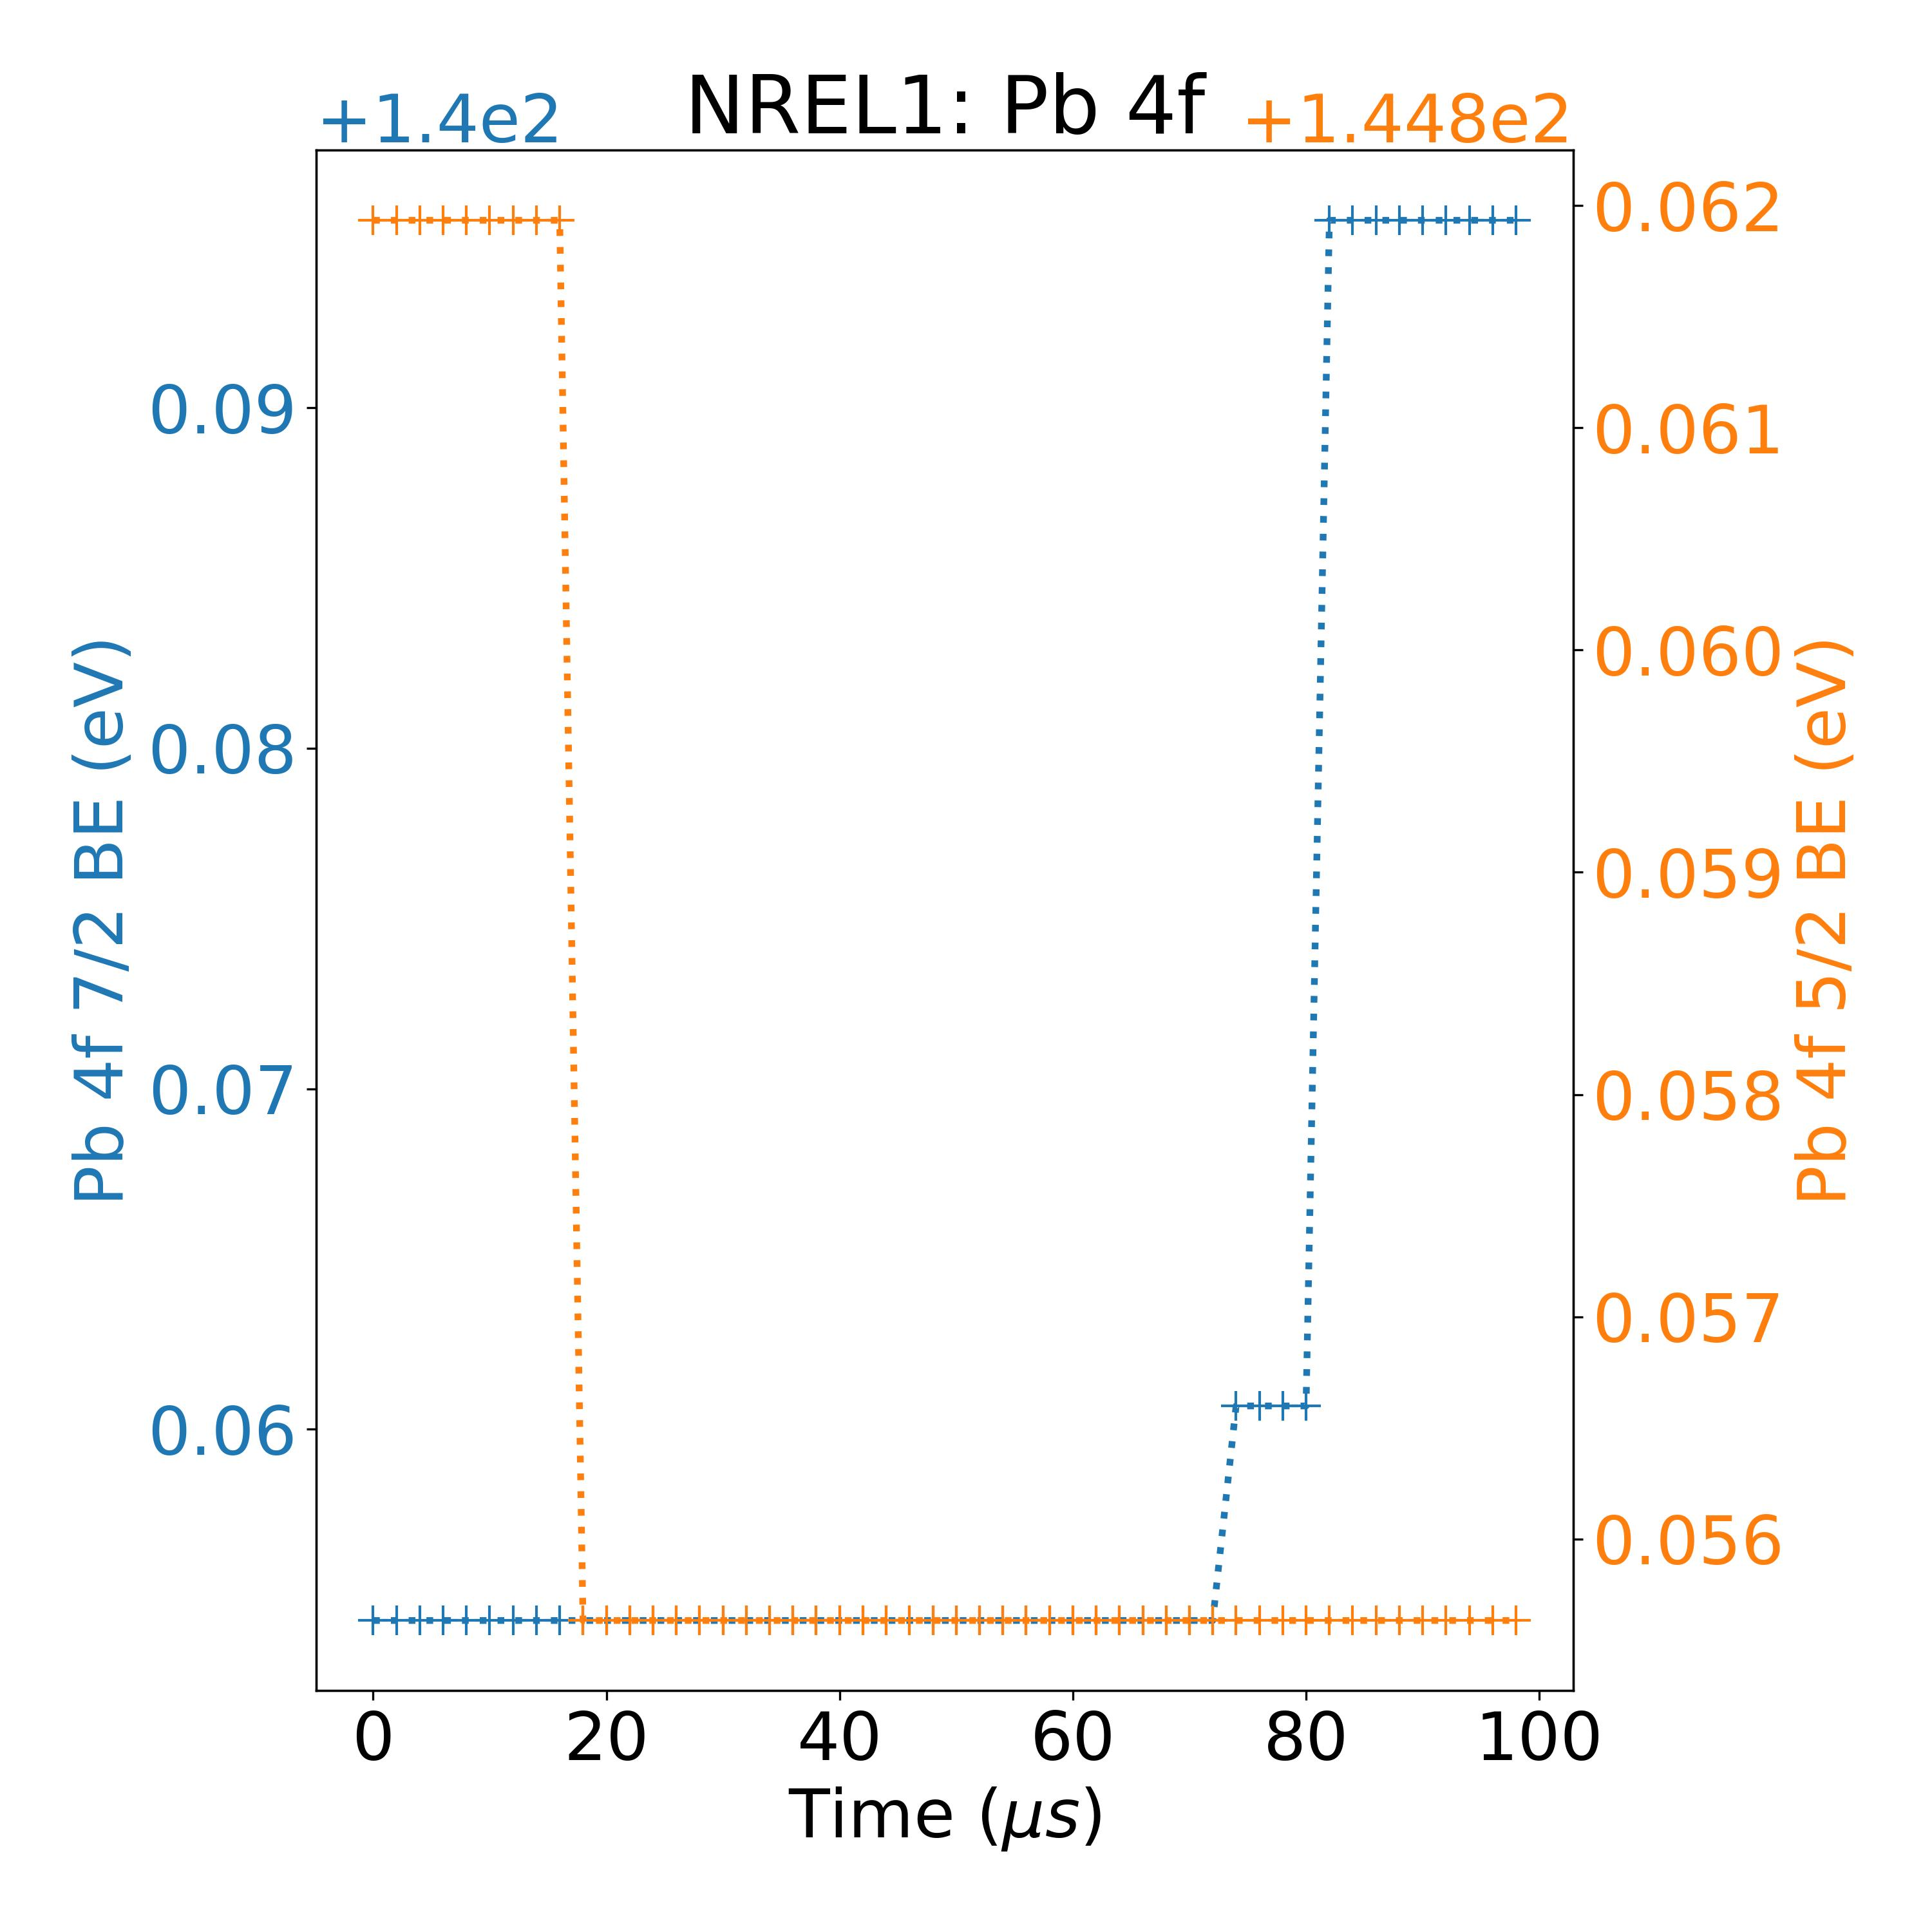

Measurement 67:

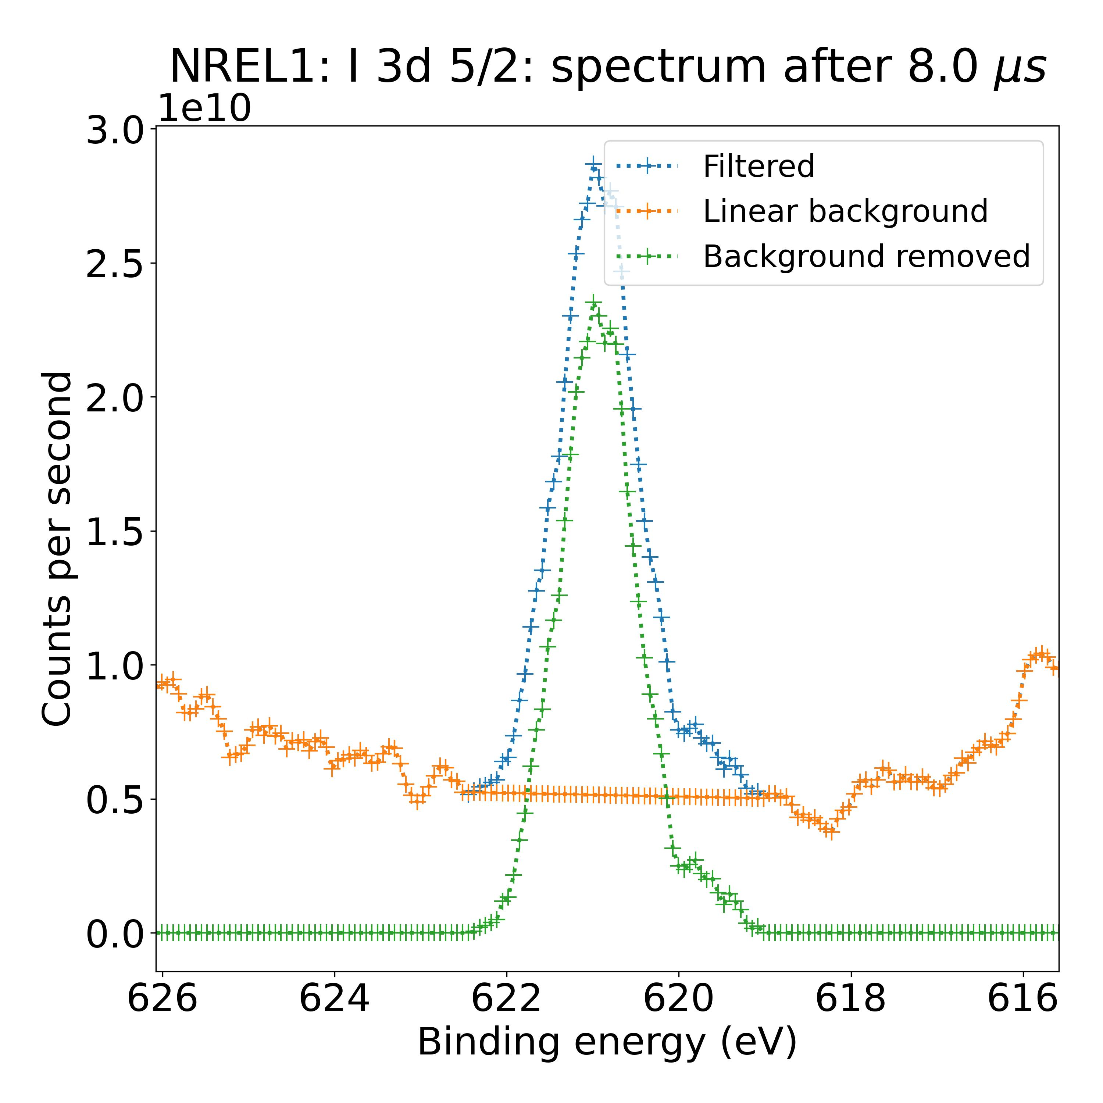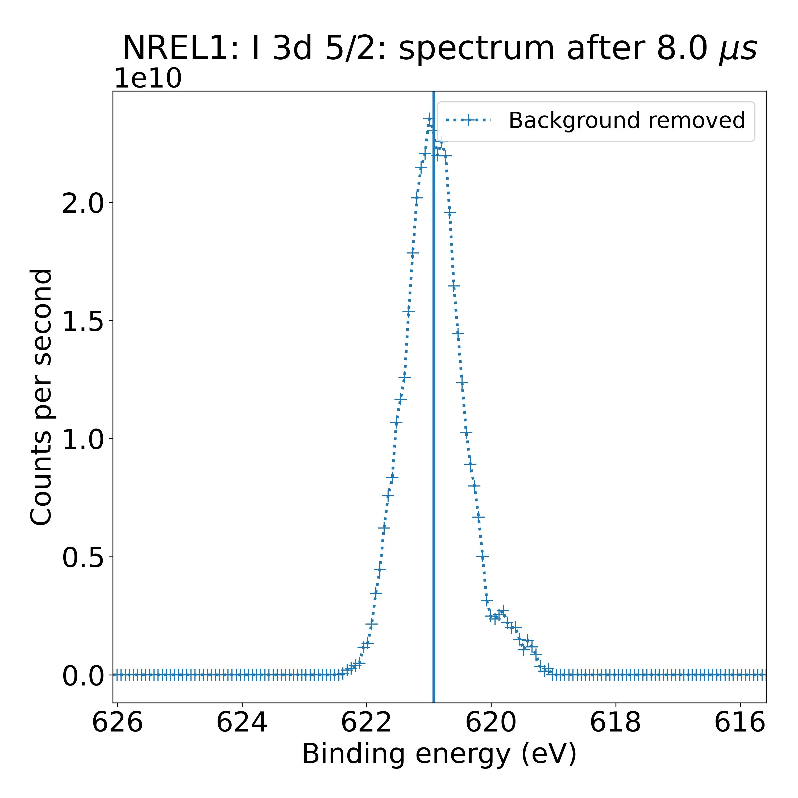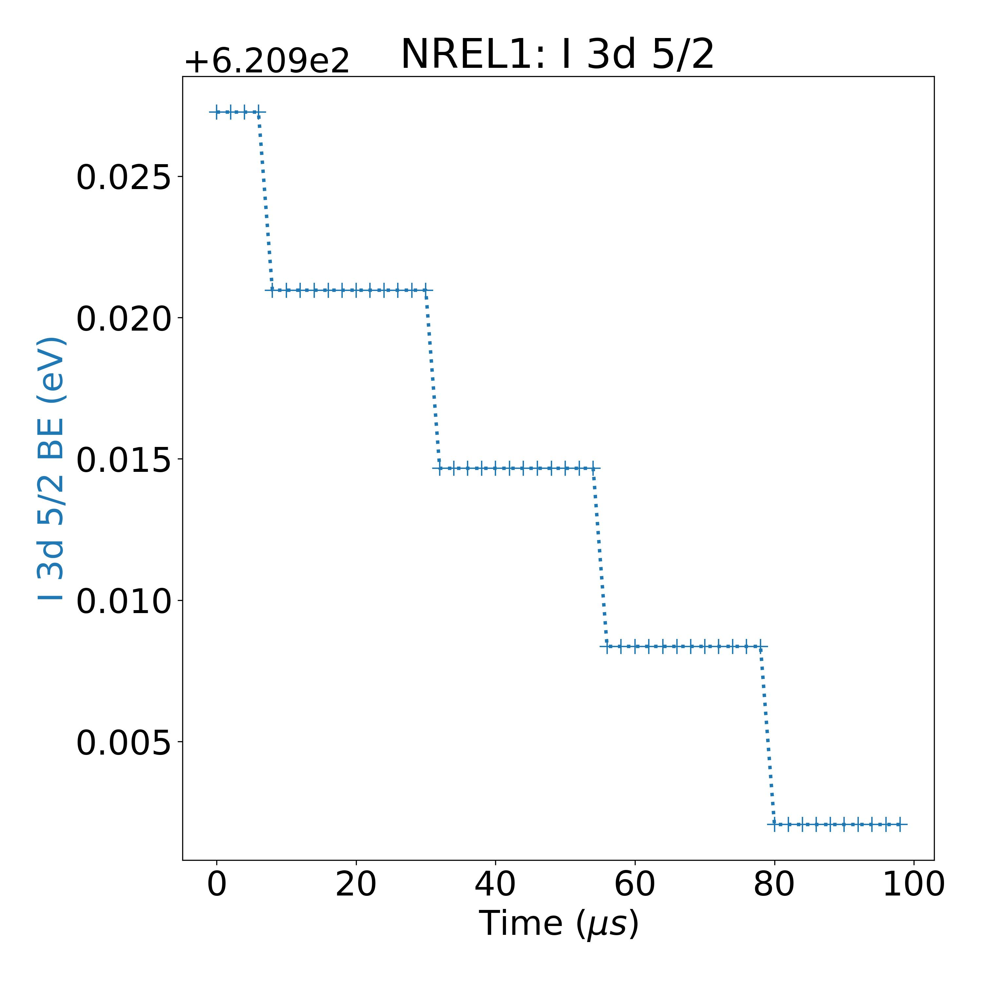

Recursive CNN fits:

Measurement 3:

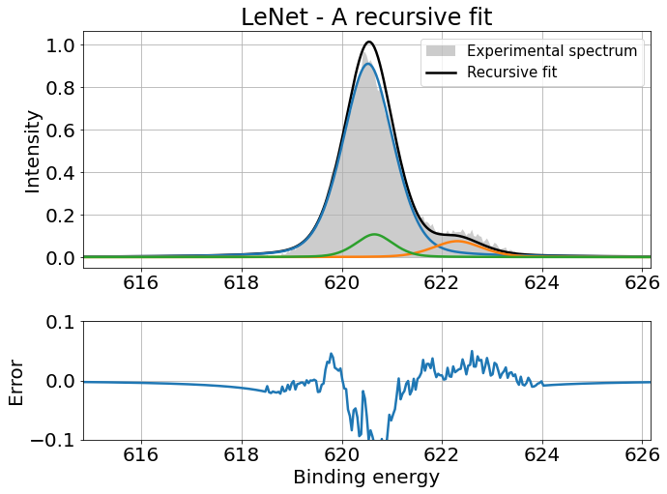

Measurement 31:

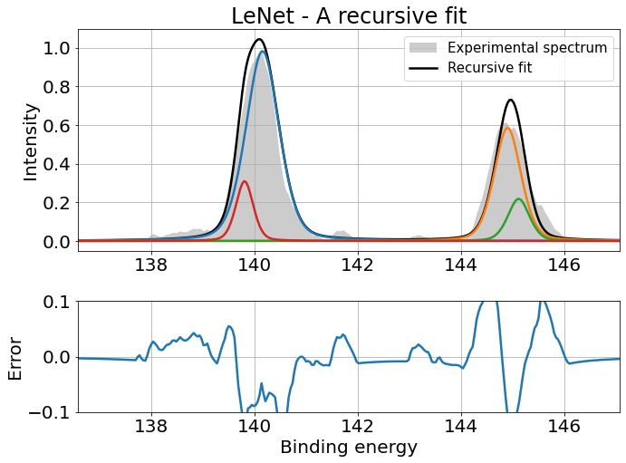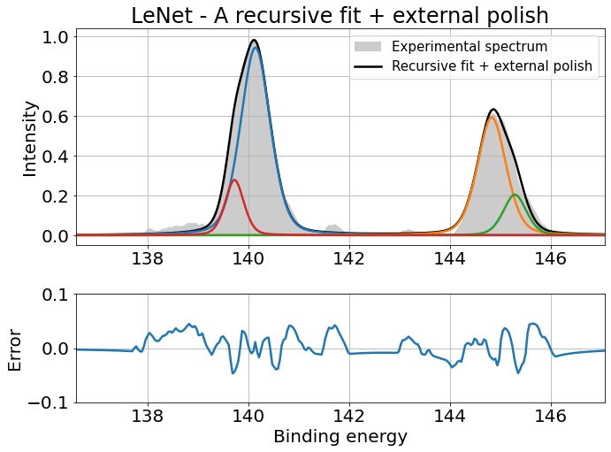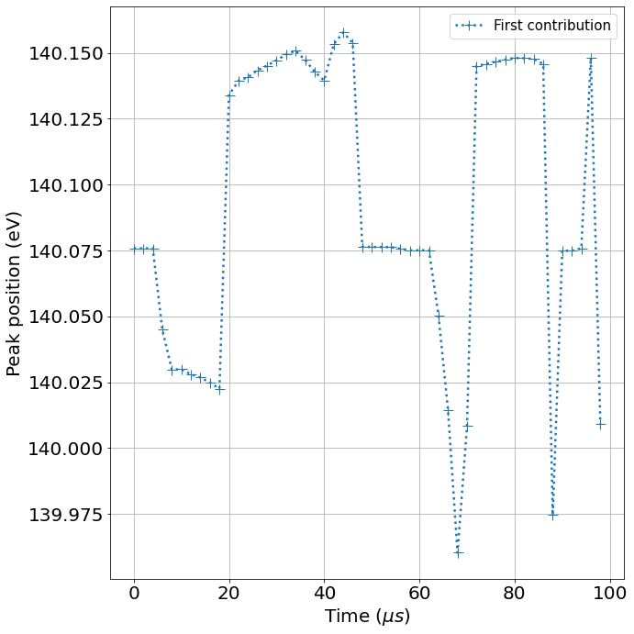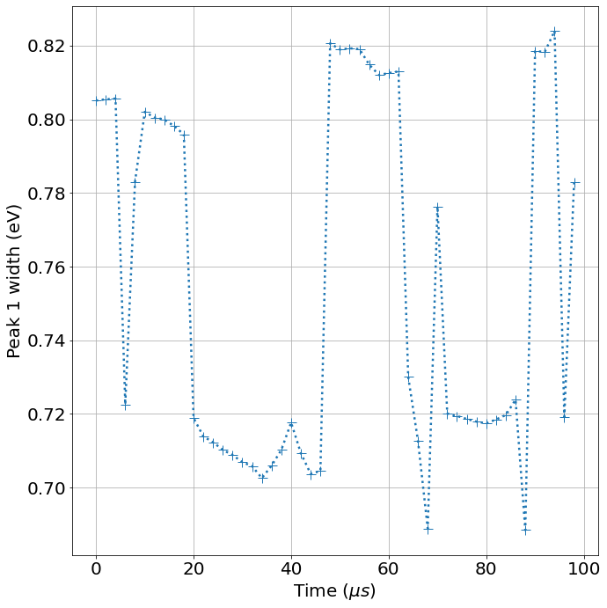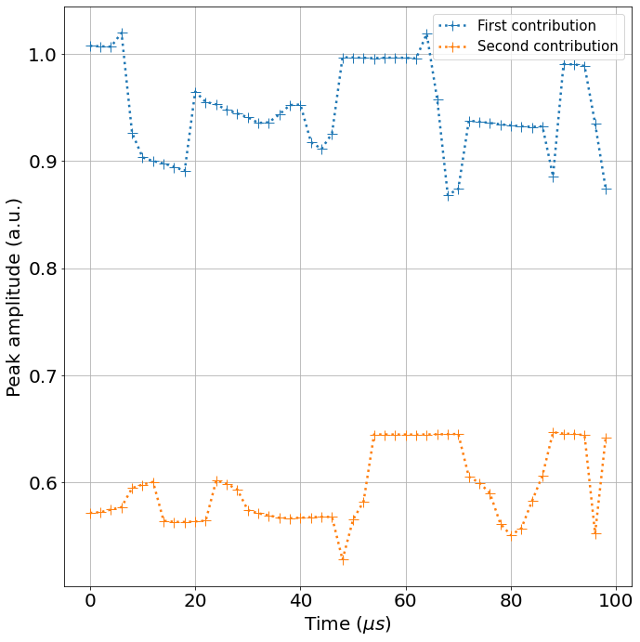

Measurement 64:



